Talend Job: Extract_Letter_Count_to_Hyper

Overview
Computes a per-file-date, per-client letter-count summary (grouped by logon, PL_GROUP, account groups, and vendor) from PCI letter, debtor, and client tables, then builds a local Tableau Hyper extract file (/output/letter_count.hyper) using the Tableau Hyper API directly from custom Java code, rather than publishing straight to Tableau Server as Extract_Letter_Count does. It covers similar business ground to Extract_Letter_Count (letter counts) but is a structurally different job with a different query, different derived columns, and a different publishing mechanism — not a duplicate.

Detail table
Field | Value
Job name | Extract_Letter_Count_to_Hyper
Version | 0.1
Project | EDW2SF
Author | jmach@harriscollect.com
Created | 2022-01-17T16:26:52.111-0800
Last Modified | 2025-09-24T10:59:50.035-0700

Step-by-step data flow
Setup subjob: tPrejob_1 → tDBConnection_1 opens the Snowflake connection → on success, tLibraryLoad_1 loads the tableauhyperapi Java library (version 6.0.0-SNAPSHOT) → on success, tJava_1 builds a Tableau Hyper file (code truncated in this metadata, but visibly creates a HyperProcess/Connection and begins defining a TableDefinition named "Letters" at /output/letter_count.hyper).
Main subjob:
- tDBInput_1 runs a query joining PCI_Letters, DimDebtor, and DimClient (filtered to File_Date BETWEEN '2018-01-01' AND CURRENT_DATE — a hardcoded lower bound), computing a vendor classification (PCI / RevSpring / Other based on filename prefix) and a "Letters Sent Flag" (0 for letters whose code starts with e — an email code — or based on mail-disposition text), then aggregates with COUNT(Customer_Key) grouped by file date, logon, PL_GROUP, account groups, vendor, letter code, and the sent flag.
- tJavaRow_1 receives each row but its code is an unmodified Talend placeholder/template (// code sample: ... output_row.id = input_row.id * 2;) — meaning no actual transformation happens here; rows pass through unchanged. See Issues observed.
There is also an orphaned tREST_1 component (a generic REST call with a blank URL) that appears in the component list but has no connections to or from any other component — it is not part of the executing flow at all.
Teardown subjob: tPostjob_1 → tDBClose_1 closes the Snowflake connection.
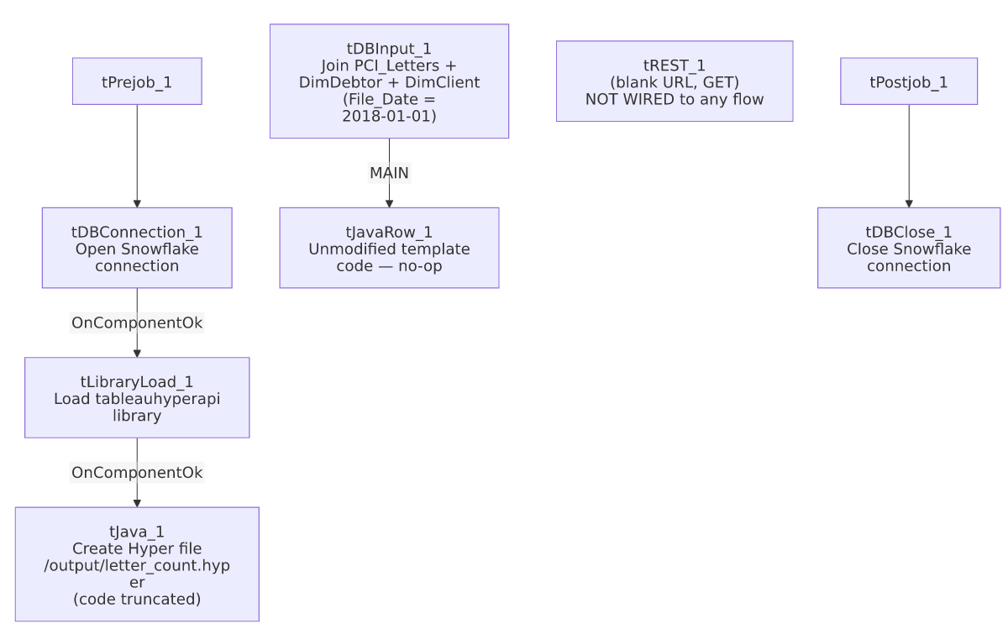

Settings tables

Source: `tDBInput_1` (`tSnowflakeInput`)
Setting | Value | What it means
Query (summarized) | Joins PCI_Letters → DimDebtor → DimClient, filtered File_Date BETWEEN '2018-01-01' AND CURRENT_DATE; derives Vendor (PCI/RevSpring/Other by filename prefix) and "Letters Sent Flag"; aggregated with COUNT(Customer_Key) | The 2018-01-01 lower bound is a hardcoded literal in the SQL text, not a context variable — every run always starts from that fixed historical date, growing the scanned range indefinitely as CURRENT_DATE advances.

Hyper file build: `tLibraryLoad_1` / `tJava_1`
Setting | Value | What it means
LIBRARY | "mvn:org.talend.libraries/tableauhyperapi/6.0.0-SNAPSHOT/jar" | Loads a SNAPSHOT (pre-release/unstable) version of the Tableau Hyper API library — see Issues observed.
Hyper file path | /output/letter_count.hyper (from the truncated tJava_1 code) | A container/server-relative path, not context-driven.

Passthrough: `tJavaRow_1`
Setting | Value | What it means
CODE | Unmodified Talend placeholder comment (// code sample: ... output_row.id = input_row.id * 2;) | This component does nothing — it's wired into the flow but never had its generated code replaced with real logic. Rows pass through as-is only because Talend's default tJavaRow behavior copies matching input/output columns unchanged when no code overrides them.

Dependencies & configuration
- Triggers/depends on other jobs: none — no tRunJob links found.
- Context variables used: none — this job uses no context.* variables anywhere; the Hyper file path, the SQL date bound, and the library version are all hardcoded literals.
- No entries in hardcoded_path_findings (the /output/... path isn't the commonly-flagged C:/Talend-Studio-... pattern), but /output/letter_count.hyper is still a fixed, non-context-driven path.

Glossary
Component type | Plain-English meaning
tSnowflakeConnection / tSnowflakeClose | Open/close the Snowflake connection used by the query.
tLibraryLoad | Loads an external Java library (here, Tableau's Hyper API) into the running job so custom Java code can use its classes.
tJava | Runs custom Java code — here used to build a Tableau .hyper file directly via the Hyper API, rather than through a dedicated Talend Tableau connector.
tJavaRow | Runs custom Java code once per input row — here left as the unedited template, so it acts as a no-op passthrough.
tREST | Makes an HTTP REST call. In this job, present but not connected to anything.

Issues observed
- `tJavaRow_1`'s code was never replaced from Talend's default placeholder (// code sample: ... output_row.id = input_row.id * 2;). It is wired into the main data flow between the aggregation query and (presumably, though the connection to tJava_1's Hyper-writing logic is not captured as a normal component-to-component FLOW link in this metadata) the Hyper file build. Because it currently does nothing but pass rows through, this is very likely intended to eventually contain custom logic (e.g., writing each row into the open Hyper table) that was never finished — verify directly in Talend Studio whether this component is fully wired to the Hyper-writing code or effectively dead.
- `tREST_1` exists in this job's component list but has zero connections to or from any other component — it's a completely orphaned, unused component with a blank URL. It has no effect on the job's execution but is dead clutter that could confuse anyone reviewing the job.
- `tLibraryLoad_1` loads a SNAPSHOT (pre-release) version of the Tableau Hyper API (tableauhyperapi/6.0.0-SNAPSHOT) rather than a stable release — SNAPSHOT artifacts can change or disappear from a Maven repository without notice, which is a build-stability risk if this job is ever rebuilt/redeployed from scratch.
- The query's `File_Date BETWEEN '2018-01-01' AND CURRENT_DATE` lower bound is a hardcoded literal, not context-driven — as time passes, this job scans an ever-growing multi-year date range with no incremental/windowing logic, which could make it progressively slower.
- This job and `Extract_Letter_Count` both summarize letter data but are not duplicates — different source joins, different derived columns and grouping, and a fundamentally different Tableau-publishing mechanism (custom Hyper-file build here vs. TableauOutput component there). Unable to determine from metadata whether both are still actively scheduled or whether this one (given its apparent unfinished tJavaRow_1 logic) is a superseded/abandoned attempt — verify with the team.
- No error/row-count logging or reject handling — no tWarn/tDie/tSendMail; a failed extract or an incomplete Hyper file write would only surface as a generic Talend execution error.

