Talend Job: Extract_MSSQL_COCHI_Debtor

Overview
Extracts the full DimDebtor table (roughly 100 columns — name, address, phone, balance/collection amounts, judgment, bankruptcy, tax-window fields, letter history, etc.) from the MSSQL EDWProdHH database, encrypts one field along the way, and loads the result into a Snowflake table named CHI_DEBTOR (truncate-and-insert). Despite the job's name suggesting it covers both the CO and CHI sites ("COCHI"), the only destination table this job writes to is CHI_DEBTOR — see Issues observed for what this implies.

Detail table
Field | Value
Job name | Extract_MSSQL_COCHI_Debtor
Version | 0.1
Project | EDW2SF
Author | jmach@harriscollect.com
Created | 2024-07-12T09:03:42.280-0700
Last Modified | 2025-09-24T11:08:03.845-0700

Step-by-step data flow
This job has no `tPrejob`/`tPostjob` and no explicit connection-open/close components for either side — unusual for this project (compare i3_CallDetail_40_Load, which explicitly opens/closes both its MSSQL and Snowflake connections). It is a single three-component flow:
- tDBInput_1 (tMSSqlInput) connects directly to MSSQL using context.EDWProdHH_Server/Port/Schema/Database/Login (password redacted, USE_EXISTING_CONNECTION=false) and reads the DimDebtor table via a query selecting ~100 named columns (DebtorNumber, LOGON, DimLogon, DimClient, DEBTOR_IDX, name/address/phone fields, balance and collection amount fields, SSN, judgment/bankruptcy fields, letter history, InsertKey/UpdateKey, etc.) — the query text is truncated in this metadata after CAST([TOTAL-BAL] AS NUMERI..., so any WHERE clause (e.g., a site filter) is not visible.
- tDataEncrypt_1 (FLOW) encrypts the row — the SSN column's declared length grows from 25 characters (source) to 255 characters (post-encrypt), a strong signal that SSN specifically is the field being encrypted, though the exact column(s) targeted by the encryption aren't separately itemized in this metadata.
- tDBOutput_1 (tSnowflakeOutput) writes the encrypted rows into CHI_DEBTOR, truncating the table first (tableAction=TRUNCATE) then inserting.
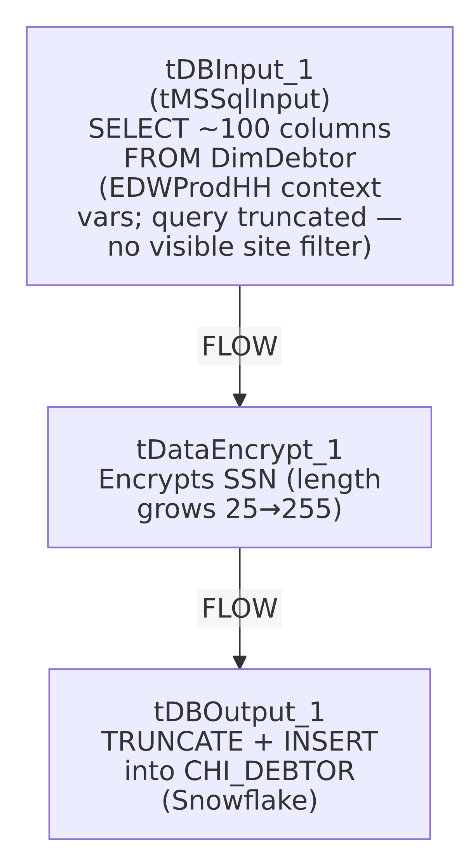

Settings tables

Source: `tDBInput_1` (`tMSSqlInput`)
Setting | Value | What it means
HOST / PORT / SCHEMA / DBNAME / USER | context.EDWProdHH_Server / Port / Schema / Database / Login | Standard EDWProdHH_* context variables, matching the EDWProdHH_0.1 context group documented in _shared_context.json/06_dependency_matrix.md.
DRIVER | JTDS | A specific JDBC driver choice for MSSQL.
TABLE | "DimDebtor" | Source table name (also set, redundantly, alongside a custom QUERY).
QUERY | ~100-column SELECT from DimDebtor, truncated after CAST([TOTAL-BAL] AS NUMERI... | The visible portion shows no WHERE clause — unable to confirm from metadata whether the query filters to CO/CHI logons specifically, or pulls the entire DimDebtor table regardless of site. See Issues observed.
PASS | ***REDACTED*** | Preserved as redacted.

Encrypt: `tDataEncrypt_1`
Setting | Value | What it means
SECRET_TYPE / SECRET_KEY / PASSWORD_M1 | ***REDACTED*** | Encryption credentials, preserved as redacted.
CRYPTO_METHOD | AES | Symmetric encryption algorithm.
CRYPTO_FILE_PATH | context.cryptoPath | Same context variable name used by the Encrypt_* jobs in this batch.
Schema change | SSN grows from length 25 to 255 across this component | Indirect evidence that SSN is the encrypted field — its ciphertext representation needs far more room than the plaintext 9-digit SSN. No other column's declared length changes across this component.

Target: `tDBOutput_1` (`tSnowflakeOutput`)
Setting | Value | What it means
Table | CHI_DEBTOR | The only destination table in this job — see Issues observed regarding the "COCHI" job name.
Table action | TRUNCATE | Table is emptied (not dropped/recreated) before the new rows are inserted — a brief empty-table window exists mid-run.
Output action | INSERT | Appends the newly loaded rows after the truncate.

Dependencies & configuration
- Triggers/depends on other jobs: none — no tRunJob links found.
- Context variables used: EDWProdHH_Database, EDWProdHH_Login, EDWProdHH_Port, EDWProdHH_Schema, EDWProdHH_Server, cryptoPath.
- No hardcoded developer-workstation paths found in this job's own components.

Glossary
Component type | Plain-English meaning
tMSSqlInput | Runs a query against a Microsoft SQL Server database and returns its result rows — here configured with its own inline connection settings rather than a shared, separately-opened connection component.
tDataEncrypt | Encrypts row/column data using a password and crypto-file-based algorithm.
tSnowflakeOutput | Writes rows to a Snowflake table, here after truncating it.

Issues observed
- The job name "COCHI" implies coverage of both the CO and CHI sites, but the only destination table this job writes to is `CHI_DEBTOR` — there is no `CO_DEBTOR` or similarly-named CO output anywhere in this job's metadata. Combined with the truncated QUERY text showing no visible site-filtering WHERE clause, there are two plausible explanations that cannot be distinguished from this metadata alone: (1) the query does filter to CO+CHI logons somewhere in its truncated portion, and both sites' debtors are being loaded into a single, oddly-named CHI_DEBTOR table (in which case the table name itself is misleading), or (2) the query pulls the entire DimDebtor table unfiltered, and the job name is aspirational/stale relative to what it currently does. This should be verified directly in Talend Studio before assuming either site's debtor data is complete or correctly scoped.
- No `tPrejob`/`tPostjob` and no explicit `tMSSqlClose`/`tSnowflakeClose` — every other job in this batch that touches a database explicitly opens and closes its connection(s); this job's tMSSqlInput and tSnowflakeOutput components appear to manage their own connections inline with no visible explicit close step, which is atypical for this project's usual pattern (compare i3_CallDetail_40_Load). Unable to determine from metadata whether this is intentional (each component closing its own connection implicitly) or an incomplete job design.
- The source `QUERY` text is truncated in this metadata, cutting off after CAST([TOTAL-BAL] AS NUMERI... — the full SELECT list, and critically any WHERE clause, cannot be confirmed from the data provided. This directly bears on the "COCHI" naming question above; verify the full query text in Talend Studio.
- No reject-row handling wired — tDBOutput_1's schema includes the standard Snowflake-output reject/error columns (columnName, errorMessage, sqlState, etc.), but there is no visible connection routing rejected rows anywhere; a malformed row would either fail the whole load or be silently dropped, consistent with the unwired-reject-flow pattern seen in ADP_Payroll_Load.
- No error/row-count logging — no tWarn/tDie/tSendMail; a failed or incomplete load would only surface as a generic Talend execution error.

