Talend Job: Extract_No_Dialer_Test_CHI

Overview
This job is named for the CHI site, but its query and output filename both actually reference DC, not CHI — it reads NO_DIALER_TEST_ASSIGNMENT_INCREMENTAL_CUBS_DC and writes a file named ..._DC.csv. Based on this batch's sibling job Extract_No_Dialer_Test_DC (whose query and filename both reference CHI instead), the CHI- and DC-named jobs appear to have had their site-specific internals swapped, most likely during a copy-paste when one was cloned from the other. See Issues observed — this is a concrete, verifiable naming/data mismatch, not a stylistic quibble.

Detail table
Field | Value
Job name | Extract_No_Dialer_Test_CHI
Version | 0.1
Project | EDW2SF
Author | jmach@harriscollect.com
Created | 2022-09-07T15:48:45.118-0700
Last Modified | 2025-11-19T07:57:37.951-0800

Step-by-step data flow
This job has no tPrejob/tPostjob and no explicit tSnowflakeConnection/tSnowflakeClose — just two steps gated by an SSL setup:
- tSetKeystore_1 configures SSL trust/keystore from context.keystorePath (passwords redacted).
- On success (OnSubjobOk), tDBInput_1 runs SELECT LOGON, DEBTORNUMBER, TEST_NO_DIALER FROM NO_DIALER_TEST_ASSIGNMENT_INCREMENTAL_CUBS_DC; — querying the DC table, not a CHI one.
- tFileOutputDelimited_1 writes the result to context.outputDir + "NO_DIALER_TEST_ASSIGNMENT_INCREMENTAL_CUBS_" + <CCYYMMDD> + "_DC.csv" — also named for DC.
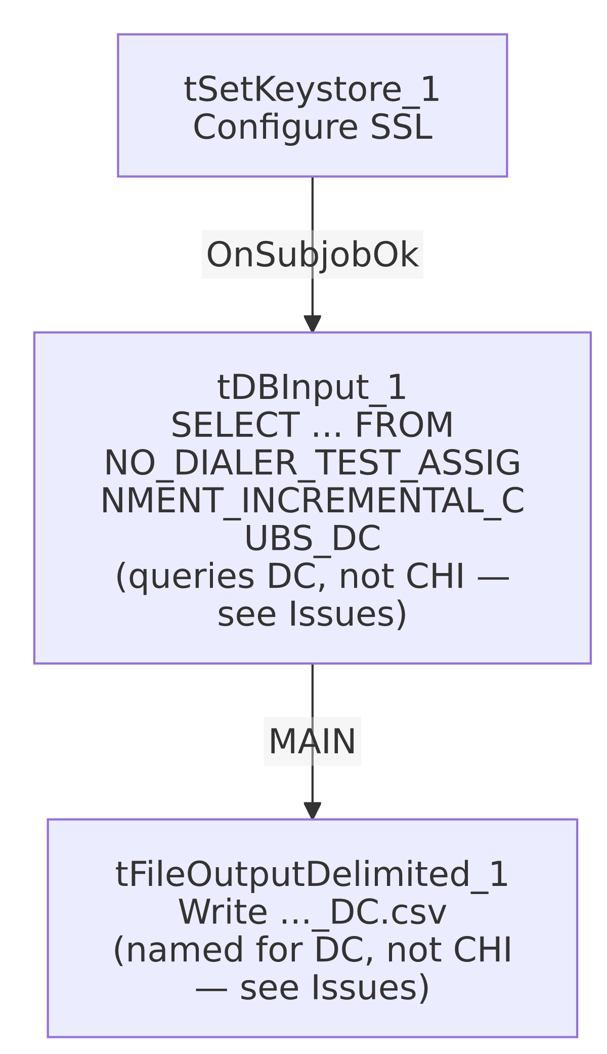

Settings tables

Source: `tDBInput_1` (`tSnowflakeInput`)
Setting | Value | What it means
Query | SELECT LOGON, DEBTORNUMBER, TEST_NO_DIALER FROM NO_DIALER_TEST_ASSIGNMENT_INCREMENTAL_CUBS_DC; | This job, named Extract_No_Dialer_Test_CHI, actually reads the DC-suffixed table.

Target: `tFileOutputDelimited_1`
Setting | Value | What it means
FILENAME | context.outputDir + "NO_DIALER_TEST_ASSIGNMENT_INCREMENTAL_CUBS_"+TalendDate.getDate("CCYYMMDD")+"_DC.csv" | Also suffixed _DC, matching the query's actual (DC) scope, but not the job's own CHI-suggesting name.

SSL setup: `tSetKeystore_1`
Setting | Value | What it means
SSL_TRUSTSERVER_TRUSTSTORE | "C:/clientTrustStore.trustStore" | Hardcoded local path, same as the *_Hermes_Decile family — see Issues observed.
SSL_KEYSTORE | context.keystorePath | Client keystore path is context-driven.
SSL_TRUSTSERVER_PASSWORD / SSL_KEYSTORE_PASSWORD / NEED_CLIENT_AUTH | ***REDACTED*** | Preserved as redacted.

Dependencies & configuration
- Triggers/depends on other jobs: none — no tRunJob links found.
- Context variables used: keystorePath, outputDir.
- 1 hardcoded path finding: tSetKeystore_1.SSL_TRUSTSERVER_TRUSTSTORE = "C:/clientTrustStore.trustStore".

Glossary
Component type | Plain-English meaning
tSetKeystore | Configures SSL/TLS trust and client keystore settings for the Snowflake connection used later in the job.
tSnowflakeInput | Runs a query against Snowflake and returns its result rows.
tFileOutputDelimited | Writes rows to a delimited (CSV-style) text file.

Issues observed
- This is a confirmed site-code swap bug, not a naming quibble. Extract_No_Dialer_Test_CHI's query reads NO_DIALER_TEST_ASSIGNMENT_INCREMENTAL_CUBS_DC and its output file is named ..._DC.csv — both internals point to DC. Its sibling job Extract_No_Dialer_Test_DC has the mirror-image problem: its query reads ..._CHI and its output is named ..._CHI.csv. The third sibling, Extract_No_Dialer_Test_CO, is internally consistent (queries and outputs ..._CO). The practical effect: whatever process runs "the CHI no-dialer-test extract" today is actually extracting and delivering DC's no-dialer-test assignment data, and vice versa for the job named "DC." If any downstream consumer (a person, a file drop location, or another system) expects CHI-specific data from the job labeled Extract_No_Dialer_Test_CHI, they have been receiving DC's data instead — this should be escalated and confirmed with the team immediately, since it directly affects which site's debtors get excluded from dialer campaigns based on this test-assignment data.
- `SSL_TRUSTSERVER_TRUSTSTORE` is a hardcoded local path, consistent with the same setting across the *_Hermes_Decile family.
- No `tPrejob`/`tPostjob`, no explicit Snowflake connection-open/close component, and no error/row-count logging — same minimal-scaffolding pattern as Equibli_Extract; a failure would only surface as a generic Talend execution error.

