Talend Job: Extract_No_Dialer_Test_CO

Overview
Extracts the CO-site "no dialer test" debtor assignment (logon, debtor number, and a flag indicating the debtor is excluded from dialer campaigns as part of a test) from a Snowflake table scoped to CO, and writes it to a dated CSV file. Unlike its two siblings in this batch (Extract_No_Dialer_Test_CHI and Extract_No_Dialer_Test_DC), this job is internally consistent — its query and output filename both correctly reference CO.

Detail table
Field | Value
Job name | Extract_No_Dialer_Test_CO
Version | 0.1
Project | EDW2SF
Author | jmach@harriscollect.com
Created | 2022-09-07T15:46:59.598-0700
Last Modified | 2025-11-19T07:57:05.670-0800

Step-by-step data flow
This job has no tPrejob/tPostjob and no explicit tSnowflakeConnection/tSnowflakeClose — just two steps gated by an SSL setup:
- tSetKeystore_1 configures SSL trust/keystore from context.keystorePath (passwords redacted).
- On success (OnSubjobOk), tDBInput_1 runs SELECT LOGON, DEBTORNUMBER, TEST_NO_DIALER FROM NO_DIALER_TEST_ASSIGNMENT_INCREMENTAL_CUBS_CO; — correctly querying the CO table.
- tFileOutputDelimited_1 writes the result to context.outputDir + "NO_DIALER_TEST_ASSIGNMENT_INCREMENTAL_CUBS_" + <CCYYMMDD> + "_CO.csv" — correctly named for CO.
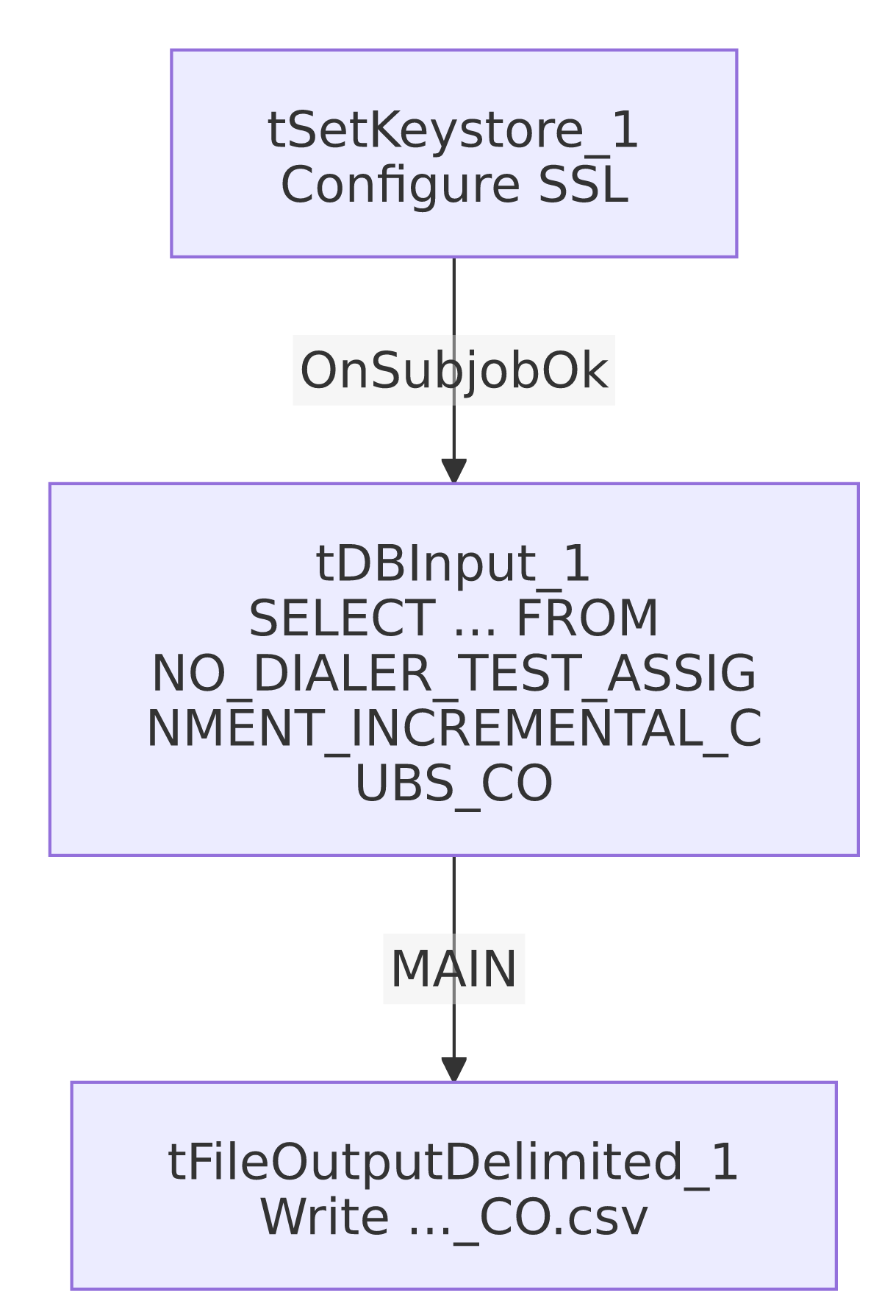

Settings tables

Source: `tDBInput_1` (`tSnowflakeInput`)
Setting | Value | What it means
Query | SELECT LOGON, DEBTORNUMBER, TEST_NO_DIALER FROM NO_DIALER_TEST_ASSIGNMENT_INCREMENTAL_CUBS_CO; | Correctly scoped to CO — consistent with the job name.

Target: `tFileOutputDelimited_1`
Setting | Value | What it means
FILENAME | context.outputDir + "NO_DIALER_TEST_ASSIGNMENT_INCREMENTAL_CUBS_"+TalendDate.getDate("CCYYMMDD")+"_CO.csv" | Correctly suffixed _CO.

SSL setup: `tSetKeystore_1`
Setting | Value | What it means
SSL_TRUSTSERVER_TRUSTSTORE | "C:/clientTrustStore.trustStore" | Hardcoded local path, same as the *_Hermes_Decile family — see Issues observed.
SSL_KEYSTORE | context.keystorePath | Client keystore path is context-driven.
SSL_TRUSTSERVER_PASSWORD / SSL_KEYSTORE_PASSWORD / NEED_CLIENT_AUTH | ***REDACTED*** | Preserved as redacted.

Dependencies & configuration
- Triggers/depends on other jobs: none — no tRunJob links found.
- Context variables used: keystorePath, outputDir.
- 1 hardcoded path finding: tSetKeystore_1.SSL_TRUSTSERVER_TRUSTSTORE = "C:/clientTrustStore.trustStore".

Glossary
Component type | Plain-English meaning
tSetKeystore | Configures SSL/TLS trust and client keystore settings for the Snowflake connection used later in the job.
tSnowflakeInput | Runs a query against Snowflake and returns its result rows.
tFileOutputDelimited | Writes rows to a delimited (CSV-style) text file.

Issues observed
- This job is correctly self-consistent, unlike its two siblings in this batch. Extract_No_Dialer_Test_CHI actually queries and outputs DC data, and Extract_No_Dialer_Test_DC actually queries and outputs CHI data — a swapped-site bug between those two jobs (see their own docs for full detail). This CO job has no such problem: its query table and output filename both correctly say CO throughout. This confirms the swap is specific to the CHI/DC pair, not a systemic pattern across the whole "No_Dialer_Test" family.
- `SSL_TRUSTSERVER_TRUSTSTORE` is a hardcoded local path, consistent with the same setting across the *_Hermes_Decile family.
- No `tPrejob`/`tPostjob`, no explicit Snowflake connection-open/close component, and no error/row-count logging — same minimal-scaffolding pattern as its siblings; a failure would only surface as a generic Talend execution error.

