Talend Job: Extract_No_Dialer_Test_DC

Overview
This job is named for the DC site, but its query and output filename both actually reference CHI, not DC — it reads NO_DIALER_TEST_ASSIGNMENT_INCREMENTAL_CUBS_CHI and writes a file named ..._CHI.csv. This is the mirror-image counterpart of Extract_No_Dialer_Test_CHI (which reads and outputs DC data instead), confirming a site-code swap between these two specific jobs in the batch — the third sibling, Extract_No_Dialer_Test_CO, is unaffected and internally consistent.

Detail table
Field | Value
Job name | Extract_No_Dialer_Test_DC
Version | 0.1
Project | EDW2SF
Author | jmach@harriscollect.com
Created | 2022-09-07T15:50:35.783-0700
Last Modified | 2025-11-19T07:56:44.249-0800

Step-by-step data flow
This job has no tPrejob/tPostjob and no explicit tSnowflakeConnection/tSnowflakeClose — just two steps gated by an SSL setup:
- tSetKeystore_1 configures SSL trust/keystore from context.keystorePath (passwords redacted).
- On success (OnSubjobOk), tDBInput_1 runs SELECT LOGON, DEBTORNUMBER, TEST_NO_DIALER FROM NO_DIALER_TEST_ASSIGNMENT_INCREMENTAL_CUBS_CHI; — querying the CHI table, not a DC one.
- tFileOutputDelimited_1 writes the result to context.outputDir + "NO_DIALER_TEST_ASSIGNMENT_INCREMENTAL_CUBS_" + <CCYYMMDD> + "_CHI.csv" — also named for CHI.
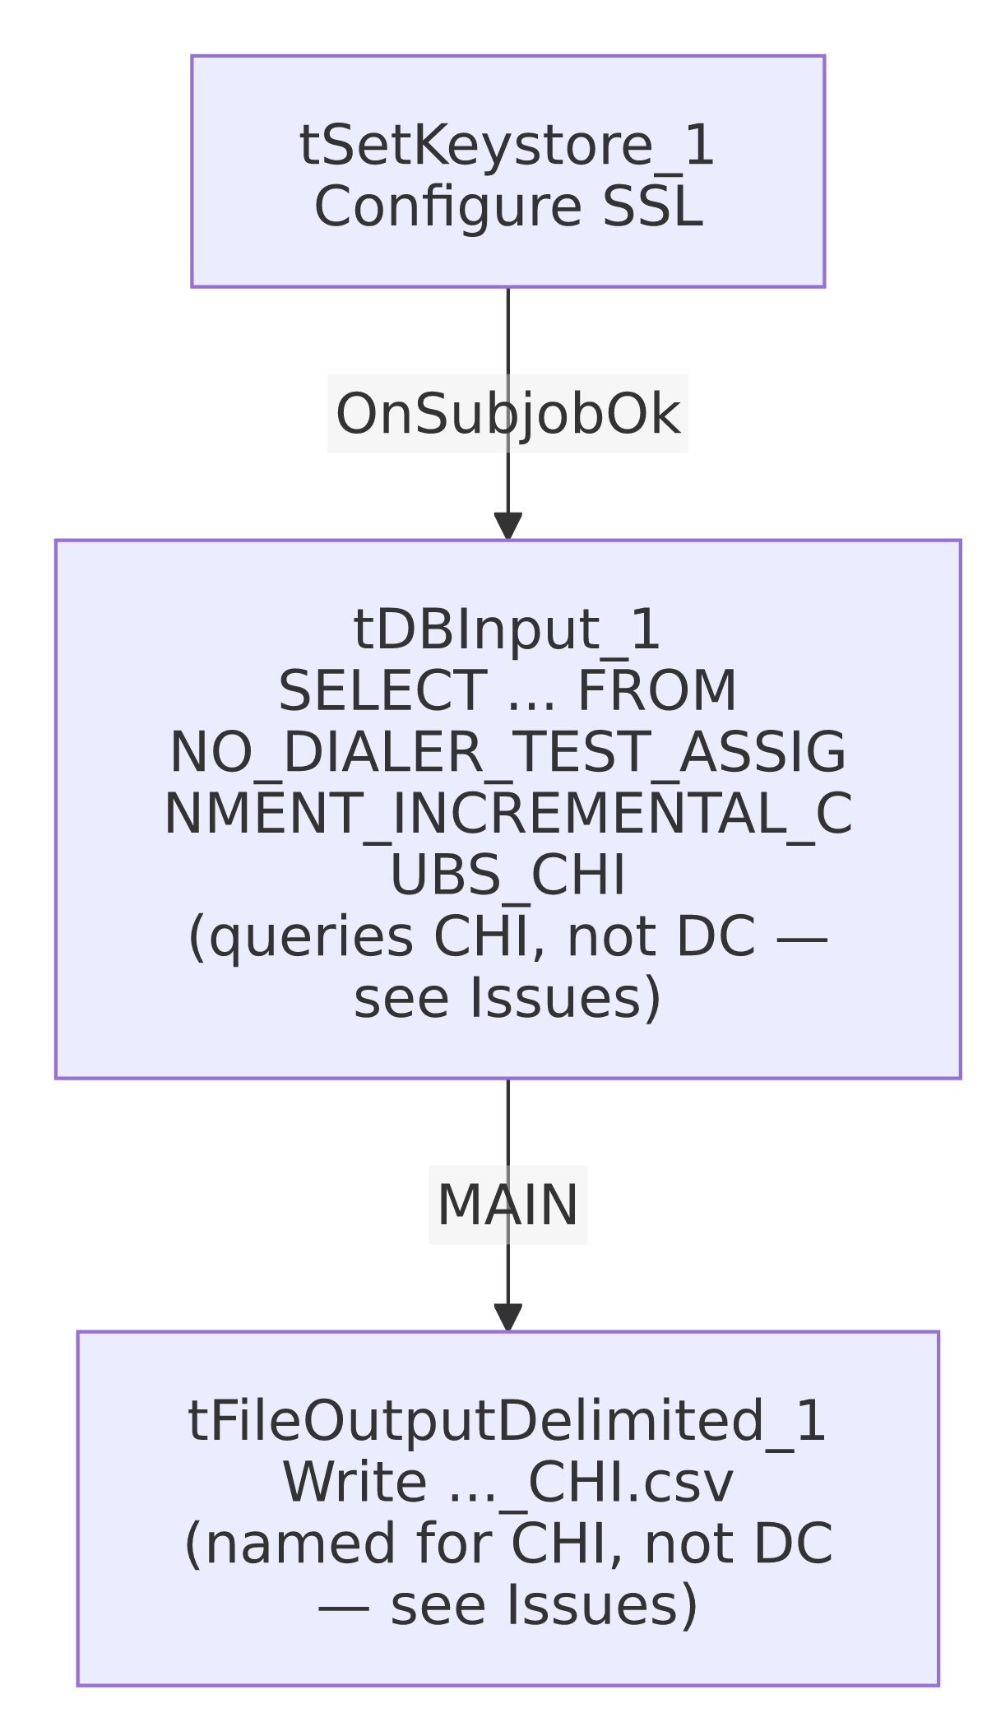

Settings tables

Source: `tDBInput_1` (`tSnowflakeInput`)
Setting | Value | What it means
Query | SELECT LOGON, DEBTORNUMBER, TEST_NO_DIALER FROM NO_DIALER_TEST_ASSIGNMENT_INCREMENTAL_CUBS_CHI; | This job, named Extract_No_Dialer_Test_DC, actually reads the CHI-suffixed table.

Target: `tFileOutputDelimited_1`
Setting | Value | What it means
FILENAME | context.outputDir + "NO_DIALER_TEST_ASSIGNMENT_INCREMENTAL_CUBS_"+TalendDate.getDate("CCYYMMDD")+"_CHI.csv" | Also suffixed _CHI, matching the query's actual (CHI) scope, but not the job's own DC-suggesting name.

SSL setup: `tSetKeystore_1`
Setting | Value | What it means
SSL_TRUSTSERVER_TRUSTSTORE | "C:/clientTrustStore.trustStore" | Hardcoded local path, same as the *_Hermes_Decile family — see Issues observed.
SSL_KEYSTORE | context.keystorePath | Client keystore path is context-driven.
SSL_TRUSTSERVER_PASSWORD / SSL_KEYSTORE_PASSWORD / NEED_CLIENT_AUTH | ***REDACTED*** | Preserved as redacted.

Dependencies & configuration
- Triggers/depends on other jobs: none — no tRunJob links found.
- Context variables used: keystorePath, outputDir.
- 1 hardcoded path finding: tSetKeystore_1.SSL_TRUSTSERVER_TRUSTSTORE = "C:/clientTrustStore.trustStore".

Glossary
Component type | Plain-English meaning
tSetKeystore | Configures SSL/TLS trust and client keystore settings for the Snowflake connection used later in the job.
tSnowflakeInput | Runs a query against Snowflake and returns its result rows.
tFileOutputDelimited | Writes rows to a delimited (CSV-style) text file.

Issues observed
- This is a confirmed site-code swap bug, not a naming quibble. Extract_No_Dialer_Test_DC's query reads NO_DIALER_TEST_ASSIGNMENT_INCREMENTAL_CUBS_CHI and its output file is named ..._CHI.csv — both internals point to CHI, the mirror image of Extract_No_Dialer_Test_CHI's DC-pointing internals. The third sibling, Extract_No_Dialer_Test_CO, is internally consistent (queries and outputs ..._CO), which rules out a systemic bug across the whole family and narrows it specifically to this CHI/DC pair. The practical effect: whatever process runs "the DC no-dialer-test extract" today is actually extracting and delivering CHI's no-dialer-test assignment data, and vice versa. This should be confirmed and fixed with the team — it directly affects which site's debtors are excluded from dialer campaigns based on this test assignment data. See job_Extract_No_Dialer_Test_CHI.md for the paired analysis.
- `SSL_TRUSTSERVER_TRUSTSTORE` is a hardcoded local path, consistent with the same setting across the *_Hermes_Decile family.
- No `tPrejob`/`tPostjob`, no explicit Snowflake connection-open/close component, and no error/row-count logging — same minimal-scaffolding pattern as its siblings; a failure would only surface as a generic Talend execution error.

