Talend Job: Extract_No_Dialer_Test_HH

Overview
Extracts the "no-dialer-test" debtor assignment list for the HH site — logon, debtor number, and a TEST_NO_DIALER flag — from a Snowflake table and writes it to a dated CSV file. This is one of at least five near-identical Extract_No_Dialer_Test_<site> jobs (CHI, CO, DC, HH, TOL) that share the same two-step shape; unlike the CHI/DC pair (documented separately, see Issues observed), this job's query and output filename are internally consistent — both point to HH.

Detail table
Field | Value
Job name | Extract_No_Dialer_Test_HH
Version | 0.1
Project | EDW2SF
Author | jmach@harriscollect.com
Created | 2022-08-29T08:40:33.651-0700
Last Modified | 2025-11-19T07:56:04.111-0800

Step-by-step data flow
This job has no tPrejob/tPostjob and no explicit tSnowflakeConnection/tSnowflakeClose — just two steps gated by an SSL setup:
- tSetKeystore_1 configures SSL trust/keystore from context.keystorePath (passwords redacted).
- On success (SUBJOB_OK / "OnSubjobOk"), tDBInput_1 runs SELECT LOGON, DEBTORNUMBER, TEST_NO_DIALER FROM NO_DIALER_TEST_ASSIGNMENT_INCREMENTAL_CUBS_HH; — querying the HH-suffixed table, matching the job's own name.
- tFileOutputDelimited_1 (connected via MAIN) writes the result to context.outputDir + "NO_DIALER_TEST_ASSIGNMENT_INCREMENTAL_CUBS_" + <CCYYMMDD> + "_HH.csv" — also named for HH.
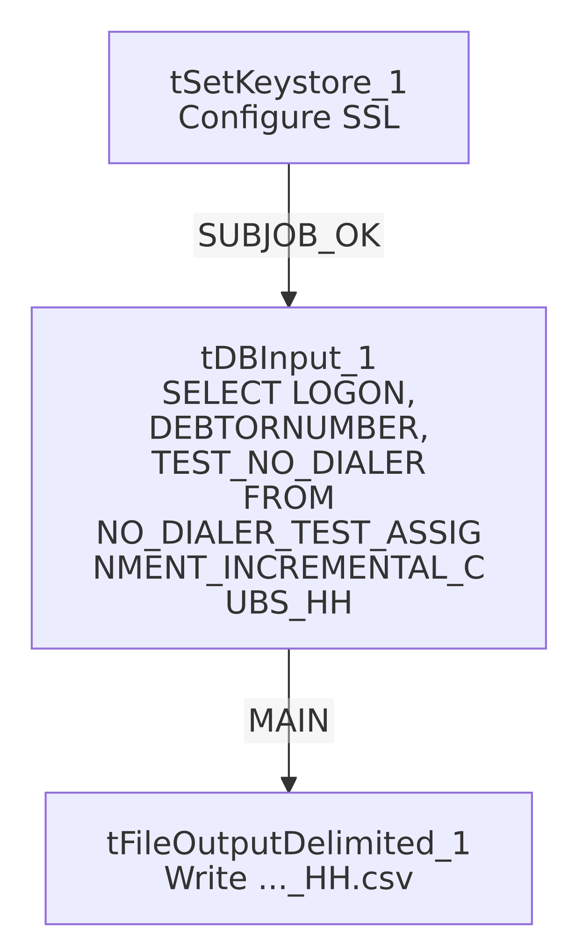

Settings tables

Source: `tDBInput_1` (`tSnowflakeInput`)
Setting | Value | What it means
Query | SELECT LOGON, DEBTORNUMBER, TEST_NO_DIALER FROM NO_DIALER_TEST_ASSIGNMENT_INCREMENTAL_CUBS_HH; | Reads the HH-suffixed table — consistent with this job's name.

Target: `tFileOutputDelimited_1`
Setting | Value | What it means
FILENAME | context.outputDir + "NO_DIALER_TEST_ASSIGNMENT_INCREMENTAL_CUBS_"+TalendDate.getDate("CCYYMMDD")+"_HH.csv" | Dated CSV, suffixed _HH — consistent with the query's scope and the job's own name.
FIELDSEPARATOR / INCLUDEHEADER | , / true | Standard comma-delimited CSV with a header row.
ENCODING | ISO-8859-15 | Non-default encoding — consistent across this job family.
APPEND | false | File is overwritten each run, not appended to.

SSL setup: `tSetKeystore_1`
Setting | Value | What it means
SSL_TRUSTSERVER_TRUSTSTORE | "C:/clientTrustStore.trustStore" | Hardcoded local path, same as the *_Hermes_Decile and sibling Extract_No_Dialer_Test_* jobs — see Issues observed.
SSL_KEYSTORE | context.keystorePath | Client keystore path is context-driven.
SSL_TRUSTSERVER_PASSWORD / SSL_KEYSTORE_PASSWORD / NEED_CLIENT_AUTH | ***REDACTED*** | Preserved as redacted.

Dependencies & configuration
- Triggers/depends on other jobs: none — runjob_targets is empty in this job's metadata.
- Context variables used: keystorePath, outputDir.
- 1 hardcoded path finding: tSetKeystore_1.SSL_TRUSTSERVER_TRUSTSTORE = "C:/clientTrustStore.trustStore".

Glossary
Component type | Plain-English meaning
tSetKeystore | Configures SSL/TLS trust and client keystore settings for the Snowflake connection used later in the job.
tSnowflakeInput | Runs a query against Snowflake and returns its result rows.
tFileOutputDelimited | Writes rows to a delimited (CSV-style) text file.

Issues observed
- This job's site internals are consistent (no swap bug). Two siblings in this family, Extract_No_Dialer_Test_CHI and Extract_No_Dialer_Test_DC, were found to have had their query/filename site codes swapped with each other (CHI's job reads and writes DC data, and vice versa — see job_Extract_No_Dialer_Test_CHI.md and job_Extract_No_Dialer_Test_DC.md). This job (Extract_No_Dialer_Test_HH) was checked against that same pattern: its query reads ..._CUBS_HH and its output file is named ..._HH.csv — both match its own name, so it does not exhibit the CHI/DC swap issue.
- `SSL_TRUSTSERVER_TRUSTSTORE` is a hardcoded local path ("C:/clientTrustStore.trustStore"), consistent with the same setting across the *_Hermes_Decile family and the other Extract_No_Dialer_Test_* siblings.
- No `tPrejob`/`tPostjob`, no explicit Snowflake connection-open/close component, and no error/row-count logging — same minimal-scaffolding pattern as its siblings; a failure would only surface as a generic Talend execution error.

