Talend Job: Extract_PRE_Hermes_Decile

Overview
This is a small extract job for the "PRE" site: it pulls debtor-level scoring/prediction data (logon, packet, debtor number, portfolio group, "local"/"global" model scores, an Equabli treatment group, and a dialer group) from a Snowflake table named MASTER_PREDICTION_SCORES_TRANSFORMATION_CUBS_DEBTOR_PRE, and writes it out as a dated CSV file for consumption by Hermes (an external scoring/decile system, based on the job and file naming). It is one of a near-identical pair with Extract_TOL_Hermes_Decile — see Issues observed for the one real structural quirk both share and the site-specific differences.

Detail table
Field | Value
Job name | Extract_PRE_Hermes_Decile
Version | 0.1
Project | EDW2SF
Author | jmach@harriscollect.com
Created | 2023-08-13T21:09:11.416-0700
Last Modified | 2025-11-05T09:31:05.134-0800

Step-by-step data flow
Setup subjob: tPrejob_1 → tJava_1 opens a per-run log file at context.logDir + jobName + "_" + <timestamp> + ".log" → on subjob-ok, tSetKeystore_1 configures SSL trust/keystore from context.keystorePath (passwords redacted) → on subjob-ok, tDBConnection_1 opens the Snowflake connection.
Main subjob — note this is a *separate, unlinked* chain (see Issues observed): tDBInput_1 runs a fixed SELECT against MASTER_PREDICTION_SCORES_TRANSFORMATION_CUBS_DEBTOR_PRE, returning LOGON, PACKET, DEBTORNUMBER, PL_GROUP, LOCAL, GLOBAL, EQUABLI_TREATMENT_GROUP, DIALERGRP. Its output flows directly (MAIN connector) to tFileOutputDelimited_1, which writes a comma-delimited CSV with header to context.outputDir + "PRE_HERMES_DECILE_" + TalendDate.getDate("CCYYMMDD") + ".csv".
Teardown: tPostjob_1 → tDBClose_1 closes the Snowflake connection.
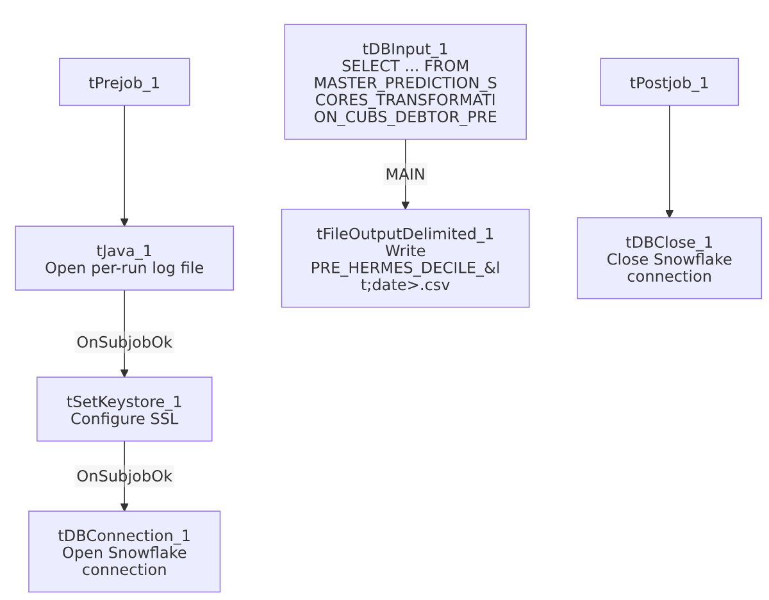

Settings tables

Source: `tDBInput_1` (`tSnowflakeInput`)
Setting | Value | What it means
Query | SELECT LOGON, PACKET, DEBTORNUMBER, PL_GROUP, "LOCAL", "GLOBAL", EQUABLI_TREATMENT_GROUP, DIALERGRP FROM MASTER_PREDICTION_SCORES_TRANSFORMATION_CUBS_DEBTOR_PRE; | A fixed, non-parameterized pull of the full scoring table for the PRE site — no date filter or incremental logic.

Target: `tFileOutputDelimited_1`
Setting | Value | What it means
FILENAME | context.outputDir + "PRE_HERMES_DECILE_" + TalendDate.getDate("CCYYMMDD") + ".csv" | Writes a new dated file each run; does not append.
FIELDSEPARATOR / INCLUDEHEADER | , / true | Standard CSV with header row.
ENCODING | ISO-8859-15

Security: `tSetKeystore_1`
Setting | Value | What it means
SSL_TRUSTSERVER_TRUSTSTORE | "C:/clientTrustStore.trustStore" (hardcoded) | A Windows-path truststore location — see Issues observed.
SSL_KEYSTORE | context.keystorePath
SSL_TRUSTSERVER_PASSWORD / SSL_KEYSTORE_PASSWORD | ***REDACTED*** | Preserved as redacted; real values not available in this metadata.

Dependencies & configuration
- Triggers/depends on other jobs: none — no tRunJob links found.
- Context variables used: keystorePath, logDir, outputDir.
- 1 hardcoded path finding: tSetKeystore_1.SSL_TRUSTSERVER_TRUSTSTORE = "C:/clientTrustStore.trustStore" — a Windows-specific path, consistent with the project-wide portability risk noted in 05_operational_runbook.md.

Glossary
Component type | Plain-English meaning
tSnowflakeInput | Runs a query against Snowflake and returns its result rows.
tFileOutputDelimited | Writes rows to a delimited (CSV-style) text file.
tSetKeystore | Configures SSL/TLS trust and client certificate settings used by subsequent secure connections in the job.
tSnowflakeConnection / tSnowflakeClose | Open/close the Snowflake connection shared by other components in the job.

Issues observed
- The main data-extraction chain (`tDBInput_1` → `tFileOutputDelimited_1`) is not wired to the setup subjob that opens the Snowflake connection. There is no connection (OnSubjobOk, OnComponentOk, or otherwise) linking tDBConnection_1 to tDBInput_1 in this job's metadata. In Talend, components sharing a connection typically still run correctly as long as the connection is opened before the query fires, but the *absence* of an explicit ordering link means there's no guarantee the connection subjob finishes (or even runs) before the extract subjob starts — both are top-level, unlinked subjobs in the same job. This is very likely fine in practice (independent subjobs in Talend commonly run in parallel or in an implicit but unenforced order), but it means a race condition is structurally possible; verify actual execution order in Talend Studio if this job's output is ever intermittently empty or fails to connect.
- The extract query has no date/incremental filter — every run re-pulls the entire scoring table for the PRE site. Given this table's name (MASTER_PREDICTION_SCORES_TRANSFORMATION_CUBS_DEBTOR_PRE) suggests it's already a transformed/scored view rather than a raw growing log, a full pull each run may be entirely intentional; unable to determine from metadata alone whether this is a performance concern.
- This job is structurally identical to `Extract_TOL_Hermes_Decile` except for the site code embedded in the source table name (..._PRE vs ..._TOL) and the output filename (PRE_HERMES_DECILE_... vs TOL_HERMES_DECILE_...). No other differences were found between the two jobs' metadata (same schema, same component wiring, same hardcoded truststore path). This is a template-per-site pattern consistent with the rest of the project (see 01_system_architecture.md's site-code glossary entry) — worth checking whether other sites (CHI, CO, DC, HH) have an equivalent Extract_<Site>_Hermes_Decile job that wasn't included in this metadata export.

