Talend Job: Extract_ProInsights_Data

Overview
This job extracts call-analytics/QA scoring data — one row per recorded call, with roughly 90 columns covering call metadata (agent, campaign, direction, duration, client/account identifiers) and a large set of boolean flags describing what happened on the call (hardship, dispute, bankruptcy, profanity, promise-to-pay, verification attempts, sentiment, etc.) — from a Snowflake table PUB_MBOICH.PROINSIGHTS_DATA, and writes it to a dated CSV file. This is a "ProInsights" call-scoring/speech-analytics export, most likely feeding an external or downstream reporting consumer given the PUB_ (publish) schema prefix on the source table.

Detail table
Field | Value
Job name | Extract_ProInsights_Data
Version | 0.1
Project | EDW2SF
Author | jmach@harriscollect.com
Created | 2024-08-22T11:14:26.521-0700
Last Modified | 2025-11-16T19:09:21.386-0800

Step-by-step data flow
- tSetKeystore_1 configures SSL trust/keystore from context.keystorePath (passwords redacted).
- On subjob-ok, tDBInput_1 runs a fixed SELECT of ~90 named columns from PUB_MBOICH.PROINSIGHTS_DATA (call ID, file/call metadata, ~70 boolean call-content flags, sentiment fields, LOGON, PL_GROUP).
- Its output flows (MAIN connector) to tFileOutputDelimited_1, which writes a comma-delimited CSV with header to context.outputDir + "proinsights_data_" + TalendDate.getDate("CCYYMMDD") + ".csv".
There is no tPrejob/tPostjob, no explicit tSnowflakeConnection/tSnowflakeClose component, and no log-file setup (tJava) visible anywhere in this job's extracted metadata — see Issues observed.
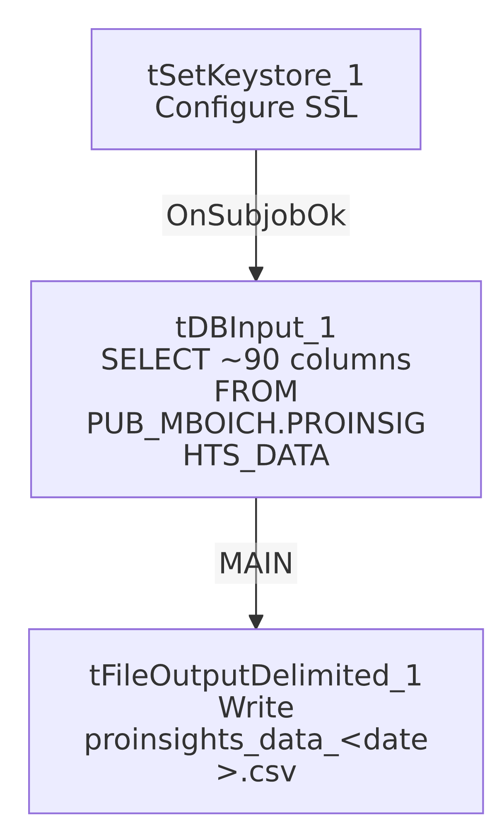

Settings tables

Source: `tDBInput_1` (`tSnowflakeInput`)
Setting | Value | What it means
Query | Fixed SELECT of ~90 named columns (call/agent metadata plus ~70 boolean call-content flags, sentiment, LOGON, PL_GROUP) from PUB_MBOICH.PROINSIGHTS_DATA | No date filter or incremental logic — every run re-pulls the full published table.

Target: `tFileOutputDelimited_1`
Setting | Value | What it means
FILENAME | context.outputDir + "proinsights_data_" + TalendDate.getDate("CCYYMMDD") + ".csv" | Writes a new dated file each run; does not append.
FIELDSEPARATOR / INCLUDEHEADER | , / true | Standard CSV with header row.
ENCODING | ISO-8859-15

Security: `tSetKeystore_1`
Setting | Value | What it means
SSL_TRUSTSERVER_TRUSTSTORE | "C:/clientTrustStore.trustStore" (hardcoded) | Same Windows-path truststore pattern used across the Extract_*_Hermes_Decile jobs.
SSL_KEYSTORE | context.keystorePath
SSL_TRUSTSERVER_PASSWORD / SSL_KEYSTORE_PASSWORD | ***REDACTED*** | Preserved as redacted.

Dependencies & configuration
- Triggers/depends on other jobs: none — no tRunJob links found.
- Context variables used: keystorePath, outputDir.
- 1 hardcoded path finding: tSetKeystore_1.SSL_TRUSTSERVER_TRUSTSTORE = "C:/clientTrustStore.trustStore".

Glossary
Component type | Plain-English meaning
tSnowflakeInput | Runs a query against Snowflake and returns its result rows.
tFileOutputDelimited | Writes rows to a delimited (CSV-style) text file.
tSetKeystore | Configures SSL/TLS trust and client certificate settings used by subsequent secure connections in the job.

Issues observed
- This job's extracted metadata contains only 3 components (tDBInput_1, tFileOutputDelimited_1, tSetKeystore_1) — there is no tPrejob/tPostjob, no tSnowflakeConnection/tSnowflakeClose, and no log-file-opening tJava step, all of which are present in every other job documented in this batch. This could mean: (a) the job genuinely has a minimal 3-component design and reuses a connection opened elsewhere (e.g., a shared/default project connection not captured per-job in this extraction), or (b) the metadata extraction for this job is incomplete. Unable to determine from metadata alone which is the case — verify directly in Talend Studio before assuming this job has no explicit Snowflake connection lifecycle.
- The query pulls the entire `PROINSIGHTS_DATA` table with no date or incremental filter on every run — if this table grows unbounded, this extract's runtime and output file size will grow unbounded too. Unable to determine table size or growth pattern from metadata.
- No error/row-count logging specific to this job's business outcome (no tWarn/tDie/tSendMail, and no per-run log file as seen in most other jobs) — a failure here would only surface as a generic Talend execution error.

