Talend Job: Extract_TOL_Hermes_Decile

Overview
This is the "TOL" site's counterpart to Extract_PRE_Hermes_Decile: it pulls the same shape of debtor-level scoring/prediction data (logon, packet, debtor number, portfolio group, "local"/"global" model scores, an Equabli treatment group, and a dialer group) from a Snowflake table named MASTER_PREDICTION_SCORES_TRANSFORMATION_CUBS_DEBTOR_TOL, and writes it out as a dated CSV file for the Hermes scoring/decile system. The two jobs are otherwise identical in structure — see Issues observed for what is and isn't different between them.

Detail table
Field | Value
Job name | Extract_TOL_Hermes_Decile
Version | 0.1
Project | EDW2SF
Author | jmach@harriscollect.com
Created | 2024-05-21T09:35:03.511-0700
Last Modified | 2025-11-05T09:38:04.097-0800

Step-by-step data flow
Setup subjob: tPrejob_1 → tJava_1 opens a per-run log file at context.logDir + jobName + "_" + <timestamp> + ".log" → on subjob-ok, tSetKeystore_1 configures SSL trust/keystore from context.keystorePath (passwords redacted) → on subjob-ok, tDBConnection_1 opens the Snowflake connection.
Main subjob — again a separate, unlinked chain (see Issues observed): tDBInput_1 runs a fixed SELECT against MASTER_PREDICTION_SCORES_TRANSFORMATION_CUBS_DEBTOR_TOL, returning LOGON, PACKET, DEBTORNUMBER, PL_GROUP, LOCAL, GLOBAL, EQUABLI_TREATMENT_GROUP, DIALERGRP. Its output flows directly (MAIN connector) to tFileOutputDelimited_1, which writes a comma-delimited CSV with header to context.outputDir + "TOL_HERMES_DECILE_" + TalendDate.getDate("CCYYMMDD") + ".csv".
Teardown: tPostjob_1 → tDBClose_1 closes the Snowflake connection.
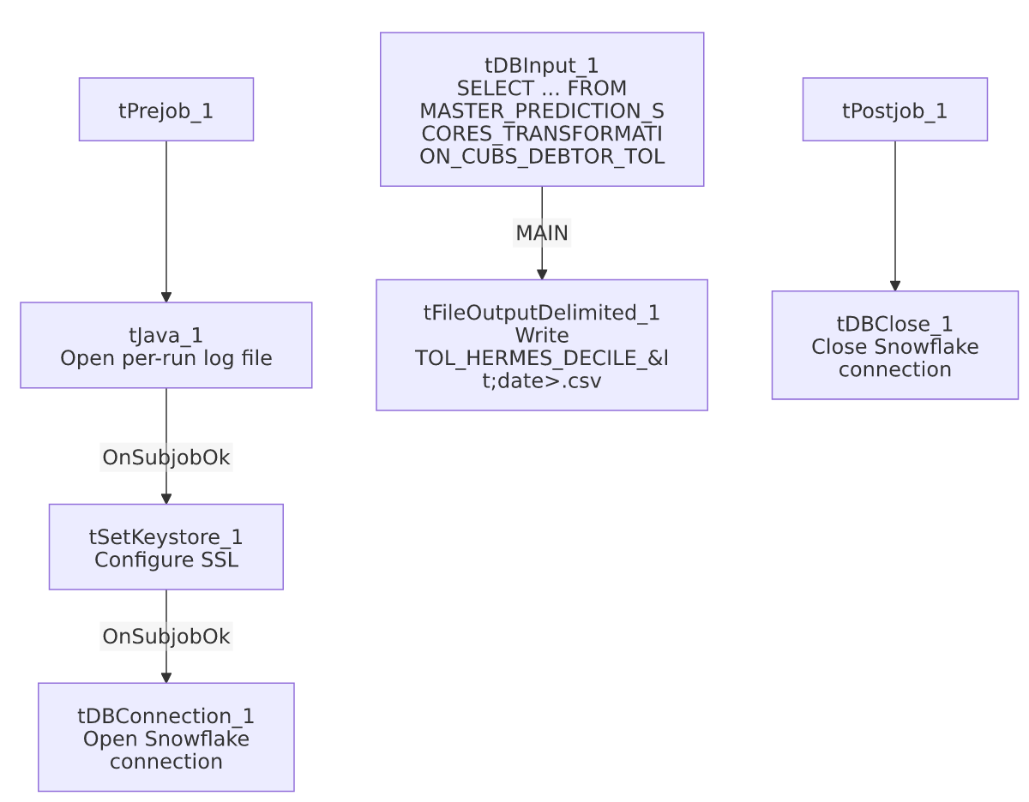

Settings tables

Source: `tDBInput_1` (`tSnowflakeInput`)
Setting | Value | What it means
Query | SELECT LOGON, PACKET, DEBTORNUMBER, PL_GROUP, "LOCAL", "GLOBAL", EQUABLI_TREATMENT_GROUP, DIALERGRP FROM MASTER_PREDICTION_SCORES_TRANSFORMATION_CUBS_DEBTOR_TOL; | A fixed, non-parameterized pull of the full scoring table for the TOL site — no date filter or incremental logic.

Target: `tFileOutputDelimited_1`
Setting | Value | What it means
FILENAME | context.outputDir + "TOL_HERMES_DECILE_" + TalendDate.getDate("CCYYMMDD") + ".csv" | Writes a new dated file each run; does not append.
FIELDSEPARATOR / INCLUDEHEADER | , / true | Standard CSV with header row.
ENCODING | ISO-8859-15

Security: `tSetKeystore_1`
Setting | Value | What it means
SSL_TRUSTSERVER_TRUSTSTORE | "C:/clientTrustStore.trustStore" (hardcoded) | A Windows-path truststore location — see Issues observed.
SSL_KEYSTORE | context.keystorePath
SSL_TRUSTSERVER_PASSWORD / SSL_KEYSTORE_PASSWORD | ***REDACTED*** | Preserved as redacted; real values not available in this metadata.

Dependencies & configuration
- Triggers/depends on other jobs: none — no tRunJob links found.
- Context variables used: keystorePath, logDir, outputDir.
- 1 hardcoded path finding: tSetKeystore_1.SSL_TRUSTSERVER_TRUSTSTORE = "C:/clientTrustStore.trustStore" — a Windows-specific path, consistent with the project-wide portability risk noted in 05_operational_runbook.md.

Glossary
Component type | Plain-English meaning
tSnowflakeInput | Runs a query against Snowflake and returns its result rows.
tFileOutputDelimited | Writes rows to a delimited (CSV-style) text file.
tSetKeystore | Configures SSL/TLS trust and client certificate settings used by subsequent secure connections in the job.
tSnowflakeConnection / tSnowflakeClose | Open/close the Snowflake connection shared by other components in the job.

Issues observed
- The main data-extraction chain (`tDBInput_1` → `tFileOutputDelimited_1`) is not wired to the setup subjob that opens the Snowflake connection — the identical structural gap documented in Extract_PRE_Hermes_Decile. No connection link exists between tDBConnection_1 and tDBInput_1 in this job's metadata either; the two subjobs are structurally independent. Same caveat applies: likely fine in practice, but not explicitly enforced.
- The extract query has no date/incremental filter, same as the PRE sibling — every run re-pulls the entire TOL scoring table.
- This job is byte-for-byte structurally identical to `Extract_PRE_Hermes_Decile` except for the site code in the source table name (..._TOL vs ..._PRE) and the output filename prefix (TOL_HERMES_DECILE_... vs PRE_HERMES_DECILE_...). Every component, parameter, and connection in both jobs' metadata matches otherwise — this is a clean per-site template, not a copy-paste job that drifted. If a third site's equivalent extract exists, it was not included in this metadata export.

