Talend Job: FactLetter_Load

Overview
Loads collection-letter records (letter ID, debtor, letter amount, pay-by date, print dates, notice sequence/rate, delinquency series, employee initials, and an UpdateKey audit column) from the legacy EDWProdHH MSSQL FactLetters table into the Snowflake FACTLETTERS table. Uses the same "check max key in Snowflake, then pull from source" incremental pattern as i3_CallDetail_40_Load, and shares that job's same unresolved question about whether the incremental filter is actually applied (see Issues observed).

Detail table
Field | Value
Job name | FactLetter_Load
Version | 0.1
Project | EDW2SF
Author | jmach@harriscollect.com
Created | 2022-01-26T08:46:18.282-0800
Last Modified | 2022-05-24T09:48:45.308-0700

Step-by-step data flow
Setup subjob: tPrejob_1 → tDBConnection_1 opens the Snowflake connection → on component-ok, tDBConnection_2 opens the MSSQL connection to context.EDWProdHH_Server/Port/Schema/Database/Login (password redacted).
Main subjob:
- tDBInput_1 runs SELECT CAST(COALESCE(MAX(UPDATEKEY),0) AS VARCHAR(10)) AS MAX_UPDATE_KEY FROM DW.FACTLETTERS; against Snowflake.
- tJavaRow_1 captures that value into context.maxUpdateKey.
- On success, tDBInput_2 runs a fixed SELECT against the source FactLetters MSSQL table (letter ID, DimLogOn, letter amount, pay-by/print dates, delinquency-notice fields, UpdateKey, etc.). The captured query text is truncated and does not visibly reference `context.maxUpdateKey` — see Issues observed.
- tMap_1 passes the ~28 source columns through to a same-shaped uppercase-named target schema.
- tFlowMeter_4 counts rows passing through (labeled "MyLabel", not renamed for this job).
- tDBOutput_1 upserts the rows into Snowflake table FACTLETTERS (UPSERT, no table-recreate action) — unlike i3_CallDetail_40_Load's plain INSERT, this job's target action would at least avoid duplicating rows even if the source query isn't actually filtered.
Separately, tStatCatcher_1 and tFlowMeterCatcher_1 feed two tLogRow components that print job statistics and flow-meter counts to the log — standard Talend internal instrumentation, not part of the business data path.
Teardown subjob: tPostjob_1 → tDBClose_1 (close Snowflake) → tDBClose_2 (close MSSQL).
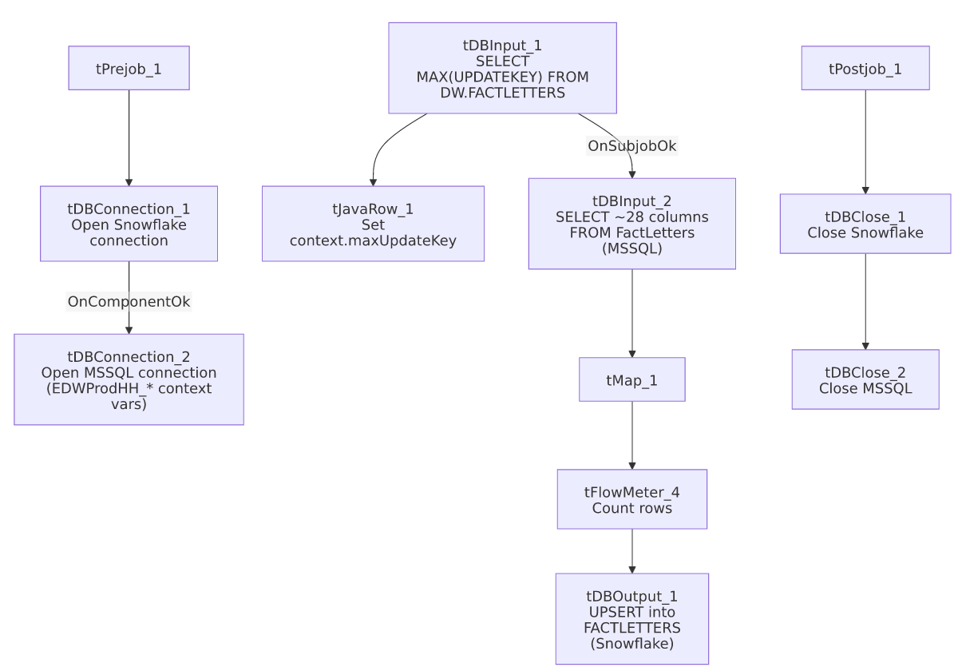

Settings tables

Source: `tDBInput_2` (`tMSSqlInput`)
Setting | Value | What it means
Connection | Shared tDBConnection_2 | Reuses the job's single MSSQL connection.
Table | FactLetters | Source letter-tracking table.
Query | Fixed SELECT of PKFactLetters, DimLogOn, LTR ID, LTR-IDX, DEBTOR, LTR_NAME, LTR_AMT, PAY_BY_DTE, print/notice-series fields, UpdateKey, etc. | The visible portion of the query does not reference context.maxUpdateKey — see Issues observed.

Target: `tDBOutput_1` (`tSnowflakeOutput`)
Setting | Value | What it means
Table | FACTLETTERS | Destination table in Snowflake.
Output action | UPSERT | Updates matching rows and inserts new ones — safer against duplication than a plain INSERT if the source query re-reads already-loaded rows.

Dependencies & configuration
- Triggers/depends on other jobs: none — no tRunJob links found.
- Context variables used: EDWProdHH_Server, EDWProdHH_Port, EDWProdHH_Schema, EDWProdHH_Database, EDWProdHH_Login (MSSQL connection details), maxUpdateKey (computed internally from the Snowflake max-key query).
- No hardcoded developer-workstation paths found in this job.

Glossary
Component type | Plain-English meaning
tSnowflakeConnection / tSnowflakeClose | Open/close a Snowflake database connection shared by other components in the job.
tMSSqlConnection / tMSSqlInput / tMSSqlClose | Open a Microsoft SQL Server connection, run a query against it, and close it.
tSnowflakeInput | Runs a query against Snowflake and returns its result rows (here, used just once for a single aggregate value).
tJavaRow | Runs custom Java code once per input row — here used to unpack a single query result into a context variable.
tMap | Maps/transforms columns from one schema to another.
tFlowMeter | Counts rows passing a point in the flow for logging/monitoring.
tStatCatcher / tFlowMeterCatcher / tLogRow | Talend's built-in job-statistics and flow-meter capture components, which print execution stats to the log; not part of the business data flow.

Issues observed
- The incremental-load logic may not actually be applied, the same open question documented for i3_CallDetail_40_Load: the job computes context.maxUpdateKey from Snowflake before reading the MSSQL source, but the captured tDBInput_2.QUERY text is truncated and does not show a WHERE UpdateKey > ... clause referencing context.maxUpdateKey in the visible portion. Unlike i3_CallDetail_40_Load, this job's target uses UPSERT rather than plain INSERT, which would at least prevent duplicate rows even if the source query pulls the full table every run — but it would still mean unnecessary full-table reads/transfers each run if the filter isn't applied. Verify the full query text directly in Talend Studio.
- No error/row-count logging specific to this job's business outcome (no tWarn/tDie/tSendMail) — a load failure here would only surface as a generic Talend execution error, with no job-specific message to distinguish it in a shared log. This differs from the tDie-on-merge-failure pattern used by file-load jobs like ADP_Payroll_Load, though this job doesn't have a separate merge step to fail on in the first place — it upserts directly.

