Talend Job: FactPaymentManager_Load

Overview
Loads payment-manager transaction records (payment ID, debtor number, logon parsed out of a LoadID field, initials, desk, pay amount, commission rate/amount, client number, payment/transaction/load dates, packet number, and an UpdateKey audit column) from the legacy EDWProdHH MSSQL database into the Snowflake FACTPAYMENTMANAGER table. Uses the same "check max key in Snowflake, then pull from source" incremental pattern seen in i3_CallDetail_40_Load and FactLetter_Load, with the same open question about whether the filter is actually applied.

Detail table
Field | Value
Job name | FactPaymentManager_Load
Version | 0.1
Project | EDW2SF
Author | jmach@harriscollect.com
Created | 2022-05-09T09:31:33.933-0700
Last Modified | 2025-09-24T10:59:11.228-0700

Step-by-step data flow
Setup subjob: tPrejob_1 → tDBConnection_1 opens the Snowflake connection → on component-ok, tDBConnection_2 opens the MSSQL connection to context.EDWProdHH_Server/Port/Schema/Database/Login (password redacted).
Main subjob:
- tDBInput_1 runs SELECT CAST(COALESCE(MAX(UPDATEKEY),0) AS VARCHAR(10)) AS MAX_UPDATE_KEY FROM DW.FACTPAYMENTMANAGER; against Snowflake.
- tJavaRow_1 captures that value into context.maxUpdateKey.
- On success, tDBInput_2 runs a fixed SELECT against the source MSSQL data — no table name is set on the component itself (TABLE param is blank; it's a free-form query), pulling [ID], a COALESCE([Debtor],'') as DebtorNumber, a Logon value parsed via SUBSTRING(LoadID,1,CHARINDEX('-',LoadID,1)-1), initials, desk, pay amount, commission rate/amount, client number, payment/transaction/load dates, packet number, and UpdateKey. The captured query text is truncated and does not visibly reference `context.maxUpdateKey` — see Issues observed.
- tMap_1 passes the source columns through to a target schema that adds a DEBTOR_IDX column not present in the source query's visible output — see Issues observed.
- tFlowMeter_2 counts rows passing through (labeled "MyLabel").
- tDBOutput_1 inserts the rows into Snowflake table FACTPAYMENTMANAGER (INSERT, no table-recreate action, no merge step afterward).
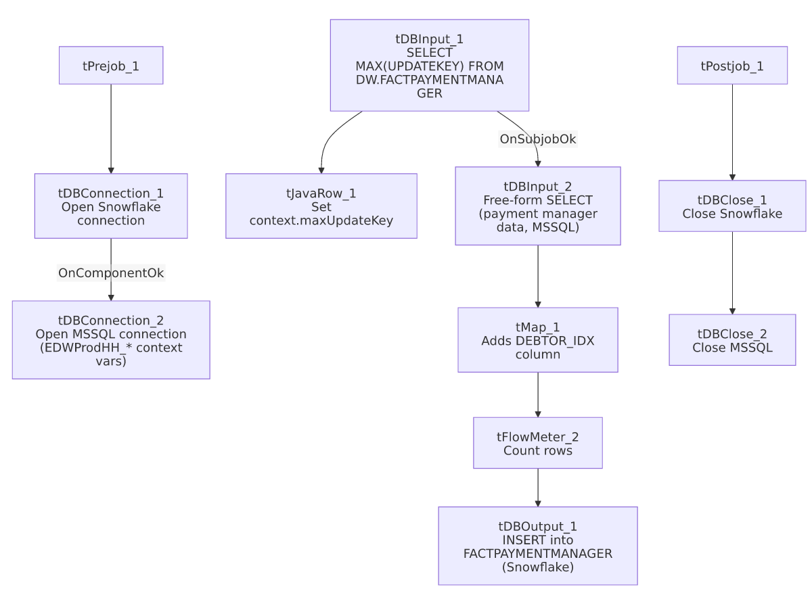

Settings tables

Source: `tDBInput_2` (`tMSSqlInput`)
Setting | Value | What it means
Connection | Shared tDBConnection_2 | Reuses the job's single MSSQL connection.
Table | *(blank — free-form query, no table set on the component)* | The query itself references the source table inline (not visible in the truncated captured text).
Query | SELECT [ID], COALESCE([Debtor],'') AS DebtorNumber, COALESCE(SUBSTRING(LoadID,1,CHARINDEX('-',LoadID,1)-1),'') AS Logon, [Initials], [Desk], CAST([PayAmt] AS numeric(16,4)), [CommRate], [ClientNum] ... (truncated) | Derives Logon by parsing the prefix of a LoadID field rather than reading it as a stored column — an inline transformation embedded in SQL rather than in tMap.

Target: `tDBOutput_1` (`tSnowflakeOutput`)
Setting | Value | What it means
Table | FACTPAYMENTMANAGER | Destination table in Snowflake.
Output action | INSERT | Appends rows — there is no TRUNCATE/staging step and no merge call, consistent with an incremental-append design, contingent on the max-key filter actually working.

Dependencies & configuration
- Triggers/depends on other jobs: none — no tRunJob links found.
- Context variables used: EDWProdHH_Server, EDWProdHH_Port, EDWProdHH_Schema, EDWProdHH_Database, EDWProdHH_Login, maxUpdateKey (computed internally).
- No hardcoded developer-workstation paths found in this job.

Glossary
Component type | Plain-English meaning
tSnowflakeConnection / tSnowflakeClose | Open/close a Snowflake database connection shared by other components in the job.
tMSSqlConnection / tMSSqlInput / tMSSqlClose | Open a Microsoft SQL Server connection, run a query against it, and close it.
tSnowflakeInput | Runs a query against Snowflake and returns its result rows (here, used just once for a single aggregate value).
tJavaRow | Runs custom Java code once per input row — here used to unpack a single query result into a context variable.
tMap | Maps/transforms columns from one schema to another.
tFlowMeter | Counts rows passing a point in the flow for logging/monitoring.

Issues observed
- The incremental-load logic may not actually be applied — same open question as i3_CallDetail_40_Load and FactLetter_Load: context.maxUpdateKey is computed but the captured tDBInput_2.QUERY text is truncated and does not show a WHERE UpdateKey > ... filter in the visible portion. Combined with a plain INSERT (not UPSERT or TRUNCATE-then-load), if the filter is not actually applied, every run would re-insert the entire source table's history into FACTPAYMENTMANAGER, duplicating all previously loaded rows. This should be verified directly in Talend Studio before assuming the incremental design works.
- `tMap_1`'s target schema includes a `DEBTOR_IDX` column that does not appear anywhere in the source query's visible schema (tDBInput_2's columns are ID, DEBTORNUMBER, LOGON, INITIALS, DESK, PAYAMT, COMMRATE, CLIENTNUM, COMMAMT, PAYMENTDATE, CREDITMONTH, CREDITYEAR, LOADID, TRANSDATE, PACKETNUM, LOADDATE, UPDATEKEY — no DEBTOR_IDX). Either tMap_1 derives DEBTOR_IDX via an internal expression/lookup not captured in this metadata, or it passes through blank/null for that column. Unable to determine from metadata; verify the actual tMap_1 mapping expressions in Talend Studio.
- No error/row-count logging specific to this job's business outcome (no tWarn/tDie/tSendMail, and no merge/stored-procedure step) — a load failure here would only surface as a generic Talend execution error.

