Talend Job: FactPostDates_Load

Overview
Loads scheduled/post-dated payment records (payment type, payment date/amount, employee payroll ID, source system, and an audit key) from the legacy EDWProdHH MSSQL database into the Snowflake FACTPOSTDATES table. Uses the same "check max audit key in Snowflake, then pull from source" incremental pattern as the other Fact*_Load jobs in this batch, and upserts (rather than plain-inserts) into the target, which limits the damage if the incremental filter isn't actually working.

Detail table
Field | Value
Job name | FactPostDates_Load
Version | 0.1
Project | EDW2SF
Author | jmach@harriscollect.com
Created | 2023-03-07T21:03:13.699-0800
Last Modified | 2025-11-04T11:08:12.449-0800

Step-by-step data flow
Setup subjob: tPrejob_1 → tSetKeystore_1 configures SSL trust/keystore from context.keystorePath → on subjob-ok, tDBConnection_1 opens the Snowflake connection → on component-ok, tDBConnection_2 opens the MSSQL connection to context.EDWProdHH_Server/Port/Schema/Database/Login.
Main subjob:
- tDBInput_1 runs SELECT CAST(COALESCE(MAX(InsertAuditKey),0) AS VARCHAR(10)) AS MAX_UPDATE_KEY FROM DW.FACTPOSTDATES; against Snowflake.
- tJavaRow_1 captures that value into context.maxUpdateKey.
- On success, tDBInput_2 runs a nested SELECT against MSSQL — an outer query selecting FactPostdateKey, PostdateID, HHLOGON, ACCOUNTNUMBER, DEBTOR_IDX, PAYMENTTYPE, PAYMENTDATE, PAYMENTAMOUNT, PostdateKEY, EMPLOYEEPAYROLLID, [SOURCE], InsertAuditKey from an inner subquery (the inner query's own filter logic isn't visible in this metadata — truncated).
- tMap_1 passes the columns through to a same-shaped uppercase-named target schema.
- tFlowMeter_6 counts rows passing through (labeled "MyLabel").
- tDBOutput_1 upserts the rows into Snowflake table FACTPOSTDATES.
Separately, tStatCatcher_1 and tFlowMeterCatcher_1 feed two tLogRow components that print job statistics to the log — standard Talend instrumentation, not part of the business data path.
Teardown subjob: tPostjob_1 → tDBClose_1 (close Snowflake) → tDBClose_2 (close MSSQL).
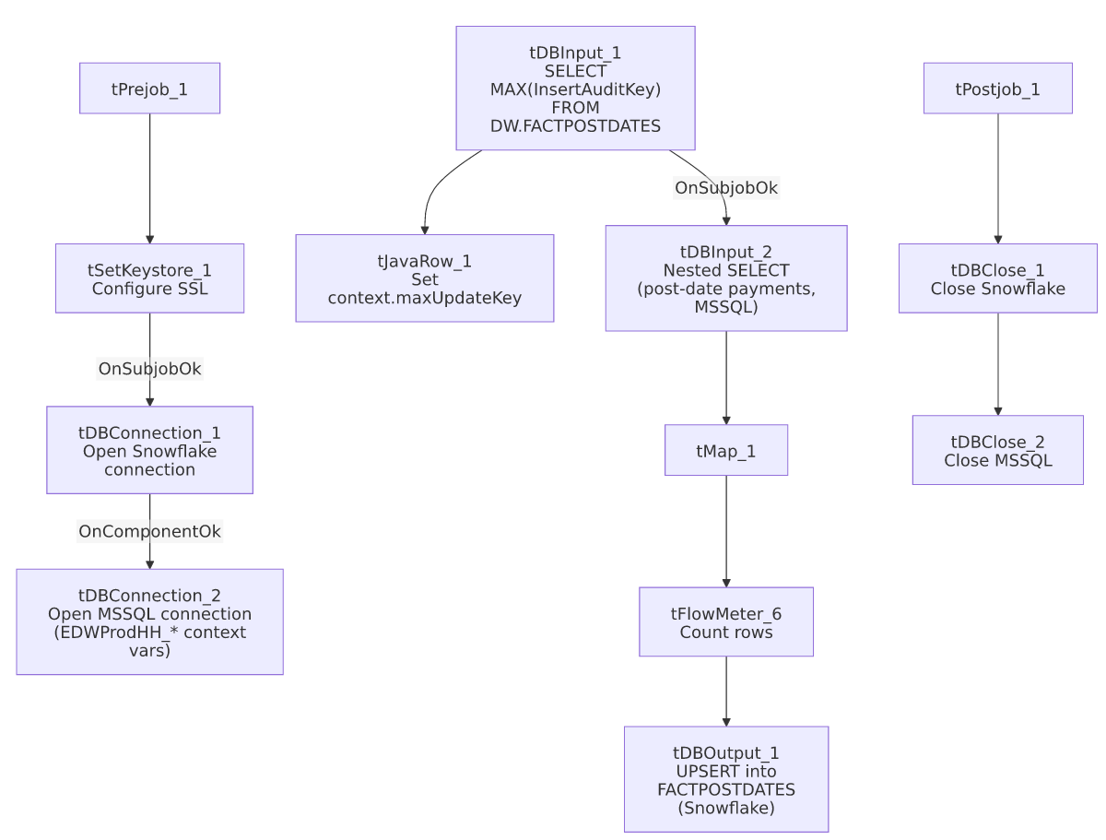

Settings tables

Source: `tDBInput_2` (`tMSSqlInput`)
Setting | Value | What it means
Connection | Shared tDBConnection_2 | Reuses the job's single MSSQL connection.
Query | SELECT FactPostdateKey, PostdateID, HHLOGON, ACCOUNTNUMBER, DEBTOR_IDX, PAYMENTTYPE, PAYMENTDATE, PAYMENTAMOUNT, PostdateKEY, EMPLOYEEPAYROLLID, [SOURCE], InsertAuditKey FROM (SELECT CAST([FactPostdateKey] AS numeri... (truncated) | Wraps an inner subquery — the actual filtering/casting logic inside that subquery is not visible in this metadata.

Target: `tDBOutput_1` (`tSnowflakeOutput`)
Setting | Value | What it means
Table | FACTPOSTDATES | Destination table in Snowflake.
Output action | UPSERT | Updates matching rows and inserts new ones — protects against duplication if the incremental filter isn't fully effective.

Security: `tSetKeystore_1`
Setting | Value | What it means
SSL_TRUSTSERVER_TRUSTSTORE | "C:/clientTrustStore.trustStore" (hardcoded) | Same Windows-path truststore pattern used across several jobs in this batch.
SSL_KEYSTORE | context.keystorePath
Passwords | ***REDACTED*** | Preserved as redacted.

Dependencies & configuration
- Triggers/depends on other jobs: none — no tRunJob links found.
- Context variables used: EDWProdHH_Server, EDWProdHH_Port, EDWProdHH_Schema, EDWProdHH_Database, EDWProdHH_Login, keystorePath, maxUpdateKey (computed internally from the Snowflake max-key query, despite tracking InsertAuditKey rather than UpdateKey).
- 1 hardcoded path finding: tSetKeystore_1.SSL_TRUSTSERVER_TRUSTSTORE = "C:/clientTrustStore.trustStore".

Glossary
Component type | Plain-English meaning
tSnowflakeConnection / tSnowflakeClose | Open/close a Snowflake database connection shared by other components in the job.
tMSSqlConnection / tMSSqlInput / tMSSqlClose | Open a Microsoft SQL Server connection, run a query against it, and close it.
tSnowflakeInput | Runs a query against Snowflake and returns its result rows (here, used just once for a single aggregate value).
tJavaRow | Runs custom Java code once per input row — here used to unpack a single query result into a context variable.
tMap | Maps/transforms columns from one schema to another.
tFlowMeter | Counts rows passing a point in the flow for logging/monitoring.
tSetKeystore | Configures SSL/TLS trust and client certificate settings used by subsequent secure connections in the job.
tStatCatcher / tFlowMeterCatcher / tLogRow | Talend's built-in job-statistics and flow-meter capture components; not part of the business data flow.

Issues observed
- The context variable name (`maxUpdateKey`) doesn't match the column it's actually derived from (`InsertAuditKey`, not `UpdateKey`) — a naming inconsistency inherited from the shared pattern used across i3_CallDetail_40_Load, FactLetter_Load, FactTrans_Load, and this job. Functionally harmless (it's just a variable name), but could confuse anyone reading this job's logic expecting maxUpdateKey to always track an UpdateKey column.
- The source query wraps an inner subquery whose own filtering/casting logic is not visible in this metadata (truncated after the outer SELECT list) — unable to confirm from metadata whether context.maxUpdateKey is actually referenced inside that subquery to filter the pull. Same incremental-load verification caveat as the other Fact*_Load jobs in this batch, though the UPSERT target action here reduces the risk of duplicate rows even if the filter isn't applied.
- This is the only `Fact*_Load` job in this batch with its own `tSetKeystore_1` component (FactLetter_Load, FactPaymentManager_Load, and FactTrans_Load all lack one). Since SSL/keystore configuration is typically needed for the Snowflake connection, it's unclear why this job needs it and its siblings don't — unable to determine from metadata whether the siblings rely on a JVM-wide keystore setting instead; worth confirming this isn't a silent connection-security gap in the other three jobs.

