Talend Job: FactTrans_Load

Overview
Loads the core transaction fact table — one row per collection transaction, with amounts broken out by category (principal, interest, agency, forwarding, direct payments and their NSF/reversal counterparts), transaction code, dates, desk, client, and a TCODE_COLLECTOR description column — from the legacy EDWProdHH MSSQL database into the Snowflake FACTTRANS table. This is almost certainly the project's central transaction fact load (the name FACTTRANS and its ~40-column business schema strongly suggest this), using the same "check max key in Snowflake, then pull from source" incremental pattern as the other Fact*_Load jobs, and upserting into the target.

Detail table
Field | Value
Job name | FactTrans_Load
Version | 0.1
Project | EDW2SF
Author | jmach@harriscollect.com
Created | 2022-01-13T08:03:16.563-0800
Last Modified | 2022-05-24T09:48:46.946-0700

Step-by-step data flow
Setup subjob: tPrejob_1 → tDBConnection_1 opens the Snowflake connection → on component-ok, tDBConnection_2 opens the MSSQL connection to context.EDWProdHH_Server/Port/Schema/Database/Login.
Main subjob:
- tDBInput_2 runs SELECT CAST(COALESCE(MAX(UPDATEKEY),0) AS VARCHAR(10)) AS MAX_UPDATE_KEY FROM DW.FACTTRANS; against Snowflake.
- tJavaRow_1 captures that value into context.maxUpdateKey.
- On success, tDBInput_1 runs a fixed SELECT against MSSQL: TRANS-IDX, DimLogon, TRANS_ID, DEBTOR_NUMBER, TCODE, COMM_RATE, and ~30 more transaction-amount and status columns (truncated after the initial column list — the query does not visibly reference `context.maxUpdateKey`, see Issues observed). Note the source query's schema already includes a TCODE_COLLECTOR column.
- tMap_1 passes the source columns through to a same-shaped uppercase-named target schema, adding a CAMPID column not present in the source query's captured schema.
- tFlowMeter_1 counts rows passing through (labeled "MyLabel"; TSTATCATCHER_STATS enabled).
- tDBOutput_1 upserts the rows into Snowflake table FACTTRANS.
Teardown subjob: tPostjob_1 → tDBClose_1 (close Snowflake) → tDBClose_2 (close MSSQL).
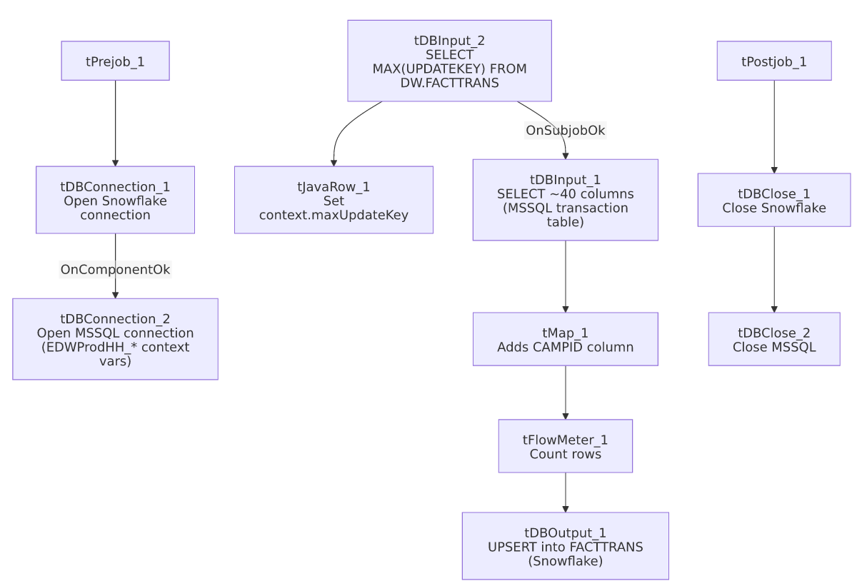

Settings tables

Source: `tDBInput_1` (`tMSSqlInput`)
Setting | Value | What it means
Connection | Shared tDBConnection_2 | Reuses the job's single MSSQL connection.
Query | SELECT [TRANS-IDX] AS TRANS_IDX, CAST([DimLogon] AS numeric(38,0)) AS DIMLOGON, [TRANS_ID], [DEBTOR_NUMBER], CAST([TCODE] AS numeric(38,0)) AS TCODE, CAST([COMM_RATE] AS numeric(16,4)) AS COMM_RATE, CAST([T... (truncated) | Pulls ~40 transaction-detail columns including a pre-populated TCODE_COLLECTOR field — see Dependencies & configuration for its likely relationship to FactTrans_TCODE_COLLECTOR_Load.

Target: `tDBOutput_1` (`tSnowflakeOutput`)
Setting | Value | What it means
Table | FACTTRANS | Destination table in Snowflake — the project's core transaction fact table.
Output action | UPSERT | Updates matching rows and inserts new ones.

Dependencies & configuration
- Triggers/depends on other jobs: none — no tRunJob links found. However, the source query's TCODE_COLLECTOR column and the small standalone job FactTrans_TCODE_COLLECTOR_Load (which reads TCODE_DESC1 AS TCODE_COLLECTOR from dbo.FACTTRANS and writes it to a Snowflake lookup table TRANS_TCODE_COLLECTOR) strongly suggest a data lineage relationship between the two jobs, even though neither calls the other via tRunJob. Unable to confirm the exact join/enrichment mechanism from metadata alone — see that job's own doc.
- Context variables used: EDWProdHH_Server, EDWProdHH_Port, EDWProdHH_Schema, EDWProdHH_Database, EDWProdHH_Login, maxUpdateKey (computed internally).
- No hardcoded developer-workstation paths found in this job.

Glossary
Component type | Plain-English meaning
tSnowflakeConnection / tSnowflakeClose | Open/close a Snowflake database connection shared by other components in the job.
tMSSqlConnection / tMSSqlInput / tMSSqlClose | Open a Microsoft SQL Server connection, run a query against it, and close it.
tSnowflakeInput | Runs a query against Snowflake and returns its result rows (here, used just once for a single aggregate value).
tJavaRow | Runs custom Java code once per input row — here used to unpack a single query result into a context variable.
tMap | Maps/transforms columns from one schema to another.
tFlowMeter | Counts rows passing a point in the flow for logging/monitoring.

Issues observed
- The incremental-load logic may not actually be applied — the same open question as i3_CallDetail_40_Load, FactLetter_Load, FactPaymentManager_Load, and FactPostDates_Load: context.maxUpdateKey is computed from Snowflake before reading MSSQL, but the captured tDBInput_1.QUERY text is truncated after the initial column list and does not show a WHERE ... > context.maxUpdateKey clause. Since this is (likely) the project's central transaction fact table, an unfiltered full-table pull each run — even with UPSERT protecting against duplication — could mean a substantial, unnecessary daily data-transfer cost if the source table is large. Verify the full query text directly in Talend Studio.
- `tMap_1`'s target schema includes a `CAMPID` column not present in the source query's captured schema (tDBInput_1's schema list does not include CAMPID). Either tMap_1 derives it via an internal expression/lookup not captured here, or it passes through blank/null. Unable to determine from metadata; verify the tMap_1 mapping expressions directly.
- No error/row-count logging specific to this job's business outcome (no tWarn/tDie/tSendMail) — given this table's apparent importance, a silent failure here would only show up as a generic Talend execution error unless caught by external monitoring.

