Talend Job: FactTrans_TCODE_COLLECTOR_Load

Overview
A small, single-purpose lookup-table load: it reads a transaction-code description column (TCODE_DESC1, aliased as TCODE_COLLECTOR) alongside the transaction index (TRANS-IDX) from the legacy EDWProdHH MSSQL dbo.FACTTRANS table, and bulk-loads it into a new/recreated Snowflake table TRANS_TCODE_COLLECTOR. This table's shape (TRANS_IDX + TCODE_COLLECTOR) matches a column that also appears directly in FactTrans_Load's own source query, suggesting this job either populates a lookup table FactTrans_Load (or something downstream of it) joins against, or is a redundant/legacy extraction of a column FactTrans_Load already pulls itself — see Issues observed.

Detail table
Field | Value
Job name | FactTrans_TCODE_COLLECTOR_Load
Version | 0.1
Project | EDW2SF
Author | jmach@harriscollect.com
Created | 2022-02-28T14:16:07.725-0800
Last Modified | 2025-09-24T11:01:15.598-0700

Step-by-step data flow
Setup subjob: tPrejob_1 → tDBConnection_1 opens the Snowflake connection → on component-ok, tDBConnection_2 opens the MSSQL connection to context.EDWProdHH_Server/Port/Schema/Database/Login.
Main subjob: tDBInput_1 runs SELECT [TRANS-IDX] AS TRANS_IDX, TCODE_DESC1 AS TCODE_COLLECTOR FROM dbo.FACTTRANS; against MSSQL, and its output flows (FLOW connector) directly into tDBOutputBulkExec_1, which bulk-loads the two columns into Snowflake table TRANS_TCODE_COLLECTOR with outputAction=INSERT and tableAction=CREATE — i.e., the table is (re)created fresh each run. There is no tMap, no row-count logging, and no merge step.
Teardown subjob: tPostjob_1 → tDBClose_1 (close Snowflake) → tDBClose_2 (close MSSQL).
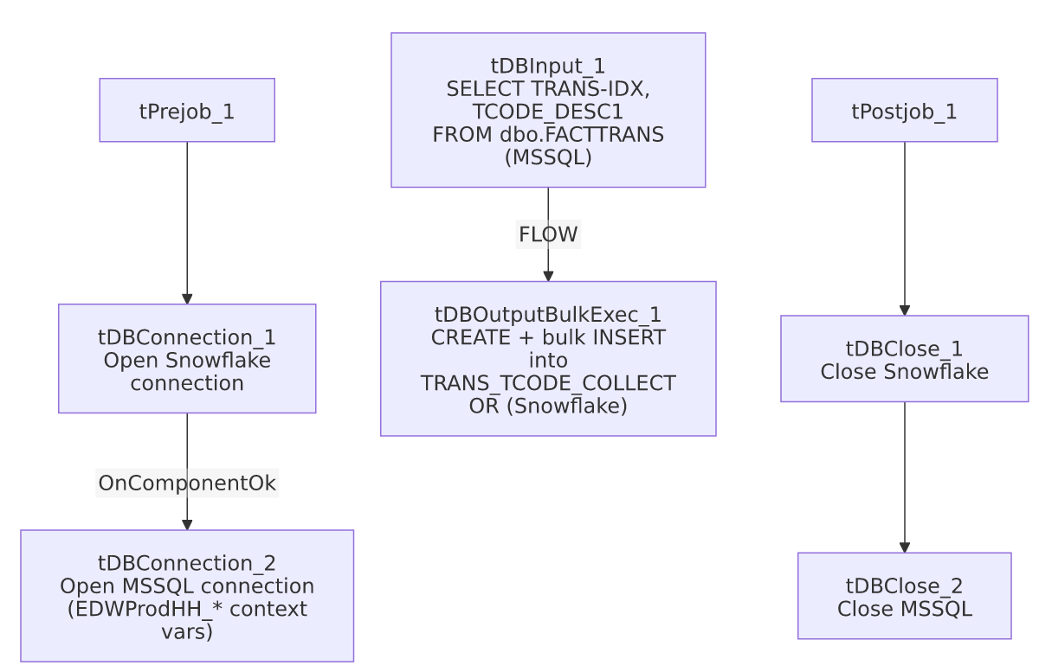

Settings tables

Source: `tDBInput_1` (`tMSSqlInput`)
Setting | Value | What it means
Query | SELECT [TRANS-IDX] AS TRANS_IDX, TCODE_DESC1 AS TCODE_COLLECTOR FROM dbo.FACTTRANS; | A simple two-column pull with no filter — reads the entire FACTTRANS MSSQL table every run.

Target: `tDBOutputBulkExec_1` (`tSnowflakeOutputBulkExec`)
Setting | Value | What it means
Table | TRANS_TCODE_COLLECTOR | Destination lookup table in Snowflake.
Output action | INSERT | Appends rows into the (freshly created) table.
Table action | CREATE | The table is dropped and recreated from scratch every run — this is a full-replace load, not an incremental one.

Dependencies & configuration
- Triggers/depends on other jobs: none — no tRunJob links found. However, see Overview and Issues observed regarding its likely data-lineage relationship with FactTrans_Load, which independently reads a TCODE_COLLECTOR column directly from its own MSSQL source query.
- Context variables used: EDWProdHH_Database, EDWProdHH_Login, EDWProdHH_Port, EDWProdHH_Schema, EDWProdHH_Server.
- No hardcoded developer-workstation paths found in this job.

Glossary
Component type | Plain-English meaning
tSnowflakeConnection / tSnowflakeClose | Open/close a Snowflake database connection shared by other components in the job.
tMSSqlConnection / tMSSqlInput / tMSSqlClose | Open a Microsoft SQL Server connection, run a query against it, and close it.
tSnowflakeOutputBulkExec | Bulk-loads rows into a Snowflake table, typically faster than row-by-row insert for large volumes; here also configured to recreate the table each run.

Issues observed
- `tableAction=CREATE` means this table is dropped and rebuilt from scratch every run, with no incremental logic and no filter on the source query — every run re-reads the entire dbo.FACTTRANS MSSQL table just to extract two columns. For a table the size implied by FactTrans_Load's own ~40-column, presumably large fact table, this could be an expensive way to maintain what is effectively a 2-column lookup/mapping table.
- This job's output table (`TRANS_TCODE_COLLECTOR`, columns `TRANS_IDX` + `TCODE_COLLECTOR`) closely mirrors a column that `FactTrans_Load` already pulls directly in its own source query (FactTrans_Load's MSSQL query schema includes a TCODE_COLLECTOR column). This raises a real question this metadata cannot answer: is TRANS_TCODE_COLLECTOR an actively-used lookup table that some other job or downstream consumer joins against (in which case this job is essential and not redundant), or is it a leftover/legacy extraction now duplicated by FactTrans_Load's own direct pull? No tRunJob link or SQL reference elsewhere in this batch's metadata resolves this — verify with the team whether TRANS_TCODE_COLLECTOR still has active downstream consumers before considering this job for retirement.
- No error/row-count logging (no tWarn/tDie, no tFlowMeter) — a failure here would only surface as a generic Talend execution error.

