Talend Job: Fact_Electronic_Media_Load

Overview
A thin orchestrator/merge job: it doesn't read or write business data columns directly. It calls CUBS_Raw_File_Load to do the actual file loading, then runs a stored procedure to merge the newly staged rows into the FACT_ELECTRONIC_MEDIA warehouse table, and branches to a warning or a job failure depending on the merge's return code. This is the same "call a loader job, then merge, then check the result" shape used by ADP_Payroll_Load, but with the merge outcome only ever producing a tWarn on the success path and a tDie on the failure path (see Issues observed for what "success" actually means here).

Detail table
Field | Value
Job name | Fact_Electronic_Media_Load
Version | 0.1
Project | EDW2SF
Author | jmach@harriscollect.com
Created | 2022-05-23T15:54:12.268-0700
Last Modified | 2022-05-24T09:49:20.346-0700

Step-by-step data flow
Setup subjob: tPrejob_1 → tDBConnection_1 opens the Snowflake connection.
Main subjob:
- tRunJob_1 calls `CUBS_Raw_File_Load` (USE_INDEPENDENT_PROCESS=false — runs inside this job's own JVM rather than as a separate process, DIE_ON_CHILD_ERROR=true, TRANSMIT_ORIGINAL_CONTEXT=true).
- On subjob-ok, tDBRow_1 runs CALL STAGING.MERGE_INTO_FACT_ELECTRONIC_MEDIA(); against Snowflake.
- tJavaRow_1 captures the procedure's RETVALUE into context.rowCount.
- The flow branches on two ordered RUN_IF conditions off tJavaRow_1 (the branch conditions themselves aren't captured in this metadata, but component wiring and message content make the intent clear):
- One branch: tDie_1 fails the job with message context.rowCount.toString() + ": an error occurred during MERGE", exit code = context.rowCount.intValue().
- The other branch: tWarn_1 logs context.rowCount.toString() + " rows added to FACT_ELECTRONIC_MEDIA" (severity 42) — a warning, not a success confirmation via any other channel.
Teardown subjob: tPostjob_1 → tDBClose_1 closes the Snowflake connection.
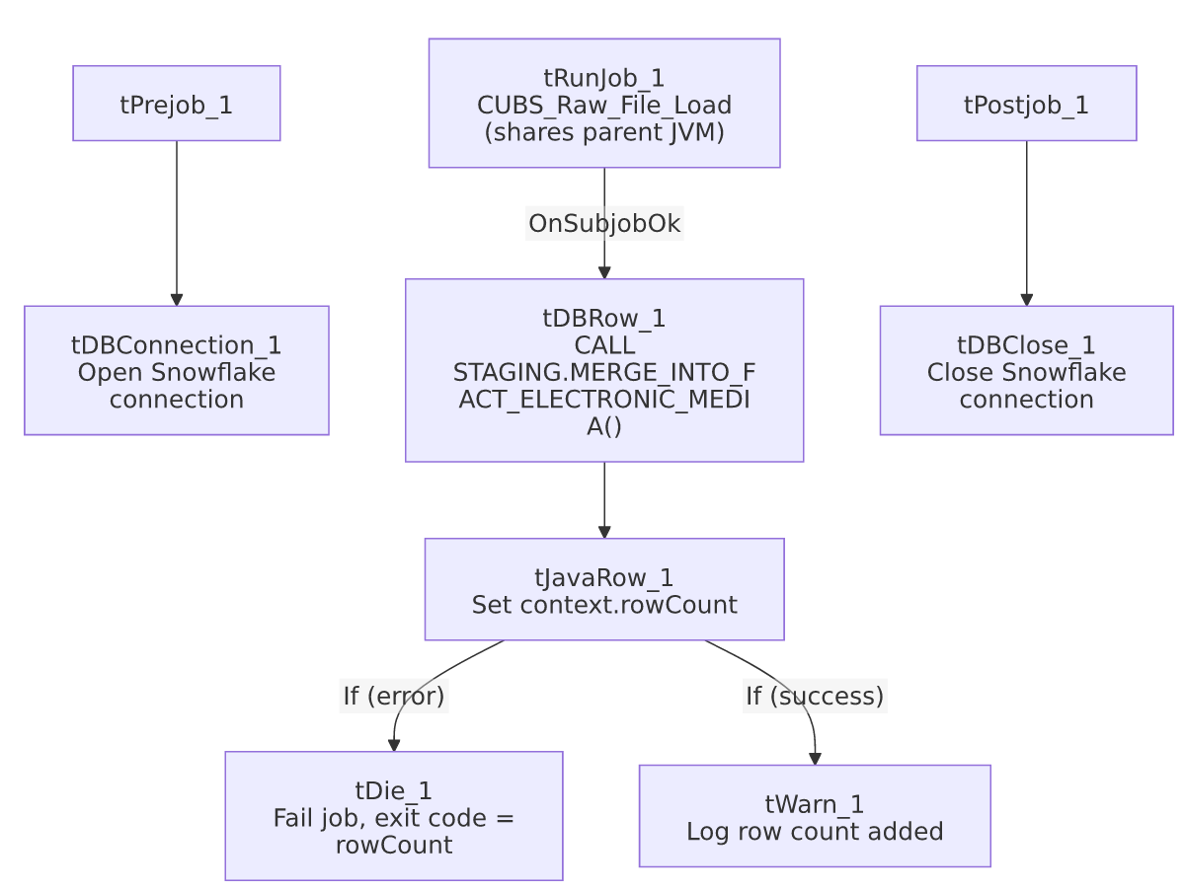

Settings tables

Orchestration: `tRunJob_1`
Setting | Value | What it means
PROCESS | CUBS_Raw_File_Load | The sub-job that actually performs the raw file load this job's merge depends on.
USE_INDEPENDENT_PROCESS | false | Runs inside this job's own JVM rather than as a separate process — the same non-default setting flagged as notable for DimFiscal_CO_Load in CO_Master_Load's doc.
DIE_ON_CHILD_ERROR | true | If CUBS_Raw_File_Load fails, this job fails too.
TRANSMIT_ORIGINAL_CONTEXT | true | The sub-job receives this job's context values.

Merge step: `tDBRow_1` (`tSnowflakeRow`)
Setting | Value | What it means
Query | CALL STAGING.MERGE_INTO_FACT_ELECTRONIC_MEDIA(); | Merges the rows CUBS_Raw_File_Load staged into the FACT_ELECTRONIC_MEDIA warehouse table.
Result handling | RETVALUE → context.rowCount → branch to tDie/tWarn | A non-zero (or otherwise "bad") return code fails the job with that code as the exit code; otherwise, only a warning-level log entry records the row count.

Dependencies & configuration
- This job calls 1 other job via `tRunJob`: CUBS_Raw_File_Load — see 06_dependency_matrix.md, which also lists DimDeskInfo_Load, DimEmployeeInfo_Load, and PaymentPlan_Load as other callers of the same sub-job.
- Context variables used: rowCount (set internally from the merge result).
- No hardcoded developer-workstation paths found in this job's own components.

Glossary
Component type | Plain-English meaning
tRunJob | Runs another Talend job as a sub-process (or, if configured not to use an independent process, inline in the same JVM), optionally waiting for it to finish before continuing.
tSnowflakeRow | Runs an arbitrary SQL statement or stored-procedure call against Snowflake.
tJavaRow | Runs custom Java code once per input row — here used to unpack a stored procedure's single return value.
tDie / tWarn | tDie ends the job with a specific failure message and exit code; tWarn logs a warning without failing the job.

Issues observed
- A successful merge is only ever recorded as a `tWarn` (severity 42), never as a plain informational log or explicit success signal — this project-wide pattern (also seen in CO_Master_Load's FACTTRANS merge branch) means the "happy path" outcome of this job's core business action shows up in logs at the same severity level typically reserved for problems, which could make log-scanning or alerting rules that trigger on tWarn produce false positives on every successful run. This is flagged as a known project-wide pattern in 05_operational_runbook.md; this job is one instance of it, and it uses tDie (not just tWarn) on the actual failure branch, which is more protective than CO_Master_Load's equivalent FACTTRANS branch (that one only warns even on failure).
- `USE_INDEPENDENT_PROCESS=false` on the only `tRunJob` in this job means CUBS_Raw_File_Load runs inside this job's own JVM. If CUBS_Raw_File_Load is resource-intensive, this could affect Fact_Electronic_Media_Load's own memory footprint or error isolation — the same consideration flagged for DimFiscal_CO_Load in CO_Master_Load. Unable to determine intent from metadata; worth confirming with the team, especially since CUBS_Raw_File_Load is called by at least 3 other jobs per 06_dependency_matrix.md and this may be the only caller that runs it in-process.

