Talend Job: HH_DEBTOR_SPECIAL_20231016_LOAD

Overview
A one-off, dated special-load job: it reads a fixed local file X:/HH_DEBTOR_SPECIAL_20231016.txt (logon, debtor number, debtor index, and a "first bill date") and inserts it into a Snowflake table HH_DEBTOR_LAST_BILL_DT, creating the table if it doesn't already exist. The job's name embeds the date it was built for (October 16, 2023), marking it as a targeted, single-use data correction or backfill rather than a recurring scheduled load.

Detail table
Field | Value
Job name | HH_DEBTOR_SPECIAL_20231016_LOAD
Version | 0.1
Project | EDW2SF
Author | jmach@harriscollect.com
Created | 2023-10-16T13:32:35.775-0700
Last Modified | 2025-09-24T11:07:35.459-0700

Step-by-step data flow
The entire job is a single flow: tFileInputDelimited_1 reads X:/HH_DEBTOR_SPECIAL_20231016.txt (tab-delimited, header row present, using a repository schema, DIE_ON_ERROR=false) and passes its rows (FLOW connector) directly into tDBOutput_1, which inserts them into Snowflake table HH_DEBTOR_LAST_BILL_DT (creating it if it doesn't exist). There is no tPrejob/tPostjob, no explicit connection-open/close component, no tMap, and no logging visible in this job's extracted metadata — see Issues observed.
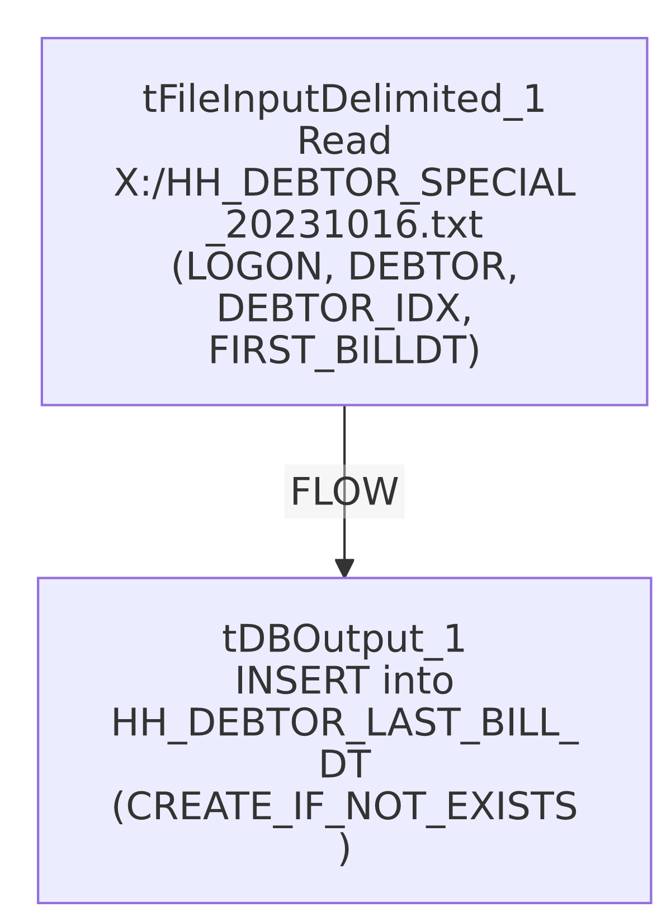

Settings tables

Source: `tFileInputDelimited_1`
Setting | Value | What it means
FILENAME | "X:/HH_DEBTOR_SPECIAL_20231016.txt" (hardcoded) | A fixed, dated, one-time source file — not driven by any context variable or file-listing loop.
FIELDSEPARATOR / HEADER | tab / 1 header row | Standard delimited file with header skipped.
SCHEMA / SCHEMA_REJECT | Both point to the same repository schema (_1eU_8GxiEe6inagxeNgb3w - metadata) | The main and reject schemas are identical — see Issues observed.
DIE_ON_ERROR | false | Malformed rows don't fail the job, but no reject flow is wired to capture them either.
TEMP_DIR | "C:/Talend-Studio-20211109_1610-V8.0.1/workspace" (hardcoded) | Same project-wide developer-workstation path risk documented in 05_operational_runbook.md.

Target: `tDBOutput_1` (`tSnowflakeOutput`)
Setting | Value | What it means
Table | HH_DEBTOR_LAST_BILL_DT | Destination table — name suggests it tracks each debtor's most recent bill date.
Output action | INSERT | Appends rows — running this job more than once would duplicate rows since there is no truncate or upsert.
Table action | CREATE_IF_NOT_EXISTS | Creates the table only if missing; does not recreate or truncate an existing table.

Dependencies & configuration
- Triggers/depends on other jobs: none — no tRunJob links found.
- Context variables used: none — this job uses no context variables at all, consistent with its one-off, hardcoded-path design.
- 1 hardcoded path finding: tFileInputDelimited_1.TEMP_DIR = "C:/Talend-Studio-20211109_1610-V8.0.1/workspace". The source file path itself (X:/HH_DEBTOR_SPECIAL_20231016.txt) is also hardcoded but was not flagged in the extracted hardcoded_path_findings field — noted here for completeness since it's central to the job's one-time-use design.

Glossary
Component type | Plain-English meaning
tFileInputDelimited | Reads a delimited (tab/CSV-style) text file according to a schema.
tSnowflakeOutput | Writes rows to a Snowflake table.

Issues observed
- This job has no visible connection-open/close, prejob/postjob, or logging components at all — unlike nearly every other job in this batch, there is no tSnowflakeConnection/tSnowflakeClose pair and no per-run log file setup captured in this metadata. This may reflect the job's minimal, ad-hoc nature (built for a single manual run rather than scheduled production use), or it may indicate the metadata extraction captured only part of the job. Unable to determine from metadata alone; if this job is still runnable/scheduled, verify its actual connection handling directly in Talend Studio.
- `SCHEMA` and `SCHEMA_REJECT` on `tFileInputDelimited_1` point to the identical repository schema entry. Normally a reject schema differs from the main schema (it typically adds errorCode/errorMessage columns for malformed rows). Having them be exactly the same repository reference suggests this reject schema was never properly configured — combined with DIE_ON_ERROR=false and no reject-flow connection wired anywhere in this job, any malformed row is silently dropped with no record of it.
- `INSERT` with no truncate/upsert and no incremental key means re-running this job (even accidentally) would duplicate every row already loaded. Given the job's one-off, dated nature, this is a real risk if it's ever run more than once — there is nothing in this job's own logic to prevent it.
- Given this is a dated, one-time special load, it should likely be retired or archived once its data has been confirmed loaded, rather than left active alongside recurring production jobs — worth confirming with the team whether it's still needed in the active job set.

