Talend Job: HH_EMedia_Load

Overview
A small, simple electronic-media status load: it reads two columns — a message identifier (EMID_IDX) and a computed status date (DATEADD(DAY, STATUS_DATE, '1967-12-31'), a legacy epoch-offset date format) — from the [dbo].[HH-ElectronicsMedia] table in the legacy EDWProdHH MSSQL database, and bulk-inserts them into a Snowflake table HH_EMESSAGE. This job should not be confused with the much larger, structurally different HH_E_Media_Load (note the extra underscore) — see Issues observed for a detailed comparison, including a significant table-name discrepancy found in that sibling job.

Detail table
Field | Value
Job name | HH_EMedia_Load
Version | 0.1
Project | EDW2SF
Author | jmach@harriscollect.com
Created | 2022-04-27T12:55:24.320-0700
Last Modified | 2025-08-28T08:57:23.583-0700

Step-by-step data flow
Setup subjob: tPrejob_1 → tDBConnection_1 opens the MSSQL connection to context.EDWProdHH_Server/Port/Schema/Database/Login (password redacted).
Main subjob: tDBInput_1 runs SELECT CAST(EMID_IDX AS VARCHAR(105)), DATEADD(DAY, STATUS_DATE,'1967-12-31') FROM [dbo].[HH-ElectronicsMedia]; → tMap_1 passes the two columns through unchanged (DIE_ON_ERROR=true) → tDBOutputBulkExec_1 bulk-inserts the rows into Snowflake table HH_EMESSAGE (INSERT, tableAction=NONE).
Teardown subjob: tPostjob_1 → tDBClose_2 closes the MSSQL connection. Note there is no tDBClose for a Snowflake connection captured in this job's metadata, even though tDBOutputBulkExec_1 writes to Snowflake — see Issues observed.
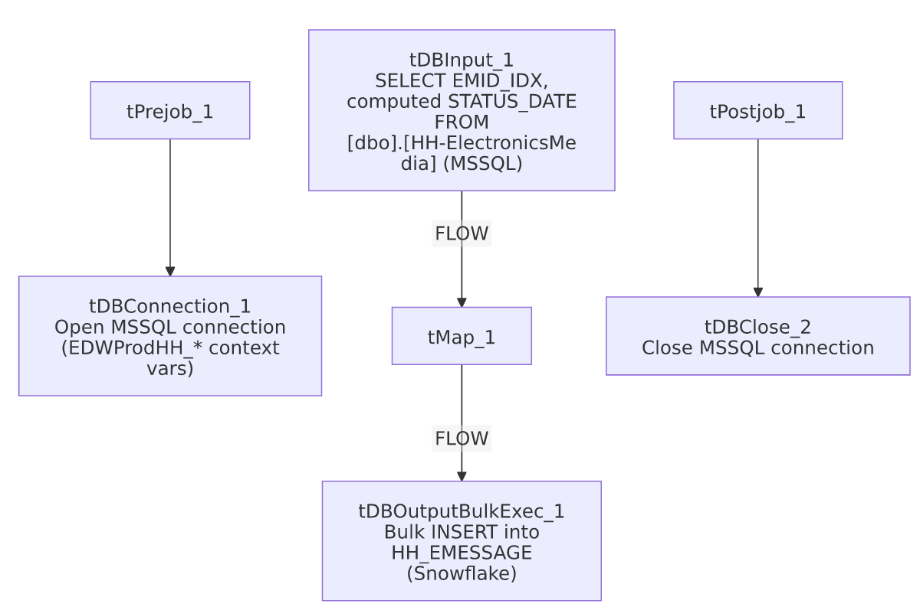

Settings tables

Source: `tDBInput_1` (`tMSSqlInput`)
Setting | Value | What it means
Query | SELECT CAST(EMID_IDX AS VARCHAR(105)), DATEADD(DAY, STATUS_DATE,'1967-12-31') FROM [dbo].[HH-ElectronicsMedia]; | Only 2 columns pulled, no filter — every run re-reads the entire source table. The DATEADD(DAY, STATUS_DATE, '1967-12-31') expression converts a legacy integer day-offset into a real date.
TRIM_ALL_COLUMN | true | Trims whitespace from all string fields.

Target: `tDBOutputBulkExec_1` (`tSnowflakeOutputBulkExec`)
Setting | Value | What it means
Table | HH_EMESSAGE | Destination table in Snowflake.
Output action | INSERT | Appends rows — no truncate/upsert, no incremental filter on the source query.
Table action | NONE | Table is not created/recreated by this job.

Dependencies & configuration
- Triggers/depends on other jobs: none — no tRunJob links found.
- Context variables used: EDWProdHH_Database, EDWProdHH_Login, EDWProdHH_Port, EDWProdHH_Schema, EDWProdHH_Server.
- No hardcoded developer-workstation paths found in this job.

Glossary
Component type | Plain-English meaning
tMSSqlConnection / tMSSqlInput / tMSSqlClose | Open a Microsoft SQL Server connection, run a query against it, and close it.
tMap | Maps/transforms columns from one schema to another.
tSnowflakeOutputBulkExec | Bulk-loads rows into a Snowflake table, typically faster than row-by-row insert for large volumes.

Issues observed
- No `TRUNCATE`, `UPSERT`, or incremental filter — every run re-reads the entire [dbo].[HH-ElectronicsMedia] MSSQL table and appends it to HH_EMESSAGE with a plain INSERT. If run more than once (or on any regular schedule), this would duplicate all previously loaded rows indefinitely, since there is no key comparison or truncate step anywhere in this job.
- No Snowflake connection-close component captured — tDBOutputBulkExec_1 writes to Snowflake, but the only tDBClose component in this job's metadata (tDBClose_2) closes the MSSQL connection (tDBConnection_1). There is no visible Snowflake connection-open component either, suggesting this job may rely on an implicit/default Snowflake connection not captured in this extraction, or the Snowflake connection lifecycle simply wasn't captured. Unable to determine from metadata; verify directly in Talend Studio.
- Do not confuse this job with `HH_E_Media_Load` (note the additional underscore between "E" and "Media"). Despite the similar name, that job is structurally much larger: it uses an incremental maxUpdateKey pattern, truncates and reloads a staging table, then runs an explicit MERGE into DW.HH_ELECTRONICSMEDIA, and — critically — its source table is configured as "DC-ElectronicsMedia", not an HH-prefixed table. See that job's own doc for details; the two jobs' outputs (HH_EMESSAGE here vs. HH_ELECTRONICSMEDIA there) are also different tables, so they are not simply duplicate implementations of the same load.

