Talend Job: HH_E_Media_Load

Overview
Loads electronic-media/letter-status tracking records (logon, message ID, letter name, status date/time/text, waterfall sequencing, series tracking, source system) from the legacy EDWProdHH MSSQL database into the Snowflake HH_ELECTRONICSMEDIA table, using an incremental maxUpdateKey check, a truncate-and-reload staging step, and an explicit MERGE into the final warehouse table. This job is dramatically larger and more fully-built than the similarly-named HH_EMedia_Load (no second underscore) — but its source table is configured as "DC-ElectronicsMedia", not an HH-prefixed table, which is a significant naming discrepancy given the job's own name. See Issues observed.

Detail table
Field | Value
Job name | HH_E_Media_Load
Version | 0.1
Project | EDW2SF
Author | jmach@harriscollect.com
Created | 2022-05-17T09:01:11.409-0700
Last Modified | 2025-09-24T11:07:38.744-0700

Step-by-step data flow
Setup subjob: tPrejob_1 → tDBConnection_1 opens the MSSQL connection to context.EDWProdHH_Server/Port/Schema/Database/Login → on subjob-ok, tDBConnection_2 opens the first Snowflake connection → on subjob-ok, tDBConnection_3 opens a second, separate Snowflake connection (see Issues observed).
Main subjob:
- tDBInput_2 runs SELECT CAST(COALESCE(MAX(UPDATEKEY),0) AS VARCHAR(10)) AS MAXUPDATEKEY FROM DW.HH_ELECTRONICSMEDIA; against Snowflake.
- tJavaRow_1 captures the value into context.maxUpdateKey.
- On success, tDBInput_1 runs a fixed SELECT against MSSQL table `"DC-ElectronicsMedia"` (per the component's TABLE parameter), pulling LOGON, EMID, EMID_IDX, LETTER_NAME, STATUS_DATE, STATUS_TIME, STATUS, STATUS_TEXT, STATUS_TYPE, WATERFALL, UPDATE_DT, UPDATE_TIME, CURR_SERIES, NEW_SERIES, CONTENT, ORIG_STATUS, SOURCE, SRC_NAME, UpdateKey (19 columns; query text truncated after these, and does not visibly reference context.maxUpdateKey).
- tMap_1 passes the columns through (DIE_ON_ERROR=true) to a same-shaped uppercase target schema.
- tFlowMeter_2 counts rows passing through (labeled "MyLabel").
- tDBOutput_1 writes to Snowflake table HH_ELECTRONICSMEDIA with outputAction=INSERT and `tableAction=TRUNCATE` — the staging table is cleared before this load's rows are inserted.
- tDBRow_1 (a separate, unlinked component per the connections list — it is not wired downstream of the truncate/insert step) runs a MERGE INTO DW.HH_ELECTRONICSMEDIA statement, sourcing from STAGING.HH_ELECTRONICSMEDIA and matching on EMID_IDX, updating matched rows and inserting new ones.
Teardown subjob: teardown components (tDBClose_1, tDBClose_2, tDBClose_3) close the two Snowflake connections and the MSSQL connection, chained together.
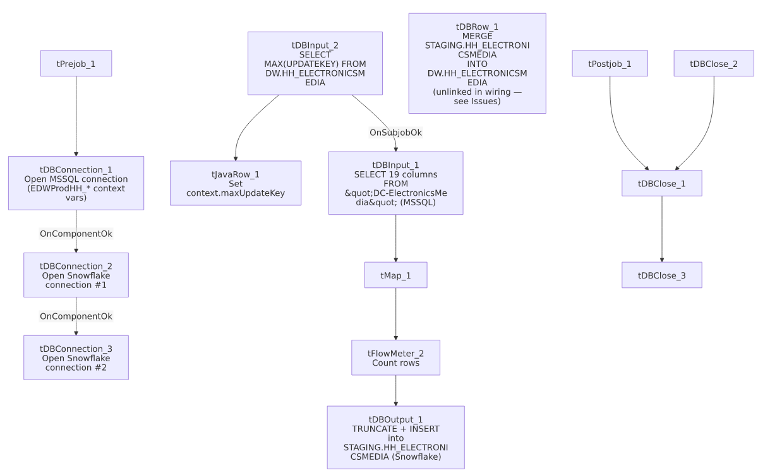

Settings tables

Source: `tDBInput_1` (`tMSSqlInput`)
Setting | Value | What it means
TABLE | "DC-ElectronicsMedia" | The source table is explicitly named for the DC site, not HH — see Issues observed.
Query | SELECT [LOGON], [EMID], [EMID_IDX], [LETTER_NAME], [STATUS_DATE], [STATUS_TIME], [STATUS], [STATUS_TEXT], [STATUS_TYPE], [WATERFALL], [UPDATE_DT], [UPDATE_TIME], [... (truncated) | Pulls 19 columns describing electronic-media letter/notice status tracking.

Staging load: `tDBOutput_1` (`tSnowflakeOutput`)
Setting | Value | What it means
Table | HH_ELECTRONICSMEDIA | Written with TRUNCATE + INSERT — functions as a staging table cleared and reloaded each run.

Merge step: `tDBRow_1` (`tSnowflakeRow`)
Setting | Value | What it means
Query | MERGE INTO DW.HH_ELECTRONICSMEDIA AS tgt USING (SELECT LEFT(LOGON,50) AS LOGON, ... FROM STAGING.HH_ELECTRONICSMEDIA) AS src ON (tgt.EMID_IDX = src.EMID_IDX) WHEN MATCHED THEN UPDATE ... WHEN NOT MATCHED THEN INSERT ... | Standard upsert-via-merge from the staging table into the final DW.HH_ELECTRONICSMEDIA warehouse table, truncating string fields to fixed lengths on the way in.
Schema reference | table.main.schema:REPOSITORY_SCHEMA_TYPE = "_m9AtkGRHEeyH09yzpUroLA - LEGACY_DIMDEBTOR" | This component's configured repository schema is `LEGACY_DIMDEBTOR` — a debtor-dimension schema, not an electronic-media schema. Its actual schema_columns metadata (captured separately) lists FILEDATE, LOGON, DEBTOR, CLIENT, NAME1, NAME2, ADD1, TOTAL_BAL, and dozens of other DIMDEBTOR-style columns that have nothing to do with electronic media — see Issues observed.

Dependencies & configuration
- Triggers/depends on other jobs: none — no tRunJob links found.
- Context variables used: EDWProdHH_Database, EDWProdHH_Login, EDWProdHH_Port, EDWProdHH_Schema, EDWProdHH_Server, maxUpdateKey.
- No hardcoded developer-workstation paths found in this job.

Glossary
Component type | Plain-English meaning
tMSSqlConnection / tMSSqlInput / tMSSqlClose | Open a Microsoft SQL Server connection, run a query against it, and close it.
tSnowflakeConnection / tSnowflakeInput / tSnowflakeOutput / tSnowflakeRow / tSnowflakeClose | Open a Snowflake connection, query it, write rows to a table, run an arbitrary SQL statement, and close the connection.
tMap | Maps/transforms columns from one schema to another.
tFlowMeter | Counts rows passing a point in the flow for logging/monitoring.
tJavaRow | Runs custom Java code once per input row — here used to unpack a single query result into a context variable.

Issues observed
- The source table is explicitly configured as `"DC-ElectronicsMedia"`, not an HH-prefixed table, despite this job being named `HH_E_Media_Load`. This is either a real, significant bug (this job is silently loading DC site data into what's presumed to be the HH electronic-media table), or the TABLE parameter is a leftover from copying a DC_E_Media_Load template that was never updated even though the rest of the job (target tables HH_ELECTRONICSMEDIA, context variables EDWProdHH_*) is consistently HH-branded. This should be verified urgently with the team — if the table name is wrong, HH_ELECTRONICSMEDIA in the warehouse may currently contain DC site data instead of (or mixed with) HH site data, or the query may simply fail at runtime if "DC-ElectronicsMedia" doesn't exist on the EDWProdHH server.
- `tDBRow_1` (the merge step) is configured with a `LEGACY_DIMDEBTOR` repository schema, and its own captured schema_columns list is a debtor-dimension schema (LOGON, DEBTOR, CLIENT, NAME1, ADD1, TOTAL_BAL, dozens more) that bears no resemblance to the actual MERGE query's electronic-media columns (EMID, LETTER_NAME, STATUS, WATERFALL, etc.). This is a clear copy-paste artifact — the component's schema metadata was never updated after being copied from a debtor-load job — though because tSnowflakeRow runs arbitrary SQL rather than relying on its declared schema for execution, this is very likely a cosmetic/metadata-only issue rather than a runtime failure. Still, it makes this component's own displayed schema actively misleading to anyone inspecting the job in Talend Studio.
- `tDBRow_1` (the merge) does not appear to be connected in this job's sequence — the captured connections list shows no link from tDBOutput_1 (the truncate+insert step) to tDBRow_1, meaning the merge may run as an independent, unlinked subjob rather than strictly after the staging load completes. If Talend executes unlinked subjobs concurrently, the merge could theoretically run against a partially-loaded or stale staging table. Verify actual subjob ordering directly in Talend Studio.
- Two separate Snowflake connections are opened (tDBConnection_2 and tDBConnection_3) rather than one shared connection reused across components — unlike most other jobs in this project. Unable to determine why a second connection is needed from this metadata; it may be intentional (e.g., isolating the merge's transaction from the staging load's), or a copy-paste leftover.
- No error/row-count logging specific to this job's business outcome (no tWarn/tDie/tSendMail) beyond the standard row-count tFlowMeter.

