Talend Job: HH_TRANS_NORTHSHORE_LOAD

Overview
A one-off, dated file load for the NorthShore client: it reads a fixed local file C:/Data/HH_TRANS_NORTHSHORE_01242023.txt — 27 columns covering debtor number, assignment/CDN identifiers, transaction code and description, transaction amount/date, client identifiers, comments, NSF flag, commission fields, and forwarding fees — and inserts it directly into a Snowflake table HH_TRANS_NORTHSHORE. The job's name and hardcoded, dated input filename mark it as a targeted one-time transaction backfill rather than a recurring scheduled load, similar in shape and purpose to HH_DEBTOR_SPECIAL_20231016_LOAD.

Detail table
Field | Value
Job name | HH_TRANS_NORTHSHORE_LOAD
Version | 0.1
Project | EDW2SF
Author | jmach@harriscollect.com
Created | 2023-01-24T14:21:52.597-0800
Last Modified | 2025-09-24T11:07:44.153-0700

Step-by-step data flow
The entire job is a single flow: tFileInputDelimited_1 reads C:/Data/HH_TRANS_NORTHSHORE_01242023.txt (tab-delimited, header row present, using a repository schema, DIE_ON_ERROR=false) → tMap_1 passes the 27 columns through unchanged to a same-shaped target schema (DIE_ON_ERROR=true) → tDBOutput_1 inserts the rows into Snowflake table HH_TRANS_NORTHSHORE. There is no tPrejob/tPostjob, no explicit connection-open/close component, and no logging visible in this job's extracted metadata.
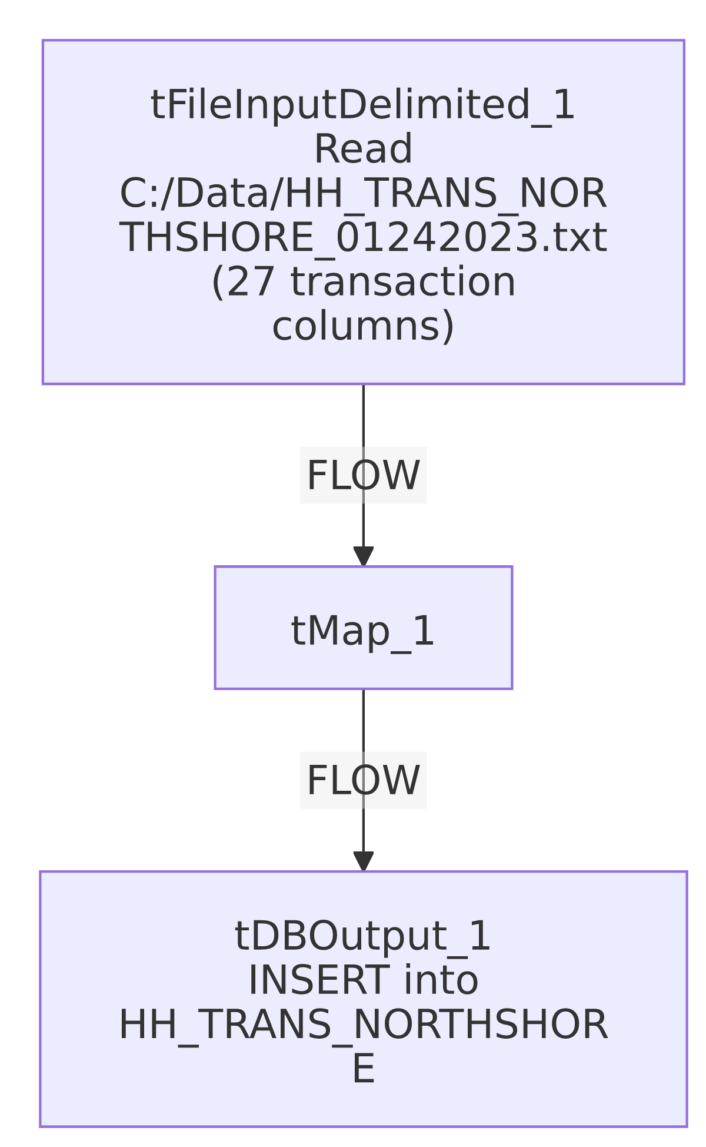

Settings tables

Source: `tFileInputDelimited_1`
Setting | Value | What it means
FILENAME | "C:/Data/HH_TRANS_NORTHSHORE_01242023.txt" (hardcoded) | A fixed, dated, one-time source file tied to a specific client (NorthShore) and date (Jan 24, 2023).
FIELDSEPARATOR / HEADER | tab / 1 header row | Standard delimited file with header skipped.
DIE_ON_ERROR | false | Malformed rows don't fail the job — no reject flow is wired to capture them either.
TEMP_DIR | "C:/Talend-Studio-20211109_1610-V8.0.1/workspace" (hardcoded) | Same project-wide developer-workstation path risk documented in 05_operational_runbook.md.

Target: `tDBOutput_1` (`tSnowflakeOutput`)
Setting | Value | What it means
Table | HH_TRANS_NORTHSHORE | A client-specific transaction table — not the shared FACTTRANS/HOPE_TRANSACTION fact tables used elsewhere in the project.
Output action | INSERT | Appends rows — running this job more than once would duplicate rows since there is no truncate or upsert.
Table action | NONE | The table is not created/recreated by this job; it must already exist.

Dependencies & configuration
- Triggers/depends on other jobs: none — no tRunJob links found.
- Context variables used: none.
- 1 hardcoded path finding: tFileInputDelimited_1.TEMP_DIR = "C:/Talend-Studio-20211109_1610-V8.0.1/workspace". The source file path itself (C:/Data/HH_TRANS_NORTHSHORE_01242023.txt) is also hardcoded and dated but was not separately flagged in the extracted hardcoded_path_findings field.

Glossary
Component type | Plain-English meaning
tFileInputDelimited | Reads a delimited (tab/CSV-style) text file according to a schema.
tMap | Maps/transforms columns from one schema to another (here, a straight pass-through).
tSnowflakeOutput | Writes rows to a Snowflake table.

Issues observed
- This job has no visible connection-open/close, prejob/postjob, or logging components — same pattern as HH_DEBTOR_SPECIAL_20231016_LOAD and HH_VAL_LTR_DATE_Backfill, all of which appear to be minimal, ad-hoc, one-time-use jobs rather than fully-instrumented recurring production loads. Unable to confirm connection handling from this metadata; verify directly in Talend Studio if this job might ever be re-run.
- `INSERT` with `tableAction=NONE` and no incremental key or truncate step means re-running this job (even accidentally) would duplicate every row already loaded into HH_TRANS_NORTHSHORE. Given the job's one-off, client- and date-specific nature, this is a real risk if run more than once.
- `tMap_1` has `DIE_ON_ERROR=true` while the upstream file read has `DIE_ON_ERROR=false` — a malformed source row would pass through the file read silently (no reject flow captured it) but could then fail the whole job at the map step if it doesn't fit the target schema. This inconsistency means the job's actual error behavior on bad data depends on exactly where in the row the malformation occurs, which is hard to predict from metadata alone.
- Given this is a dated, client-specific one-time load, it should likely be retired or archived once confirmed loaded, rather than left active alongside recurring production jobs — worth confirming with the team.

