Talend Job: HH_VAL_LTR_DATE_Backfill

Overview
A one-off backfill job: it reads a fixed local file C:/Data/VAL_LTR_DATE.TXT (logon, debtor number, debtor index, and a "validation letter date") and inserts it into a temporary Snowflake staging table TMP_HH_VAL_LTR_DATE. Unlike the other one-off loads in this batch (HH_DEBTOR_SPECIAL_20231016_LOAD, HH_TRANS_NORTHSHORE_LOAD), this job's target table name is explicitly prefixed TMP_, signaling it's meant as a staging landing spot for a manual or separate downstream process (e.g., a SQL script or another job) to pick up and merge — not a final destination table itself.

Detail table
Field | Value
Job name | HH_VAL_LTR_DATE_Backfill
Version | 0.1
Project | EDW2SF
Author | jmach@harriscollect.com
Created | 2025-06-23T11:12:49.271-0700
Last Modified | 2025-09-24T11:00:10.011-0700

Step-by-step data flow
The entire job is a single flow: tFileInputDelimited_1 reads C:/Data/VAL_LTR_DATE.TXT (tab-delimited, header row present, TRIMALL=true, REMOVE_EMPTY_ROW=true, DIE_ON_ERROR=false) and passes its rows (FLOW connector) directly into tDBOutput_1, which inserts them into Snowflake table TMP_HH_VAL_LTR_DATE. There is no tPrejob/tPostjob, no explicit connection-open/close component, no tMap, and no logging visible in this job's extracted metadata.
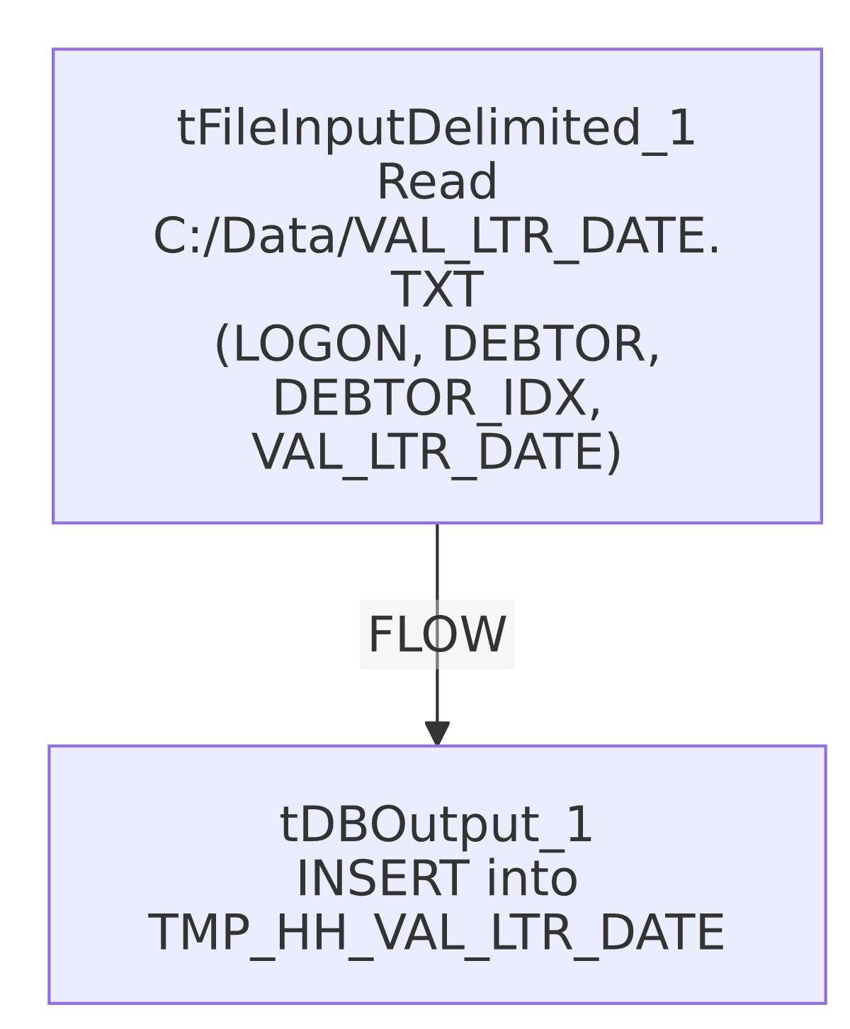

Settings tables

Source: `tFileInputDelimited_1`
Setting | Value | What it means
FILENAME | "C:/Data/VAL_LTR_DATE.TXT" (hardcoded) | A fixed, one-time source file — not driven by any context variable.
FIELDSEPARATOR / HEADER | tab / 1 header row | Standard delimited file with header skipped.
TRIMALL | true | Trims whitespace from all fields — a data-cleanliness step not seen in the other one-off loads in this batch.
REMOVE_EMPTY_ROW | true | Blank lines in the source file are dropped rather than loaded as empty rows.
DIE_ON_ERROR | false | Malformed rows don't fail the job — no reject flow is wired to capture them either.
TEMP_DIR | "C:/Talend-Studio-20211109_1610-V8.0.1/workspace" (hardcoded) | Same project-wide developer-workstation path risk documented in 05_operational_runbook.md.

Target: `tDBOutput_1` (`tSnowflakeOutput`)
Setting | Value | What it means
Table | TMP_HH_VAL_LTR_DATE | A TMP_-prefixed staging table — the name signals this is not the final destination for this data.
Output action | INSERT | Appends rows — running this job more than once would duplicate rows since there is no truncate or upsert.
Table action | NONE | The table is not created/recreated by this job; it must already exist.

Dependencies & configuration
- Triggers/depends on other jobs: none — no tRunJob links found. There is also no visible merge step or downstream job in this batch's metadata that reads from TMP_HH_VAL_LTR_DATE, so what consumes this staging table cannot be confirmed from metadata alone.
- Context variables used: none.
- 1 hardcoded path finding: tFileInputDelimited_1.TEMP_DIR = "C:/Talend-Studio-20211109_1610-V8.0.1/workspace". The source file path itself (C:/Data/VAL_LTR_DATE.TXT) is also hardcoded but was not separately flagged in the extracted hardcoded_path_findings field.

Glossary
Component type | Plain-English meaning
tFileInputDelimited | Reads a delimited (tab/CSV-style) text file according to a schema.
tSnowflakeOutput | Writes rows to a Snowflake table.

Issues observed
- This job loads into a `TMP_`-prefixed table with no merge step of its own, and no other job in this batch was found to reference TMP_HH_VAL_LTR_DATE or a similarly-named final table. This means the actual "last mile" of this backfill — moving the staged validation-letter dates into whatever permanent table they belong in — happens outside of what this metadata can see (likely a manual SQL script or a job not included in this export). Unable to confirm from metadata; verify with the team what downstream process consumes TMP_HH_VAL_LTR_DATE, since without it this job's data never reaches a permanent home.
- This job has no visible connection-open/close, prejob/postjob, or logging components — consistent with the other one-off, ad-hoc loads in this batch, but worth confirming actual connection handling in Talend Studio if this job is ever re-run.
- `INSERT` with no truncate/upsert means re-running this job would duplicate rows in the staging table. Since the table is meant as a TMP_ landing spot, this may be an accepted risk if the downstream consumer truncates it before or after consuming — but that can't be confirmed from this job's own metadata.
- Given this is a one-time backfill, it should likely be retired or archived once its data has been confirmed loaded and merged downstream, rather than left active alongside recurring production jobs.

