Talend Job: HOPE_Credit_Request

Overview
Loads commission/credit-adjustment requests (who requested it, when, which table/transaction it applies to, whether it was granted, the reason, request type, new commission rate, and a reference ID) from the "HOPE" MySQL system's tblcreditrequest table into the Snowflake CREDIT_REQUEST table, using an incremental load keyed on the request date. HOPE appears to be an internal collector-performance/commission-tracking system (see the related HOPE_Goals_Load, HOPE_Notes_Load, HOPE_SPTransactions_Load, and HOPE_Transactions_Load jobs).

Detail table
Field | Value
Job name | HOPE_Credit_Request
Version | 0.1
Project | EDW2SF
Author | jmach@harriscollect.com
Created | 2022-03-15T14:23:19.958-0700
Last Modified | 2025-11-04T11:08:21.049-0800

Step-by-step data flow
Setup subjob: tPrejob_1 → tJava_1 opens a per-run log file at context.logDir + jobName + "_" + <timestamp> + ".log" → on subjob-ok, tDBConnection_1 opens the MySQL connection to host "MP-HOPE-V01", database "hope", user "svc_edw" (password redacted) → on subjob-ok, tSetKeystore_1 configures SSL trust/keystore from context.keystorePath → on subjob-ok, tDBConnection_2 opens the Snowflake connection.
Main subjob:
- tDBInput_2 runs SELECT CAST(COALESCE(MAX(REQ_DATE),'2000-01-01') AS VARCHAR(50)) AS MAX_DATE FROM CREDIT_REQUEST; against Snowflake.
- tJavaRow_1 captures the value into context.maxDate.
- On success, tDBInput_1 reads from MySQL repository schema tblcreditrequest, selecting tblReqID, TransactionID, Initials, ReqDate, curTable, Completed, Granted, Reason, ReqType, NewRate, RefID (query text truncated — does not visibly show a WHERE filter referencing context.maxDate in the captured portion; see Issues observed).
- tMap_1 renames/passes columns through to TRANS_IDX, INITIALS, REQ_DATE, CURRENT_TABLE, COMPLETED, GRANTED, REASON, REQ_TYPE, NEW_RATE, REF_ID (DIE_ON_ERROR=true).
- tFlowMeter_1 counts rows passing through.
- tDBOutput_1 inserts the rows into Snowflake table CREDIT_REQUEST (INSERT, tableAction=NONE, no merge step).
Teardown subjob: tPostjob_1 → tDBClose_1 (close MySQL) → tDBClose_2 (close Snowflake).
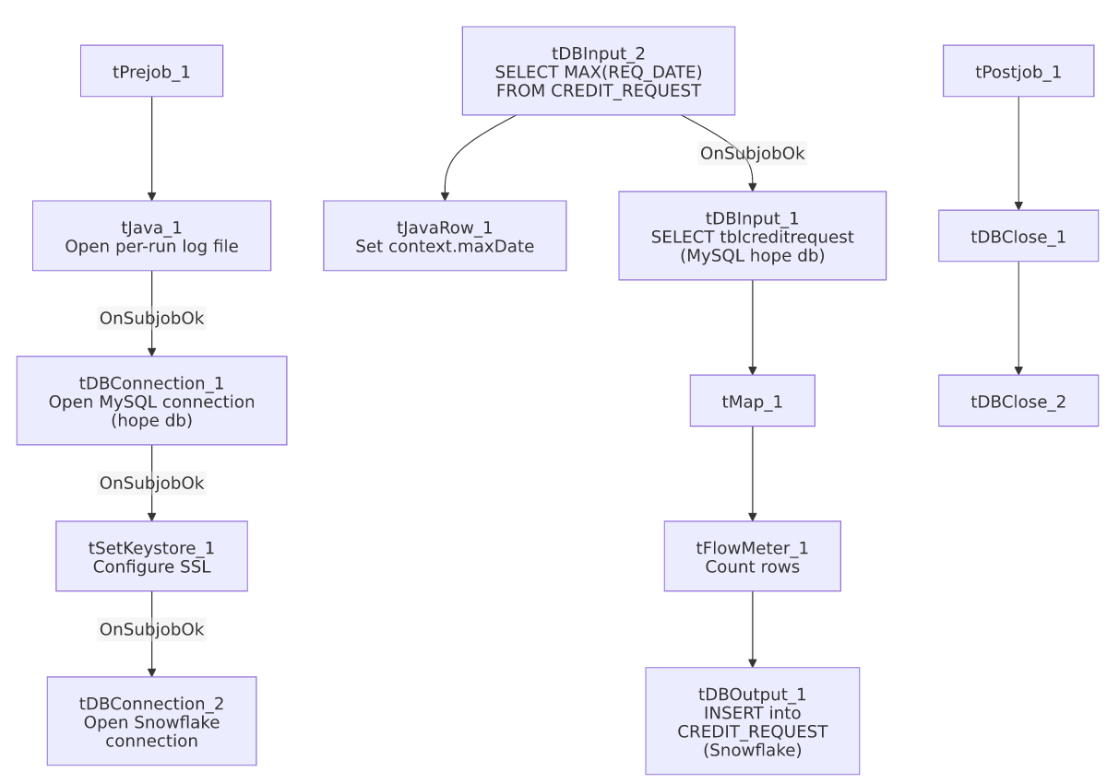

Settings tables

Source: `tDBInput_1` (`tMysqlInput`)
Setting | Value | What it means
Connection | Shared tDBConnection_1 (host MP-HOPE-V01, db hope, user svc_edw) | Reuses the job's MySQL connection to the HOPE system.
Table | tblcreditrequest | Source commission/credit-request table.
Query | SELECT tblReqID, TransactionID, Initials, ReqDate, curTable, Completed, Granted, Reason, ReqType, NewRate, RefID FROM tblcreditrequest (truncated) | No visible date filter in the captured portion — see Issues observed.

Target: `tDBOutput_1` (`tSnowflakeOutput`)
Setting | Value | What it means
Table | CREDIT_REQUEST | Destination table in Snowflake.
Output action | INSERT | Appends rows — relies entirely on the source query being correctly filtered to avoid duplicates, since there's no TRUNCATE or UPSERT.

Dependencies & configuration
- Triggers/depends on other jobs: none — no tRunJob links found.
- Context variables used: keystorePath, logDir, maxDate (computed internally).
- 1 hardcoded path finding: tSetKeystore_1.SSL_TRUSTSERVER_TRUSTSTORE = "C:/clientTrustStore.trustStore".

Glossary
Component type | Plain-English meaning
tMysqlConnection / tMysqlInput / tMysqlClose | Open a MySQL connection, run a query against it, and close it.
tSnowflakeConnection / tSnowflakeInput / tSnowflakeOutput / tSnowflakeClose | Open a Snowflake connection, query it, write rows to a table, and close the connection.
tMap | Maps/transforms columns from one schema to another.
tFlowMeter | Counts rows passing a point in the flow for logging/monitoring.
tJavaRow | Runs custom Java code once per input row — here used to unpack a single query result into a context variable.
tSetKeystore | Configures SSL/TLS trust and client certificate settings used by subsequent secure connections in the job.

Issues observed
- The incremental-load logic may not actually be applied — context.maxDate is computed from Snowflake before reading MySQL, but the captured tDBInput_1.QUERY text is truncated and does not show a WHERE ReqDate > ... clause referencing context.maxDate in the visible portion. Combined with a plain INSERT (no TRUNCATE/UPSERT), if the filter isn't actually applied, every run would duplicate all previously loaded credit-request rows in CREDIT_REQUEST. This should be verified directly in Talend Studio.
- No error/row-count logging specific to this job's business outcome (no tWarn/tDie/tSendMail) — a load failure here would only surface as a generic Talend execution error.

