Talend Job: HOPE_Goals_Load

Overview
Loads collector performance-goal records (username, initials, vertical, role, a calculated threshold, credit month/year, and goal type) from the "HOPE" MySQL system's tblgoals table into the Snowflake HOPE_GOALS table, truncating and reloading the table each run, then calling two stored procedures in sequence to merge the data into HOPE_GOALS and a downstream HOPE_FACT_GOALS fact table. Unlike its sibling HOPE_Credit_Request (incremental, insert-only, no merge), this job is a full-refresh-then-merge design.

Detail table
Field | Value
Job name | HOPE_Goals_Load
Version | 0.1
Project | EDW2SF
Author | jmach@harriscollect.com
Created | 2022-03-17T16:21:43.345-0700
Last Modified | 2025-11-04T11:18:03.414-0800

Step-by-step data flow
Setup subjob: tPrejob_1 → tJava_1 opens a per-run log file → on subjob-ok, tDBConnection_1 opens the MySQL connection to "MP-HOPE-V01" / "hope" / "svc_edw" (password redacted) → on subjob-ok, tSetKeystore_1 configures SSL trust/keystore from context.keystorePath → on subjob-ok, tDBConnection_2 opens the Snowflake connection.
Main subjob:
- tDBInput_1 reads from MySQL table tblgoals via a stored query (repository query store usergoals) selecting username, initials, vertical, role, a CASE-derived threshold (rounding logic varies by role — visible portion mentions 'COLLECTOR - BILINGUAL' and 'FLOOR COACH' roles), CREDIT_MONTH, CREDIT_YEAR, GOAL_TYPE (query truncated beyond this point).
- tMap_1 maps the columns to INITIALS, GOAL, LOAD_DATE, CREDIT_MONTH, CREDIT_YEAR, CREDIT_DATE, EFF_DATE, EXP_DATE, VERTICAL, USER_ROLE, GOAL_TYPE (DIE_ON_ERROR=true).
- tFlowMeter_1 counts rows passing through.
- tDBOutput_1 writes to Snowflake table HOPE_GOALS with outputAction=INSERT and `tableAction=TRUNCATE` — a full refresh each run.
- On subjob-ok, tDBRow_1 runs CALL STAGING.MERGE_INTO_HOPE_GOALS();, then on subjob-ok, tDBRow_2 runs CALL STAGING.MERGE_INTO_HOPE_FACT_GOALS(); — two chained merge calls.
Teardown subjob: tPostjob_1 → tDBClose_2 (close MySQL) → tDBClose_1 (close Snowflake).
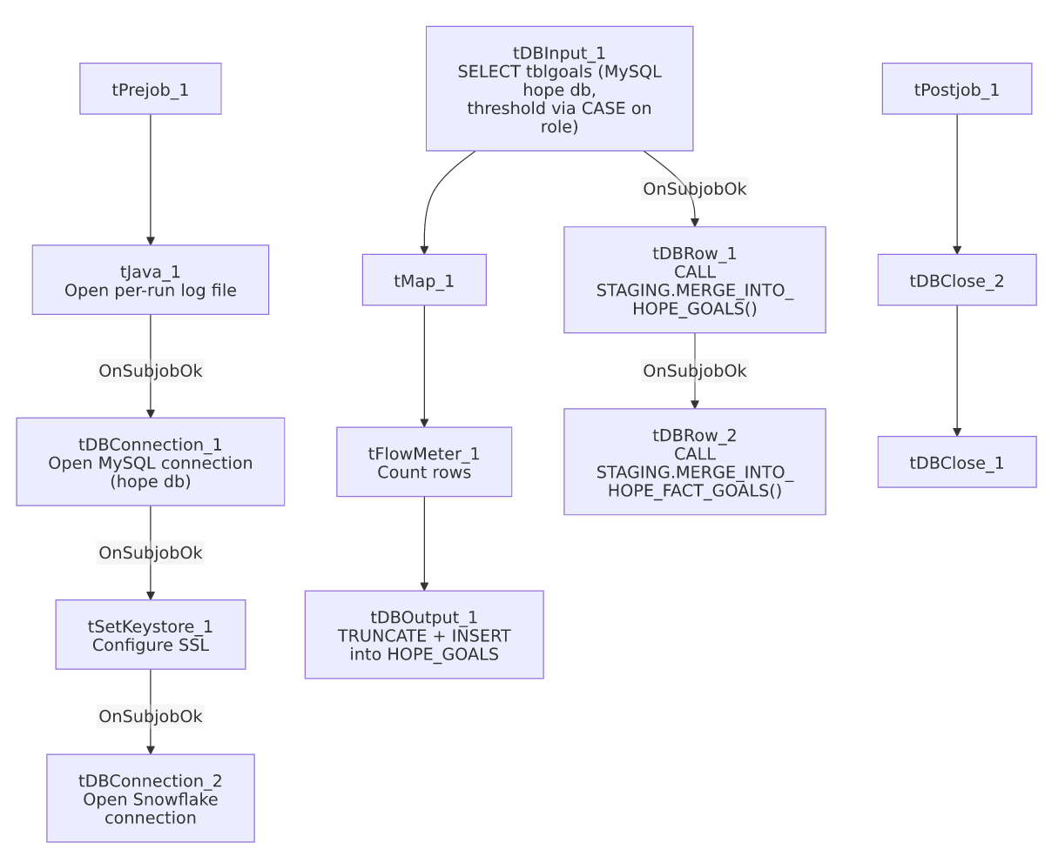

Settings tables

Source: `tDBInput_1` (`tMysqlInput`)
Setting | Value | What it means
Table | tblgoals | Source performance-goal table.
Query | SELECT u.username, u.initials, u.vertical, u.role, CASE WHEN u.role IN ('COLLECTOR - BILINGUAL', 'FLOOR COACH') THEN ROUND(th.... (truncated) | Role-dependent threshold calculation embedded in SQL — the full rounding logic isn't visible in this metadata.
TRIM_ALL_COLUMN | true | Trims whitespace from all fields.

Target: `tDBOutput_1` (`tSnowflakeOutput`)
Setting | Value | What it means
Table | HOPE_GOALS | Written with TRUNCATE + INSERT each run — a full-refresh staging pattern, unlike HOPE_Credit_Request's incremental append.

Merge steps: `tDBRow_1` / `tDBRow_2`
Setting | Value | What it means
Query 1 | CALL STAGING.MERGE_INTO_HOPE_GOALS(); | Merges the freshly truncated/loaded staging data into the HOPE_GOALS warehouse structure.
Query 2 | CALL STAGING.MERGE_INTO_HOPE_FACT_GOALS(); | Chained a second merge into a HOPE_FACT_GOALS fact table — the only job in this batch with two sequential merge calls to different targets.

Dependencies & configuration
- Triggers/depends on other jobs: none — no tRunJob links found.
- Context variables used: keystorePath, logDir.
- 1 hardcoded path finding: tSetKeystore_1.SSL_TRUSTSERVER_TRUSTSTORE = "C:/clientTrustStore.trustStore".

Glossary
Component type | Plain-English meaning
tMysqlConnection / tMysqlInput / tMysqlClose | Open a MySQL connection, run a query against it, and close it.
tSnowflakeConnection / tSnowflakeOutput / tSnowflakeRow / tSnowflakeClose | Open a Snowflake connection, write rows to a table, run an arbitrary SQL statement, and close the connection.
tMap | Maps/transforms columns from one schema to another.
tFlowMeter | Counts rows passing a point in the flow for logging/monitoring.
tSetKeystore | Configures SSL/TLS trust and client certificate settings used by subsequent secure connections in the job.

Issues observed
- Neither merge call's result (`RETVALUE`) is captured or checked — unlike Fact_Electronic_Media_Load, ADP_Payroll_Load, and HH_E_Media_Load, this job's two tDBRow merge calls have no tJavaRow capturing a return value and no tWarn/tDie branching on success or failure. If either MERGE_INTO_HOPE_GOALS() or MERGE_INTO_HOPE_FACT_GOALS() fails silently (e.g., returns an error code rather than throwing an exception Talend would catch), this job would report success with no record of the merge's actual outcome.
- `tDBRow_1`'s "start" trigger is `tDBInput_1`'s `OnSubjobOk`, not the completion of the truncate/insert (`tDBOutput_1`) — per the captured connections, tDBRow_1 fires when the MySQL read subjob completes successfully, running in parallel with (not strictly after) the tMap_1 → tFlowMeter_1 → tDBOutput_1 chain. If the merge is meant to run only after the fresh data has been loaded into the HOPE_GOALS staging table, this wiring could let the merge run against stale or partially-loaded staging data. Verify actual subjob ordering directly in Talend Studio.
- The role-based threshold calculation is embedded directly in the source SQL query (a CASE statement referencing specific role names) rather than in tMap_1 or a lookup table — business logic like this is harder to discover, test, or update independently of the query text, and any change to role names in the HOPE source system's role column would need this SQL updated in lockstep, not just a config value changed.

