Talend Job: HOPE_Notes_Load

Overview
Loads collector notes (transaction ID, note text, date/time, initials, and pay amount) from a MySQL paymentmanager database's tblnotes table into the Snowflake NOTES table, using an incremental load keyed on the note date. Despite being one of the "HOPE" family of jobs (alongside HOPE_Credit_Request, HOPE_Goals_Load, HOPE_SPTransactions_Load, HOPE_Transactions_Load), its actual source is the separate paymentmanager MySQL database, not the hope database its own connection component is configured for — see Issues observed.

Detail table
Field | Value
Job name | HOPE_Notes_Load
Version | 0.1
Project | EDW2SF
Author | jmach@harriscollect.com
Created | 2022-03-15T10:13:23.695-0700
Last Modified | 2025-11-04T10:24:18.036-0800

Step-by-step data flow
Setup subjob: tPrejob_1 → tJava_1 opens a per-run log file at a hardcoded /logs/ path (see Issues observed) → on component-ok, tDBConnection_1 opens the MySQL connection (host "MP-HOPE-V01", db "hope", user "svc_edw", password redacted) → on subjob-ok, tDBConnection_2 opens the Snowflake connection.
Main subjob:
- tDBInput_2 runs SELECT CAST(MAX(NOTES_DATE) AS VARCHAR(50)) AS MAX_DATE FROM HOPE.NOTES; against Snowflake.
- tJavaRow_1 captures the value into context.maxDate.
- On success, tDBInput_1 reads MySQL, but with its own HOST/DBNAME overridden to "HH-MP-PMGR" / "paymentmanager" (see Issues observed): SELECT PrimKey, TransactionID, Notes, Date, Time, Initials, PayAmt FROM tblnotes WHERE Date > '" + context.maxDate + "' — this is the one job in the HOPE family where the incremental filter is clearly visible and applied.
- tMap_1 maps to TRANS_IDX, NOTES, NOTES_DATE, INITIALS, PAY_AMT (DIE_ON_ERROR=true).
- tFlowMeter_1 counts rows passing through.
- tDBOutput_1 inserts the rows into Snowflake table NOTES (INSERT, tableAction=NONE, no merge step).
Teardown subjob: tPostjob_1 → tDBClose_1 (close MySQL) → tDBClose_2 (close Snowflake).
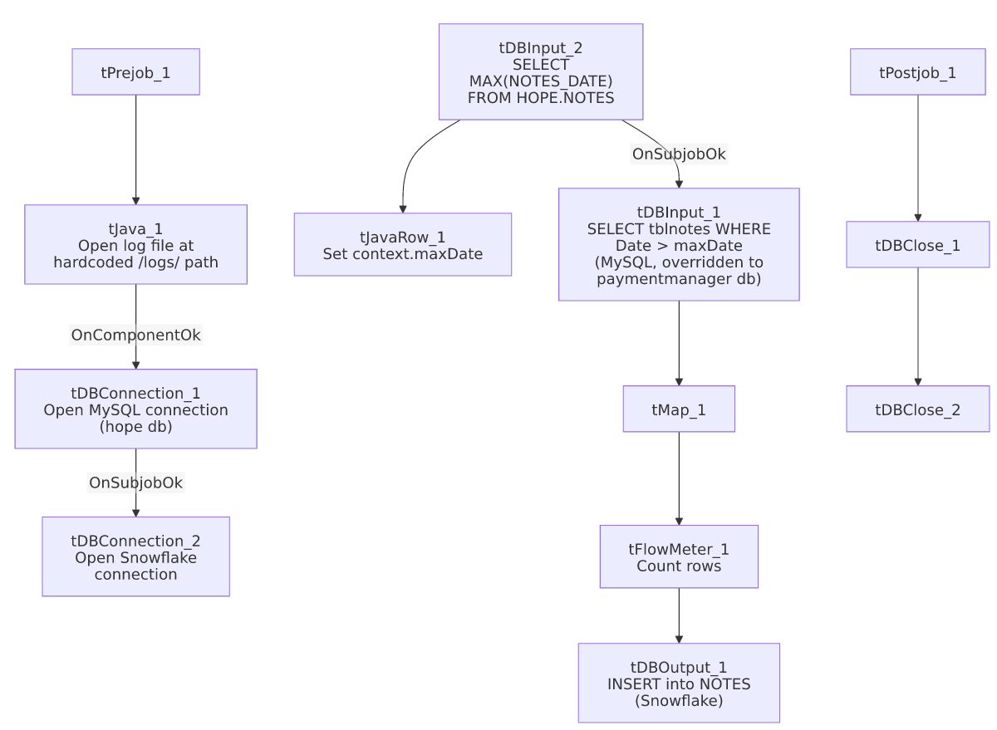

Settings tables

Source: `tDBInput_1` (`tMysqlInput`)
Setting | Value | What it means
CONNECTION | tDBConnection_1 (USE_EXISTING_CONNECTION=true) | Declares it reuses the shared connection...
HOST / DBNAME (component's own) | "HH-MP-PMGR" / "paymentmanager" | ...but the component's own HOST/DBNAME parameters are set to a different server/database than tDBConnection_1's (MP-HOPE-V01 / hope) — see Issues observed.
Query | SELECT PrimKey, TransactionID, Notes, Date, Time, Initials, PayAmt FROM tblnotes WHERE Date > '" + context.maxDate + "' | The incremental filter is fully visible and clearly applied here, unlike most other incremental jobs in this batch.

Target: `tDBOutput_1` (`tSnowflakeOutput`)
Setting | Value | What it means
Table | NOTES | Destination table in Snowflake, INSERT/NONE — relies on the source query's date filter to avoid duplicates.

Dependencies & configuration
- Triggers/depends on other jobs: none — no tRunJob links found.
- Context variables used: maxDate (computed internally). Notably, this job does not reference context.logDir or context.keystorePath — see Issues observed.
- No hardcoded developer-workstation paths were flagged in the extracted hardcoded_path_findings field for this job, though see Issues observed regarding the hardcoded /logs/ log path.

Glossary
Component type | Plain-English meaning
tMysqlConnection / tMysqlInput / tMysqlClose | Open a MySQL connection, run a query against it, and close it.
tSnowflakeConnection / tSnowflakeInput / tSnowflakeOutput / tSnowflakeClose | Open a Snowflake connection, query it, write rows to a table, and close the connection.
tMap | Maps/transforms columns from one schema to another.
tFlowMeter | Counts rows passing a point in the flow for logging/monitoring.
tJavaRow | Runs custom Java code once per input row — here used to unpack a single query result into a context variable.

Issues observed
- `tDBInput_1` declares `USE_EXISTING_CONNECTION=true` pointing at `tDBConnection_1` (host `MP-HOPE-V01`, database `hope`), but its own `HOST` and `DBNAME` parameters are separately set to `"HH-MP-PMGR"` / `"paymentmanager"`. When a Talend DB input component is set to use an existing connection, its own connection parameters are typically ignored at runtime in favor of the shared connection's settings — meaning this query most likely actually runs against MP-HOPE-V01/hope, not the HH-MP-PMGR/paymentmanager values visibly configured on the component. This is very likely a copy-paste artifact (the component's standalone connection settings were probably configured before it was switched to share tDBConnection_1, and never cleared). This same pattern also appears in HOPE_SPTransactions_Load. Which database this job actually reads from cannot be confirmed from static metadata alone — verify directly in Talend Studio, since it materially affects which system's tblnotes table is the real source of this job's data.
- The log-file path is hardcoded to `/logs/` rather than using `context.logDir` (tJava_1's code reads new java.io.File("/logs/"+jobName+...)), unlike every other job in this batch that opens a log file, all of which use context.logDir. This is a Linux-style absolute path with no context-variable indirection — if logDir differs by environment (dev/test/prod) as suggested by _shared_context.json's StandardFolders_0.1 group, this job's logs would always go to a fixed location regardless of environment, unlike its siblings.
- This is the only "HOPE" family job with the incremental date filter fully visible and applied in the captured query text (WHERE Date > '" + context.maxDate + "'), giving higher confidence that it works as intended, compared to the load-bearing uncertainty flagged in other jobs' truncated queries.

