Talend Job: HOPE_SPTransactions_Load

Overview
Loads collector transaction records with split-commission details (transaction ID, date posted, debtor/logon, transaction code, commission rate/amount, pay amount, collector initials, client ID, split percentage, credit month/year) from a MySQL paymentmanager database's transaction data into a Snowflake TRANS table, using an incremental load keyed on a rolling look-back window. Despite the very similar name, this job is structurally unrelated to HOPE_Transactions_Load — that job is a one-time flat-file backfill into a differently-named table (HOPE_TRANSACTION); this job is the ongoing, recurring database-driven load. See Issues observed for the full comparison.

Detail table
Field | Value
Job name | HOPE_SPTransactions_Load
Version | 0.2
Project | EDW2SF
Author | jmach@harriscollect.com
Created | 2024-03-11T12:45:26.277-0700
Last Modified | 2025-11-04T11:05:29.738-0800

Step-by-step data flow
Setup subjob: tPrejob_1 → tJava_1 opens a per-run log file → on subjob-ok, tDBConnection_1 opens the MySQL connection (host "MP-HOPE-V01", db "hope", user "svc_edw", password redacted) → on subjob-ok, tSetKeystore_1 configures SSL trust/keystore from context.keystorePath → on subjob-ok, tDBConnection_2 opens the Snowflake connection.
Main subjob:
- tDBRow_1 runs a Snowflake query computing a rolling look-back date: SELECT CAST(DATEADD(D,-<context.lookBackDays>,MAX(DATE_POSTED)) AS VARCHAR(10)) AS MAX_POST_DATE FROM HOPE.TRANS; (the captured query text has an apparent quoting artifact around the context.lookBackDays concatenation — see Issues observed).
- tJavaRow_1 captures the value into context.maxPostDate.
- On success, tDBInput_1 reads MySQL, again with its own HOST/DBNAME overridden to "HH-MP-PMGR" / "paymentmanager" (same pattern flagged in HOPE_Notes_Load — see Issues observed): a SELECT DISTINCT of TransactionID, DatePosted, Debtor, Logon, TransCode (cast to DECIMAL(11,0)), CommRate, CommAmt, CollInitials, PayAmt, ClientID, SplitPercentage, CreditMonth (cast), and more (query truncated).
- tMap_1 maps the columns to LOGON, TRANSACTION_ID, DATE_POSTED, TRANS_CODE, COMM_RATE, COMM_AMT, PAY_AMT, COLL_INITIALS, DEBTOR_NUMBER, CLIENT_ID, SPLIT_PERCENTAGE, CREDIT_MONTH, CREDIT_YEAR, and adds a DEBTOR_IDX column not present in the source schema (DIE_ON_ERROR=true).
- tFlowMeter_3 counts rows passing through.
- tDBOutput_1 upserts the rows into Snowflake table TRANS.
Teardown subjob: tPostjob_1 → tDBClose_1 (close Snowflake) → tDBClose_2 (close MySQL).
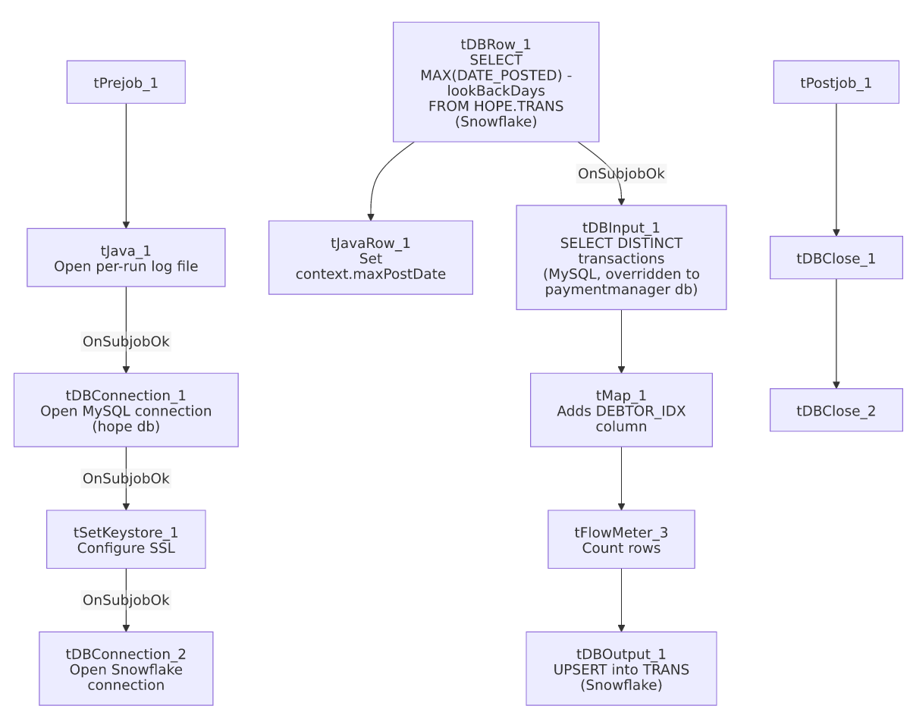

Settings tables

Look-back calculation: `tDBRow_1` (`tSnowflakeRow`)
Setting | Value | What it means
Query | SELECT CAST(DATEADD(D,-"+context.lookBackDays+",MAX(DATE_POSTED)) AS VARCHAR(10)) AS MAX_POST_DATE FROM HOPE.TRANS; | Rather than a hard incremental cutoff, this job re-pulls a rolling window: the max posted date minus context.lookBackDays, to catch late-arriving or updated transactions.

Source: `tDBInput_1` (`tMysqlInput`)
Setting | Value | What it means
CONNECTION | tDBConnection_1 (USE_EXISTING_CONNECTION=true) | Declares reuse of the shared MySQL connection to hope...
HOST / DBNAME (component's own) | "HH-MP-PMGR" / "paymentmanager" | ...but its own parameters point elsewhere — same pattern as HOPE_Notes_Load; see Issues observed.
Query | SELECT DISTINCT TransactionID, DatePosted, Debtor, Logon, CAST(TransCode AS DECIMAL(11,0)) AS TRANS_CODE, CommRate, CommAmt, CollInitials, PayAmt, ClientID, SplitPercentage, CAST(CreditMonth AS DECIMAL(2,0)) AS CREDIT_MONT... (truncated) | Does not visibly reference context.maxPostDate in the captured portion — unable to confirm the look-back filter is actually applied.

Target: `tDBOutput_1` (`tSnowflakeOutput`)
Setting | Value | What it means
Table | TRANS | Destination table in Snowflake, UPSERT — safer against duplication than plain insert if the look-back window re-reads already-loaded rows.

Dependencies & configuration
- Triggers/depends on other jobs: none — no tRunJob links found.
- Context variables used: keystorePath, logDir, maxPostDate (computed internally), and lookBackDays (referenced in the SQL but not listed in this job's own context_vars_referenced array — see Issues observed).
- 1 hardcoded path finding: tSetKeystore_1.SSL_TRUSTSERVER_TRUSTSTORE = "C:/clientTrustStore.trustStore".

Glossary
Component type | Plain-English meaning
tMysqlConnection / tMysqlInput / tMysqlClose | Open a MySQL connection, run a query against it, and close it.
tSnowflakeConnection / tSnowflakeRow / tSnowflakeOutput / tSnowflakeClose | Open a Snowflake connection, run an arbitrary SQL statement, write rows to a table, and close the connection.
tMap | Maps/transforms columns from one schema to another.
tFlowMeter | Counts rows passing a point in the flow for logging/monitoring.
tJavaRow | Runs custom Java code once per input row — here used to unpack a single query result into a context variable.
tSetKeystore | Configures SSL/TLS trust and client certificate settings used by subsequent secure connections in the job.

Issues observed
- `context.lookBackDays` is referenced directly in `tDBRow_1`'s SQL text but does not appear in this job's own `context_vars_referenced` metadata list — this is either an extraction gap (the variable-usage scanner may not have picked up references inside embedded SQL string concatenation) or a sign that lookBackDays is set as a job-level default not tracked the same way as other context references. Unable to determine its actual value or which context group defines it from this job's metadata alone; verify in Talend Studio.
- The `tDBRow_1` query text shows an unusual quoting pattern ("SELECT CAST(DATEADD(D,-"+context.lookBackDays+",MAX(DATE_POSTED))...) where the opening quote appears immediately before SELECT with no leading escape visible, unlike the cleanly-escaped concatenation seen in HOPE_Notes_Load's equivalent query. This may simply be an artifact of how this metadata extraction serialized the string-concatenation expression, not a real syntax error in the job itself — unable to confirm either way from static metadata; if this job's look-back query has ever failed at runtime with a syntax error, this is the first place to check.
- Same connection-parameter mismatch as `HOPE_Notes_Load`: tDBInput_1 declares USE_EXISTING_CONNECTION=true against tDBConnection_1 (host MP-HOPE-V01, db hope) but its own HOST/DBNAME are set to "HH-MP-PMGR" / "paymentmanager". Which database this job actually queries at runtime cannot be confirmed from static metadata — verify directly in Talend Studio.
- `tMap_1` adds a `DEBTOR_IDX` column not present in the source query's schema — same pattern seen in FactPaymentManager_Load; either derived via an internal lookup not captured here, or passed through blank. Verify the mapping expression directly.
- Do not confuse this job with `HOPE_Transactions_Load` — despite the similar name, that job is a one-time flat-file backfill (/mnt/analytics_team/Drop_zone/HOPE_detail_20220908_085732.csv) loading into a differently-named table (HOPE_TRANSACTION, truncate+insert, no incremental logic), while this job is the ongoing, incremental, MySQL-driven load into TRANS. See that job's own doc.

