Talend Job: HOPE_Transactions_Load

Overview
A one-time flat-file backfill of collector transaction records (transaction ID, date posted, transaction code, commission rate/amount, pay amount, collector initials, debtor number, client ID, split percentage, credit month/year) from a fixed, dated CSV file (/mnt/analytics_team/Drop_zone/HOPE_detail_20220908_085732.csv) into a Snowflake table HOPE_TRANSACTION. Despite the near-identical name, this job is structurally and functionally unrelated to the ongoing, recurring HOPE_SPTransactions_Load — see Issues observed for the full comparison.

Detail table
Field | Value
Job name | HOPE_Transactions_Load
Version | 0.1
Project | EDW2SF
Author | jmach@harriscollect.com
Created | 2022-09-12T11:24:51.689-0700
Last Modified | 2022-09-12T13:38:29.744-0700

Step-by-step data flow
Setup subjob: tPrejob_1 → tDBConnection_1 opens the Snowflake connection.
Main subjob: tFileInputDelimited_1 reads the fixed, dated CSV file /mnt/analytics_team/Drop_zone/HOPE_detail_20220908_085732.csv (comma-delimited, header row, TRIMALL=true, REMOVE_EMPTY_ROW=true, DIE_ON_ERROR=false), pulling RECORD_NUM, TRANSACTION_ID, DATE_POSTED, TRANS_CODE, COMM_RATE, COMM_AMT, PAY_AMT, COLL_INITIALS, DEBTOR_NUMBER, CLIENT_ID, SPLIT_PERCENTAGE, CREDIT_MONTH, CREDIT_YEAR → tMap_2 passes the columns through unchanged (DIE_ON_ERROR=true) → tFlowMeter_1 counts rows passing through → tDBOutput_1 writes to Snowflake table HOPE_TRANSACTION with outputAction=INSERT and `tableAction=TRUNCATE`.
Teardown subjob: tPostjob_1 → tDBClose_1 closes the Snowflake connection.
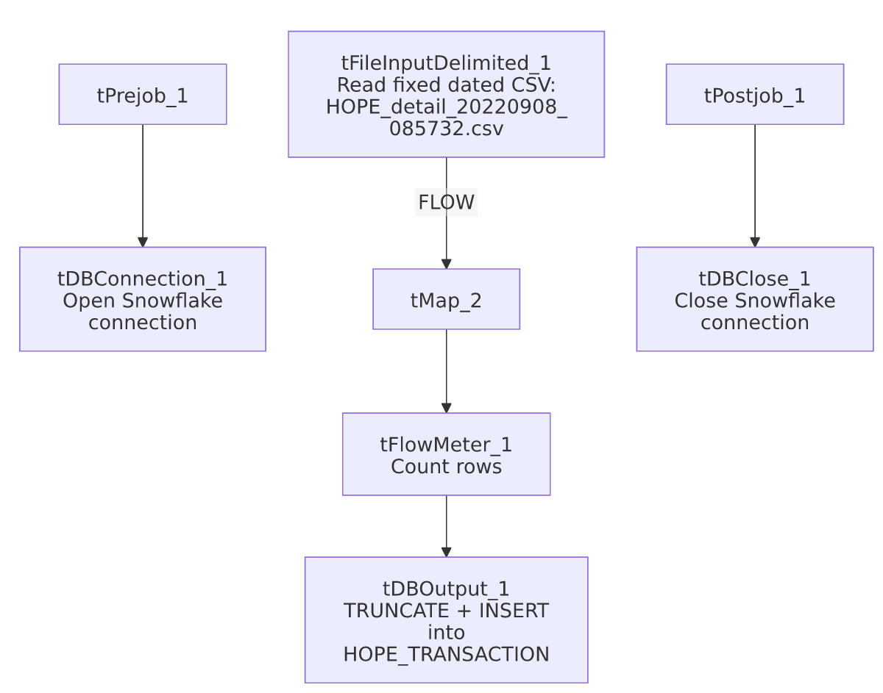

Settings tables

Source: `tFileInputDelimited_1`
Setting | Value | What it means
FILENAME | "/mnt/analytics_team/Drop_zone/HOPE_detail_20220908_085732.csv" (hardcoded, dated) | A fixed, one-time source file with a timestamp embedded in its own name — not driven by any context variable, file-listing loop, or date-parameterized pattern.
TEMP_DIR | "C:/Talend-Studio-20211109_1610-V8.0.1/workspace" (hardcoded) | Same project-wide developer-workstation path risk documented in 05_operational_runbook.md — notably a Windows path even though the source FILENAME itself uses a Linux-style /mnt/... path, suggesting this job was built/tested on Windows but intended to run against a Linux-mounted share.

Target: `tDBOutput_1` (`tSnowflakeOutput`)
Setting | Value | What it means
Table | HOPE_TRANSACTION | Destination table — note this is a different table name than HOPE_SPTransactions_Load's target (TRANS), despite both jobs loading HOPE transaction data.
Output action / Table action | INSERT / TRUNCATE | Table is cleared and reloaded from this single fixed file every run.

Dependencies & configuration
- Triggers/depends on other jobs: none — no tRunJob links found.
- Context variables used: none — this job uses no context variables at all, consistent with a one-off, hardcoded design.
- 1 hardcoded path finding: tFileInputDelimited_1.TEMP_DIR = "C:/Talend-Studio-20211109_1610-V8.0.1/workspace". The source file path itself is also hardcoded and dated but was not separately flagged in the extracted hardcoded_path_findings field.

Glossary
Component type | Plain-English meaning
tFileInputDelimited | Reads a delimited (CSV-style) text file according to a schema.
tMap | Maps/transforms columns from one schema to another (here, a straight pass-through).
tFlowMeter | Counts rows passing a point in the flow for logging/monitoring.
tSnowflakeConnection / tSnowflakeOutput / tSnowflakeClose | Open a Snowflake connection, write rows to a table, and close the connection.

Issues observed
- Do not confuse this job with `HOPE_SPTransactions_Load`. Despite both jobs loading "HOPE" collector transaction data with a very similar column set, they are structurally unrelated: this job is a one-time flat-file backfill (fixed, dated CSV, TRUNCATE+INSERT, no incremental logic, no MySQL connection at all) loading into HOPE_TRANSACTION, while HOPE_SPTransactions_Load is the ongoing, recurring, MySQL-driven incremental load into a differently-named table TRANS. The two jobs do not appear to feed each other and were not found to share a tRunJob link.
- `tableAction=TRUNCATE` against a single fixed, dated source file means this job is designed to be run exactly once (or, if re-run, will simply reload the identical historical file again, wiping out anything else that may have since been loaded into HOPE_TRANSACTION by another process). Given the September 2022 timestamp embedded in both the filename and this job's own creation date, this job has very likely already served its purpose — worth confirming with the team whether it should be retired or archived, especially since TRUNCATE makes it destructive if accidentally re-run against a table that other processes now also write to.
- The hardcoded `TEMP_DIR` uses a Windows path while `FILENAME` uses a Linux `/mnt/...` path — an inconsistency suggesting the job was developed in a Windows-based Talend Studio environment but its actual source file lives on a Linux-mounted network share. This mismatch is cosmetic for TEMP_DIR's purpose (temp file staging) but is a reminder that this job's paths are not portable across environments without manual adjustment, consistent with the project-wide hardcoded-path risk in 05_operational_runbook.md.

