Talend Job: HUB_Departments_Load

Overview
Loads the Departments reference table (department ID, name, active flag, minimum daily seat goal) from the legacy MSSQL "HUB" database (host CHI-SQL-V01, database Harris2a) into the Snowflake DEPARTMENTS table. This is one of six small, near-identical HUB_*_Load jobs that populate the workforce/organizational-hierarchy reference tables (departments, segments, teams, employees, transactions) referenced elsewhere in the project as the "HUB" mart — see 01_system_architecture.md, which lists the HUB MSSQL connection label as used by exactly 6 jobs.

Detail table
Field | Value
Job name | HUB_Departments_Load
Version | 0.1
Project | EDW2SF
Author | jmach@harriscollect.com
Created | 2022-03-08T14:15:32.048-0800
Last Modified | 2025-11-16T19:14:26.285-0800

Step-by-step data flow
Setup subjob: tPrejob_1 → tDBConnection_1 opens the MSSQL connection to CHI-SQL-V01/Harris2a (user svc_HUB, password redacted) → on success, tDBConnection_2 opens the Snowflake connection.
Main subjob:
- tDBInput_1 runs a fixed SELECT ID, Name, Active, MinimumDailySeatGoal FROM dbo.Departments against the MSSQL connection.
- tMap_1 passes the four columns through unchanged (renamed to uppercase: DEPARTMENTID, DEPARTMENTNAME, ACTIVE, MINIMUMDAILYSEATGOAL); DIE_ON_ERROR=true.
- tFlowMeter_1 counts rows passing through (labeled "MyLabel", not renamed for this job).
- tDBOutput_1 UPSERTs the rows into Snowflake table DEPARTMENTS (no table-recreate action).
Teardown subjob: tPostjob_1 → tDBClose_1 (close MSSQL) → tDBClose_2 (close Snowflake).
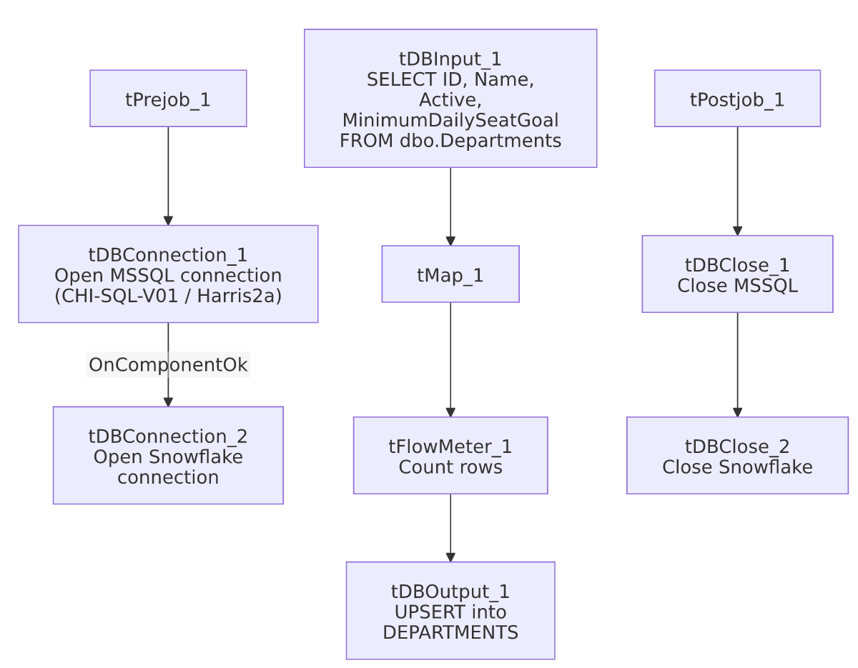

Settings tables

Source: `tDBInput_1` (`tMSSqlInput`)
Setting | Value | What it means
Connection | HUB (host CHI-SQL-V01, db Harris2a, user svc_HUB, password ***REDACTED***) | Legacy HR/timekeeping database — see 01_system_architecture.md's connection-label table.
Table / Query | Departments / SELECT dbo.Departments."ID", dbo.Departments.Name, dbo.Departments.Active, dbo.Departments.MinimumDailySeatGoal FROM dbo.Departments | Fixed, unfiltered read of the full source table — no incremental key or WHERE clause.
TRIM_ALL_COLUMN | false | Values are loaded as-is, without trimming whitespace.

Target: `tDBOutput_1` (`tSnowflakeOutput`)
Setting | Value | What it means
Table | DEPARTMENTS | Destination table in Snowflake.
Output action | UPSERT | Inserts new rows and updates existing ones by key — safe to rerun without truncating first, since UPSERT is idempotent for unchanged/updated rows.
Table action | NONE | Table is not recreated/altered by this job.

Dependencies & configuration
- Triggers/depends on other jobs: none — no tRunJob links found.
- Context variables used: none — every connection setting and the source query are hardcoded on the components rather than parameterized via context.*, unlike most other jobs in this project.
- Hardcoded paths: none found in this job's own components.

Glossary
Component type | Plain-English meaning
tMSSqlConnection / tMSSqlInput / tMSSqlClose | Open a Microsoft SQL Server connection, run a query against it, and close it.
tSnowflakeConnection / tSnowflakeOutput / tSnowflakeClose | Open a Snowflake connection, write rows to a table, and close the connection.
tMap | Maps/transforms columns from one schema to another.
tFlowMeter | Counts rows passing through a point in the flow, for logging/monitoring.

Issues observed
- No context variables at all — every connection detail (host, database, user) and the source query are hardcoded directly on the MSSQL connection and input components, rather than parameterized through a context group as is standard elsewhere in this project (e.g. EDWProdHH_0.1). This means changing environments (dev/test/prod) for this job would require editing the job itself rather than switching a context. The same pattern repeats across all six HUB_*_Load jobs in this batch, which is a project-wide inconsistency worth flagging (see 05_operational_runbook.md for other project-wide risk patterns), not unique to this job.
- No incremental logic, no error handling — the source query pulls the entire table every run with no tWarn/tDie on failure; a load failure here would only surface as a generic Talend execution error. Given UPSERT is used on the output side, this is low-risk (rerunning simply re-upserts the same data), consistent with 05_operational_runbook.md's general restart guidance.
- Beyond the above, this job has no notable anomalies of its own — it is a straightforward, small reference-table load.

