Talend Job: HUB_HH_Employee_Load

Overview
Loads the HH_Employees reference table (username, employee initials, department name, segment name, team name) from the legacy MSSQL "HUB" database (host CHI-SQL-V01, database Harris2a) into the Snowflake HH_EMPLOYEES table. Sibling of HUB_Departments_Load, HUB_Segments_Load, and HUB_Teams_Load; this one maps individual employees to their department/segment/team by name rather than by numeric ID, unlike the other three reference-table loads.

Detail table
Field | Value
Job name | HUB_HH_Employee_Load
Version | 0.1
Project | EDW2SF
Author | jmach@harriscollect.com
Created | 2022-03-07T14:41:51.649-0800
Last Modified | 2025-11-16T19:14:27.443-0800

Step-by-step data flow
Setup subjob: tPrejob_1 → tDBConnection_1 opens the MSSQL connection to CHI-SQL-V01/Harris2a (user svc_HUB) → on success, tDBConnection_2 opens the Snowflake connection.
Main subjob:
- tDBInput_1 runs a repository-schema-backed SELECT Username, EmpInitials, DeptName, SegmentName, TeamName FROM dbo.HH_Employees, with TRIM_ALL_COLUMN=true (unlike its HUB_Departments_Load/HUB_Segments_Load/HUB_Teams_Load siblings, which all use false).
- tMap_1 passes the five columns through, renamed to uppercase; DIE_ON_ERROR=true.
- tFlowMeter_2 counts rows passing through.
- tDBOutput_1 UPSERTs the rows into Snowflake table HH_EMPLOYEES.
Teardown subjob: tPostjob_1 → tDBClose_1 (close MSSQL) → tDBClose_2 (close Snowflake).
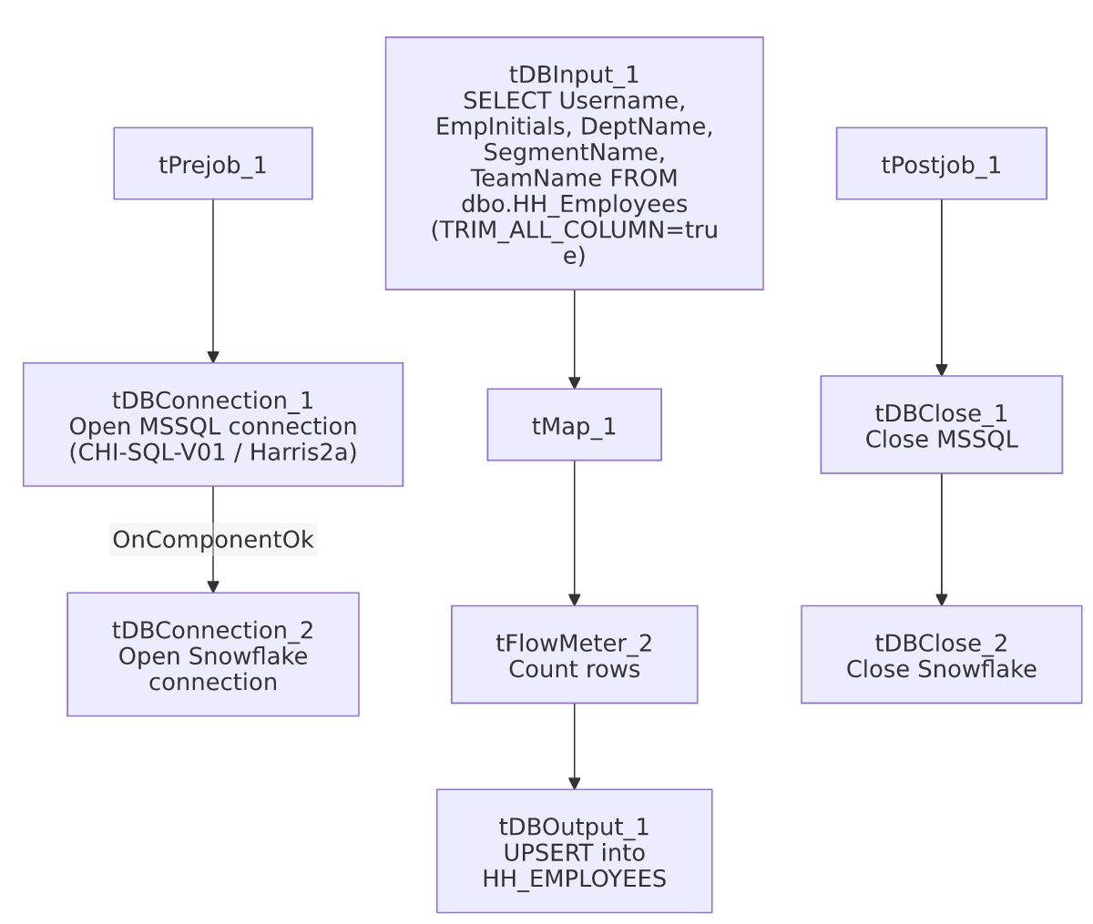

Settings tables

Source: `tDBInput_1` (`tMSSqlInput`)
Setting | Value | What it means
Connection | HUB (host CHI-SQL-V01, db Harris2a, user svc_HUB) | Same legacy HR/timekeeping database as the other HUB_*_Load jobs.
Table / Query | HH_Employees / SELECT dbo.HH_Employees.Username, dbo.HH_Employees.EmpInitials, dbo.HH_Employees.DeptName, dbo.HH_Employees.SegmentName, dbo.HH_Employees.TeamName FROM dbo.HH_Employees | Fixed, unfiltered read of the full source table.
Schema | Repository schema HH_Employees | Column layout is sourced from a shared repository schema, unlike the other HUB reference-load jobs which have no named repository schema on their input.
TRIM_ALL_COLUMN | true | Leading/trailing whitespace is stripped from every column value — the only one of the four small HUB reference loads in this batch that does this.

Target: `tDBOutput_1` (`tSnowflakeOutput`)
Setting | Value | What it means
Table | HH_EMPLOYEES | Destination table in Snowflake.
Output action | UPSERT | Idempotent — safe to rerun.
Table action | NONE | Table is not recreated/altered by this job.
Schema | Includes 8 extra columns (columnName, rowNumber, category, character, errorMessage, byteOffset, line, sqlState, code) beyond the 5 business columns | These are Talend's standard reject-row error-schema columns, but no reject flow is wired into this component — see Issues observed.

Dependencies & configuration
- Triggers/depends on other jobs: none — no tRunJob links found.
- Context variables used: none — same as the other three small HUB reference-table loads, all connection/query details are hardcoded on the components.
- Hardcoded paths: none found in this job's own components.

Glossary
Component type | Plain-English meaning
tMSSqlConnection / tMSSqlInput / tMSSqlClose | Open a Microsoft SQL Server connection, run a query against it, and close it.
tSnowflakeConnection / tSnowflakeOutput / tSnowflakeClose | Open a Snowflake connection, write rows to a table, and close the connection.
tMap | Maps/transforms columns from one schema to another.
tFlowMeter | Counts rows passing through a point in the flow, for logging/monitoring.

Issues observed
- `tDBOutput_1`'s schema carries 8 extra error/reject-style columns (columnName, rowNumber, category, character, errorMessage, byteOffset, line, sqlState, code) that don't appear anywhere upstream in tMap_1's or tFlowMeter_2's schema, and there is no reject flow connected to this component. This looks like a schema left over from copying/reconfiguring the component (possibly from a version that once had error handling wired up) rather than an active reject-row capture — it doesn't affect the job's actual behavior since the main FLOW connection only carries the 5 business columns, but it's worth cleaning up so the component's declared schema matches what it actually receives. The same pattern also appears in this batch's HUB_Teams_Load.
- No context variables at all, same project-wide pattern noted in HUB_Departments_Load's doc — see that doc's Issues section for the shared implication.
- `TRIM_ALL_COLUMN=true` here vs. `false` in the sibling HUB reference loads is a minor but real inconsistency: if source data in HH_Employees has incidental whitespace, this job's uppercase-mapped columns would be trimmed while Departments/Segments/Teams loads would not, which could affect exact-match joins against those tables downstream. Unable to determine from metadata whether this is intentional; verify with the team.

