Talend Job: HUB_Segments_Load

Overview
Loads the Segments reference table (segment ID, name, parent department ID, active flag) from the legacy MSSQL "HUB" database (host CHI-SQL-V01, database Harris2a) into the Snowflake SEGMENTS table. Sibling of HUB_Departments_Load; segments are the next level down in the organizational hierarchy, each tied to a DepartmentID.

Detail table
Field | Value
Job name | HUB_Segments_Load
Version | 0.1
Project | EDW2SF
Author | jmach@harriscollect.com
Created | 2022-03-07T16:21:31.495-0800
Last Modified | 2025-11-16T19:14:26.643-0800

Step-by-step data flow
Setup subjob: tPrejob_1 → tDBConnection_1 opens the MSSQL connection to CHI-SQL-V01/Harris2a (user svc_HUB) → on success, tDBConnection_2 opens the Snowflake connection.
Main subjob:
- tDBInput_1 runs a fixed SELECT ID, Name, DepartmentID, Active FROM dbo.Segments.
- tMap_1 passes the four columns through, renamed to uppercase (SEGMENTID, SEGMENTNAME, DEPARTMENTID, ACTIVE); DIE_ON_ERROR=true.
- tFlowMeter_1 counts rows passing through.
- tDBOutput_1 UPSERTs the rows into Snowflake table SEGMENTS.
Teardown subjob: tPostjob_1 → tDBClose_1 (close MSSQL) → tDBClose_2 (close Snowflake).
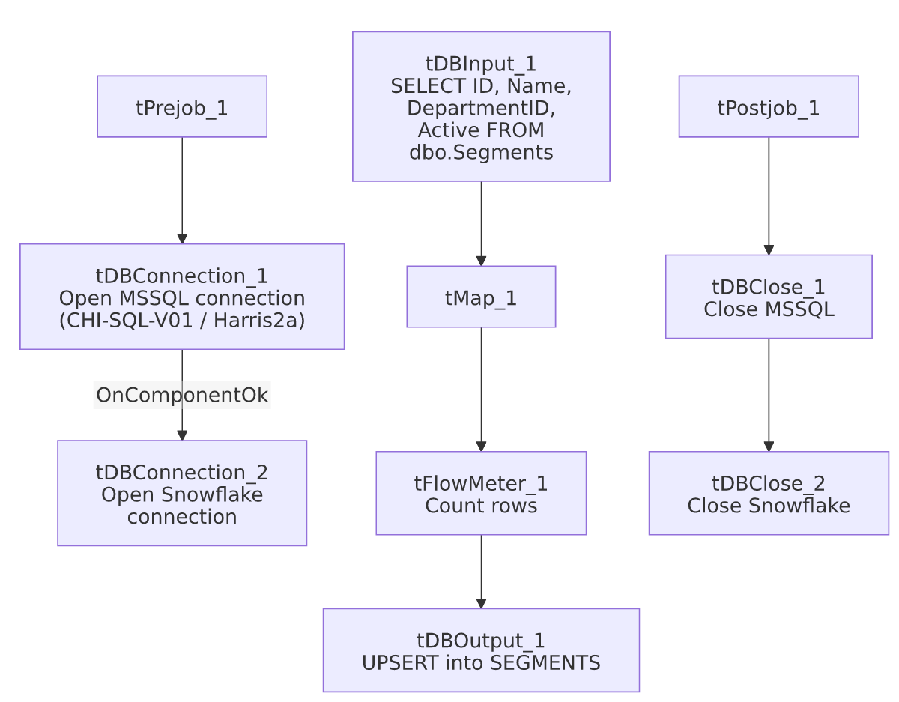

Settings tables

Source: `tDBInput_1` (`tMSSqlInput`)
Setting | Value | What it means
Connection | HUB (host CHI-SQL-V01, db Harris2a, user svc_HUB) | Same legacy HR/timekeeping database as the other HUB_*_Load jobs.
Table / Query | Segments / SELECT dbo.Segments."ID", dbo.Segments.Name, dbo.Segments.DepartmentID, dbo.Segments.Active FROM dbo.Segments | Fixed, unfiltered read of the full source table.
TRIM_ALL_COLUMN | false | Values are loaded as-is.

Target: `tDBOutput_1` (`tSnowflakeOutput`)
Setting | Value | What it means
Table | SEGMENTS | Destination table in Snowflake.
Output action | UPSERT | Idempotent — safe to rerun.
Table action | NONE | Table is not recreated/altered by this job.

Dependencies & configuration
- Triggers/depends on other jobs: none — no tRunJob links found.
- Context variables used: none — same pattern as the other three small HUB reference-table loads.
- Hardcoded paths: none found in this job's own components.

Glossary
Component type | Plain-English meaning
tMSSqlConnection / tMSSqlInput / tMSSqlClose | Open a Microsoft SQL Server connection, run a query against it, and close it.
tSnowflakeConnection / tSnowflakeOutput / tSnowflakeClose | Open a Snowflake connection, write rows to a table, and close the connection.
tMap | Maps/transforms columns from one schema to another.
tFlowMeter | Counts rows passing through a point in the flow, for logging/monitoring.

Issues observed
- No context variables at all, same project-wide pattern noted in HUB_Departments_Load's doc.
- `DepartmentID` is carried through with no validation against `HUB_Departments_Load`'s `DEPARTMENTS` table — if this job runs before or independently of HUB_Departments_Load, a segment could reference a department ID not yet present in Snowflake. Unable to determine from metadata whether these jobs are scheduled together or in a specific order; there is no tRunJob orchestration tying them together in this extraction.
- Beyond the above, this job has no notable anomalies of its own — it is a straightforward, small reference-table load, structurally identical to HUB_Departments_Load and HUB_Teams_Load.

