Talend Job: HUB_Teams_Load

Overview
Loads the Teams reference table (team ID, name, parent segment ID, active flag) from the legacy MSSQL "HUB" database (host CHI-SQL-V01, database Harris2a) into the Snowflake TEAMS table. Third level of the organizational hierarchy loaded by the HUB reference jobs (Department → Segment → Team), each team tied to a SegmentID.

Detail table
Field | Value
Job name | HUB_Teams_Load
Version | 0.1
Project | EDW2SF
Author | jmach@harriscollect.com
Created | 2022-03-07T15:45:43.957-0800
Last Modified | 2025-11-16T19:14:25.923-0800

Step-by-step data flow
Setup subjob: tPrejob_1 → tDBConnection_1 opens the MSSQL connection to CHI-SQL-V01/Harris2a (user svc_HUB) → on success, tDBConnection_2 opens the Snowflake connection.
Main subjob:
- tDBInput_1 runs a repository-schema-backed SELECT ID, Name, SegmentID, Active FROM dbo.Teams.
- tMap_1 passes the four columns through, renamed to uppercase (TEAMID, TEAMNAME, SEGMENTID, ACTIVE); DIE_ON_ERROR=true.
- tFlowMeter_1 counts rows passing through.
- tDBOutput_1 UPSERTs the rows into Snowflake table TEAMS.
Teardown subjob: tPostjob_1 → tDBClose_1 (close MSSQL) → tDBClose_2 (close Snowflake).
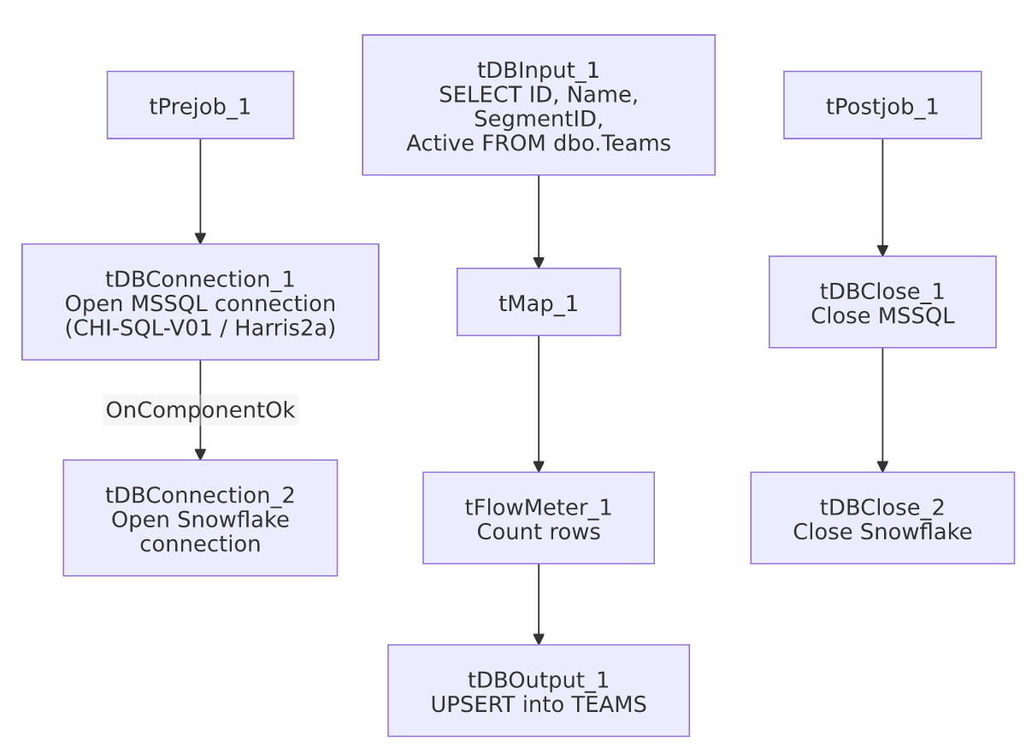

Settings tables

Source: `tDBInput_1` (`tMSSqlInput`)
Setting | Value | What it means
Connection | HUB (host CHI-SQL-V01, db Harris2a, user svc_HUB) | Same legacy HR/timekeeping database as the other HUB_*_Load jobs.
Table / Query | Teams / SELECT dbo.Teams."ID", dbo.Teams.Name, dbo.Teams.SegmentID, dbo.Teams.Active FROM dbo.Teams | Fixed, unfiltered read of the full source table.
Schema | Repository schema Teams | Column layout is sourced from a shared repository schema.
TRIM_ALL_COLUMN | false | Values are loaded as-is.

Target: `tDBOutput_1` (`tSnowflakeOutput`)
Setting | Value | What it means
Table | TEAMS | Destination table in Snowflake.
Output action | UPSERT | Idempotent — safe to rerun.
Table action | NONE | Table is not recreated/altered by this job.
Schema | Includes 8 extra columns (columnName, rowNumber, category, character, errorMessage, byteOffset, line, sqlState, code) beyond the 4 business columns | Standard Talend reject-row error-schema columns, but no reject flow is wired into this component — see Issues observed.

Dependencies & configuration
- Triggers/depends on other jobs: none — no tRunJob links found.
- Context variables used: none — same pattern as the other three small HUB reference-table loads.
- Hardcoded paths: none found in this job's own components.

Glossary
Component type | Plain-English meaning
tMSSqlConnection / tMSSqlInput / tMSSqlClose | Open a Microsoft SQL Server connection, run a query against it, and close it.
tSnowflakeConnection / tSnowflakeOutput / tSnowflakeClose | Open a Snowflake connection, write rows to a table, and close the connection.
tMap | Maps/transforms columns from one schema to another.
tFlowMeter | Counts rows passing through a point in the flow, for logging/monitoring.

Issues observed
- `tDBOutput_1`'s schema carries 8 extra error/reject-style columns not present in the upstream flow and not backed by any wired reject connection — the same artifact documented in HUB_HH_Employee_Load's doc. Cosmetic/schema-drift only; doesn't affect this job's behavior since the main FLOW connection carries only the 4 business columns.
- No context variables at all, same project-wide pattern noted in HUB_Departments_Load's doc.
- `SegmentID` is carried through with no validation against `HUB_Segments_Load`'s `SEGMENTS` table, mirroring the same cross-job ordering concern noted in HUB_Segments_Load's own doc regarding DepartmentID. No tRunJob orchestration ties these HUB reference loads together in this extraction, so the actual run order (if any) is unable to determine from metadata.

