Talend Job: HUB_TempTransaction_Load

Overview
Loads the TransactionTemp table (a staging/temp transaction table — user, team, client, debtor identifiers, amount, transaction/post dates, payment type) from the legacy MSSQL "HUB" database (host CHI-SQL-V01, database Harris2a) into the Snowflake TRANSACTIONTEMP table. Unlike the four small HUB reference loads (Departments/Segments/Teams/HH_Employees), this job first computes the highest ID already loaded into Snowflake before reading the MSSQL source, suggesting an intended incremental-load design.

Detail table
Field | Value
Job name | HUB_TempTransaction_Load
Version | 0.1
Project | EDW2SF
Author | jmach@harriscollect.com
Created | 2022-03-08T14:49:28.155-0800
Last Modified | 2025-11-16T19:15:29.339-0800

Step-by-step data flow
Setup subjob: tPrejob_1 → tDBConnection_1 opens the MSSQL connection (CHI-SQL-V01/Harris2a, user svc_HUB) → on subjob-ok, tSetKeystore_1 configures SSL trust/keystore (truststore path hardcoded, keystore path from context.keystorePath, passwords redacted) → on subjob-ok, tDBConnection_2 opens the Snowflake connection.
Main subjob — runs independently of the setup subjob:
- tDBInput_2 (Snowflake) runs SELECT CAST(COALESCE(MAX(ID),0) AS VARCHAR(10)) AS MAX_ID FROM TransactionTemp; to find the highest ID already loaded.
- tJavaRow_1 captures that value into context.maxID.
- On success, tDBInput_1 (MSSQL) runs a SELECT of ~18 columns from dbo.TransactionTemp (user/team/client/debtor identifiers, amount, transaction/post/added/modified/delete dates, payment type) — the captured query text is truncated in this metadata after the first several columns, so whether it actually filters on context.maxID cannot be confirmed (see Issues observed).
- tMap_1 passes the columns through, renamed to uppercase; DIE_ON_ERROR=true.
- tFlowMeter_1 counts rows passing through.
- tDBOutput_1 UPSERTs the rows into Snowflake table TRANSACTIONTEMP.
Teardown subjob: tPostjob_1 → tDBClose_1 (close MSSQL) → tDBClose_2 (close Snowflake).
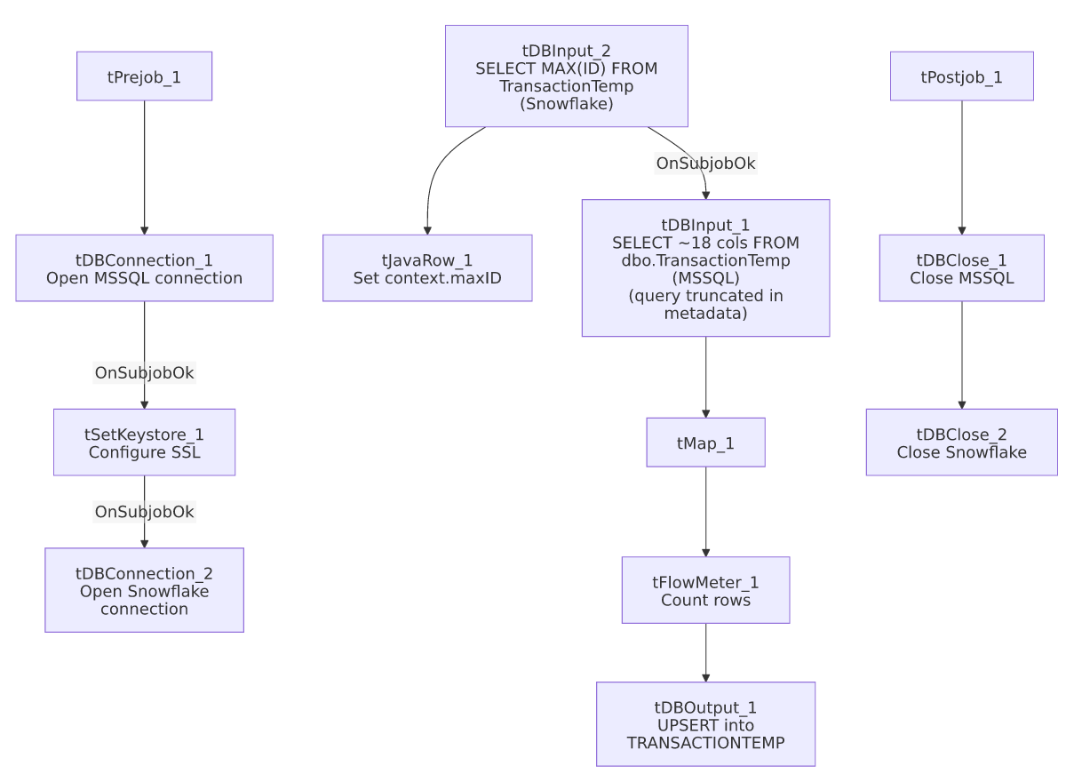

Settings tables

Incremental-key check: `tDBInput_2` (`tSnowflakeInput`)
Setting | Value | What it means
Query | SELECT CAST(COALESCE(MAX(ID),0) AS VARCHAR(10)) AS MAX_ID FROM TransactionTemp; | Finds the highest ID already loaded into the Snowflake TRANSACTIONTEMP table, defaulting to 0 if the table is empty.
Result handling | MAX_ID → context.maxID (tJavaRow_1) | Stored for (intended) use filtering the MSSQL source read.

Source: `tDBInput_1` (`tMSSqlInput`)
Setting | Value | What it means
Connection | HUB (host CHI-SQL-V01, db Harris2a, user svc_HUB) | Same legacy HR/timekeeping database as the other HUB_* jobs.
Table / Query | TransactionTemp / SELECT dbo.TransactionTemp."ID", ... (truncated in this metadata) | Whether the query's WHERE clause actually references context.maxID is not visible in the captured text — see Issues observed.

Target: `tDBOutput_1` (`tSnowflakeOutput`)
Setting | Value | What it means
Table | TRANSACTIONTEMP | Destination table in Snowflake.
Output action | UPSERT | Idempotent — even if the source read is not actually filtered by context.maxID, re-reading and re-upserting the whole source table would not create duplicates (unlike a plain INSERT).
Table action | NONE | Table is not recreated/altered by this job.
Schema | Includes 8 extra reject-style error columns (columnName, rowNumber, category, character, errorMessage, byteOffset, line, sqlState, code) with no wired reject flow | Same schema-drift artifact seen in HUB_HH_Employee_Load and HUB_Teams_Load.

SSL setup: `tSetKeystore_1`
Setting | Value | What it means
SSL_TRUSTSERVER_TRUSTSTORE | "C:/clientTrustStore.trustStore" (hardcoded) | A developer-workstation-style hardcoded path — see Issues observed.
SSL_KEYSTORE | context.keystorePath | Parameterized via context, unlike the truststore path above.

Dependencies & configuration
- Triggers/depends on other jobs: none — no tRunJob links found.
- Context variables used: keystorePath, maxID (set internally from the Snowflake max-key query).
- 1 hardcoded path finding: tSetKeystore_1.SSL_TRUSTSERVER_TRUSTSTORE = "C:/clientTrustStore.trustStore".

Glossary
Component type | Plain-English meaning
tMSSqlConnection / tMSSqlInput / tMSSqlClose | Open a Microsoft SQL Server connection, run a query against it, and close it.
tSnowflakeConnection / tSnowflakeInput / tSnowflakeOutput / tSnowflakeClose | Open a Snowflake connection, query it, write rows to a table, and close the connection.
tJavaRow | Runs custom Java code once per input row — here used to unpack a single query result into a context variable.
tSetKeystore | Configures SSL trust/keystore settings used by subsequent database connections in the job.
tMap | Maps/transforms columns from one schema to another.
tFlowMeter | Counts rows passing through a point in the flow, for logging/monitoring.

Issues observed
- Whether the incremental-load logic is actually applied is unable to determine from this metadata — the same pattern flagged in i3_CallDetail_40_Load's doc. context.maxID is computed before the MSSQL read, but the captured tDBInput_1.QUERY text is truncated after the column list and does not show a WHERE ID > ... clause in the visible portion. Unlike i3_CallDetail_40_Load, however, this job's output action is UPSERT rather than INSERT, so even an unfiltered full-table re-read would not accumulate duplicate rows — it would just mean the max-key computation and the context.maxID variable are unused overhead rather than an active correctness risk. Verify directly in Talend Studio.
- `SSL_TRUSTSERVER_TRUSTSTORE` is a hardcoded local path (C:/clientTrustStore.trustStore) rather than parameterized via context, while the keystore path on the same component does use context.keystorePath — an inconsistency within the same component. Same project-wide hardcoded-path risk documented in 05_operational_runbook.md.
- `tDBOutput_1`'s schema carries unused reject-style error columns, the same schema-drift artifact seen in other HUB jobs in this batch — cosmetic only.
- This job's sibling `HUB_Transactions_Load` (see its own doc) targets a similarly-named but different table (`Transactions`/`TRANSACTIONS`) using the same max-key pattern but with `INSERT` instead of `UPSERT` — worth checking with the team whether HUB_TempTransaction_Load was created as a safer replacement for (or complement to) HUB_Transactions_Load, since HUB_Transactions_Load was last modified in 2022 while this job and the other HUB loads were all touched again in November 2025.

