Talend Job: HUB_Transactions_Load

Overview
Loads the Transactions table (user, team, client, debtor identifiers, transaction type, amount, transaction/post/added/modified/delete dates, payment type — no ClientInitials/PostDateNum columns, unlike its TransactionTemp counterpart) from the legacy MSSQL "HUB" database (host CHI-SQL-V01, database Harris2a) into the Snowflake TRANSACTIONS table using a bulk-load output component. Structurally the same incremental-check pattern as HUB_TempTransaction_Load, but targets a different table and uses a plain INSERT rather than UPSERT, which changes the risk profile if the incremental filter isn't actually applied (see Issues observed).

Detail table
Field | Value
Job name | HUB_Transactions_Load
Version | 0.1
Project | EDW2SF
Author | jmach@harriscollect.com
Created | 2022-03-08T09:32:10.218-0800
Last Modified | 2022-05-24T09:48:49.796-0700

Step-by-step data flow
Setup subjob: tPrejob_1 → tDBConnection_1 opens the MSSQL connection (CHI-SQL-V01/Harris2a, user svc_HUB) → on success, tDBConnection_2 opens the Snowflake connection.
Main subjob — runs independently of the setup subjob:
- tDBInput_1 (Snowflake) runs SELECT CAST(COALESCE(MAX(TransactionID),0) AS VARCHAR(10)) AS MAX_ID FROM Transactions; to find the highest TransactionID already loaded.
- tJavaRow_1 captures that value into context.maxTxID.
- On success, tDBInput_2 (MSSQL) runs a SELECT of ~15 columns from dbo.Transactions — the captured query text is truncated after the initial columns, so whether it filters on context.maxTxID cannot be confirmed (same uncertainty as HUB_TempTransaction_Load and i3_CallDetail_40_Load).
- tMap_1 passes the columns through, renamed to uppercase; DIE_ON_ERROR=true.
- tFlowMeter_2 counts rows passing through.
- tDBOutputBulkExec_1 inserts the rows into Snowflake table TRANSACTIONS using a bulk-load mechanism (INSERT, no table-recreate action).
Teardown subjob: tPostjob_1 → tDBClose_1 (close MSSQL) → tDBClose_2 (close Snowflake).
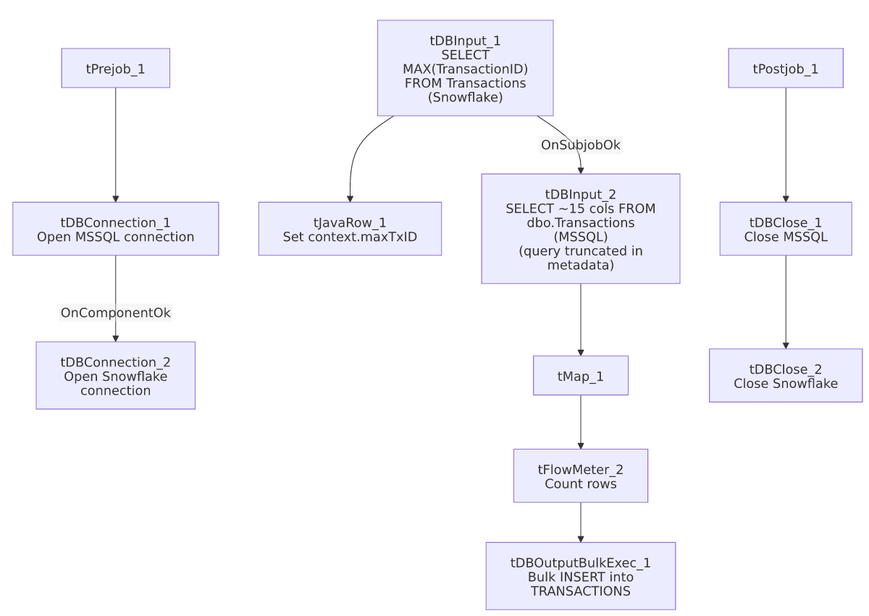

Settings tables

Incremental-key check: `tDBInput_1` (`tSnowflakeInput`)
Setting | Value | What it means
Query | SELECT CAST(COALESCE(MAX(TransactionID),0) AS VARCHAR(10)) AS MAX_ID FROM Transactions; | Finds the highest TransactionID already loaded, defaulting to 0 if empty.
Result handling | MAX_ID → context.maxTxID (tJavaRow_1) | Stored for (intended) use filtering the MSSQL source read.

Source: `tDBInput_2` (`tMSSqlInput`)
Setting | Value | What it means
Connection | HUB (host CHI-SQL-V01, db Harris2a, user svc_HUB) | Same legacy HR/timekeeping database as the other HUB_* jobs.
Table / Query | Transactions / SELECT dbo.Transactions."ID", dbo.Transactions.UserName, dbo.Transactions.CubsInitials, ... (truncated in this metadata) | Whether the query's WHERE clause actually references context.maxTxID is not visible in the captured text — see Issues observed.

Target: `tDBOutputBulkExec_1` (`tSnowflakeOutputBulkExec`)
Setting | Value | What it means
Table | TRANSACTIONS | Destination table in Snowflake.
Output action | INSERT | Not UPSERT — appends rows. There is no TRUNCATE step before this insert.
Table action | NONE | Table is not recreated/altered by this job.

Dependencies & configuration
- Triggers/depends on other jobs: none — no tRunJob links found.
- Context variables used: maxTxID (set internally from the Snowflake max-key query).
- Hardcoded paths: none found in this job's own components.

Glossary
Component type | Plain-English meaning
tMSSqlConnection / tMSSqlInput / tMSSqlClose | Open a Microsoft SQL Server connection, run a query against it, and close it.
tSnowflakeConnection / tSnowflakeInput / tSnowflakeClose | Open a Snowflake connection, query it, and close the connection.
tSnowflakeOutputBulkExec | Writes rows to a Snowflake table via a bulk-load mechanism (typically staging a file then a COPY INTO), generally faster than row-by-row insert for large volumes.
tJavaRow | Runs custom Java code once per input row — here used to unpack a single query result into a context variable.
tMap | Maps/transforms columns from one schema to another.
tFlowMeter | Counts rows passing through a point in the flow, for logging/monitoring.

Issues observed
- If the source query is not actually filtered by `context.maxTxID`, this job would duplicate every previously-loaded row on each run. Unlike HUB_TempTransaction_Load/i3_CallDetail_40_Load (which mask the same uncertainty with an UPSERT output action), this job uses a plain INSERT with no TRUNCATE beforehand — so if the intended incremental filter isn't actually wired into the truncated query text, every run would re-insert the entire Transactions table on top of what's already in Snowflake, growing TRANSACTIONS unboundedly. This is a materially higher-risk version of the same unconfirmed pattern seen elsewhere in this project; verify the query's WHERE clause directly in Talend Studio before assuming this job is safe to run repeatedly.
- Not modified since 2022-05-24, while its apparent successor/sibling HUB_TempTransaction_Load (and the four other HUB reference loads) were all touched again in November 2025. This may indicate HUB_Transactions_Load has been superseded by HUB_TempTransaction_Load and is no longer actively scheduled — unable to determine from metadata; verify with the team before assuming this job is still in production use, especially given the duplicate-row risk above.
- No error/row-count logging specific to this job's business outcome (no tWarn/tDie/tSendMail) — a load failure or an unexpectedly large insert would only surface as a generic Talend execution error or an unusually long run, with no job-specific alert.

