Talend Job: HealthPartners_Close_Reports_Extract

Overview
Extracts a HealthPartners "close" cohort report (debtor/account close-report fields: location, client, name, CDN, account, assignment date/PN, status code, cancelled amount/date, total balance, principal collected, last payment date, status-change date) from the Snowflake REPORT_COHORT_HEALTHPARTNERS_CLOSE view/table and writes it to a monthly CSV file. This job is never run directly on a schedule by itself — it is called 12 times by HealthPartners_Close_Rpt_Master (see that job's doc), almost certainly once per location/context variant, though the specific per-call differences aren't visible in this job's own metadata.

Detail table
Field | Value
Job name | HealthPartners_Close_Reports_Extract
Version | 0.1
Project | EDW2SF
Author | jmach@harriscollect.com
Created | 2024-01-07T20:50:35.134-0800
Last Modified | 2025-09-24T10:46:40.310-0700

Step-by-step data flow
Setup subjob: tPrejob_1 → tJava_1 opens a per-run log file at context.logDir + jobName + "_" + <timestamp> + ".log" and redirects System.out/System.err to it → on subjob-ok, tDBConnection_1 opens the Snowflake connection.
Main subjob — runs independently of the setup subjob:
- tDBInput_1 queries the REPORT_COHORT_HEALTHPARTNERS_CLOSE table; the actual QUERY parameter is set to context.locationFilter rather than a literal SQL string — i.e. the filtering SQL text itself is supplied entirely by a context variable (see Issues observed).
- tFlowMeter_1 counts rows passing through (labeled "MyLabel").
- tFileOutputDelimited_1 writes the 14 columns to a comma-delimited CSV at context.outputDir + <CCYY-MM> + "/" + context.rptFile + <CCYYMM> + ".csv" (no header row, INCLUDEHEADER=false).
Teardown subjob: tPostjob_1 → tDBClose_1 (close Snowflake).
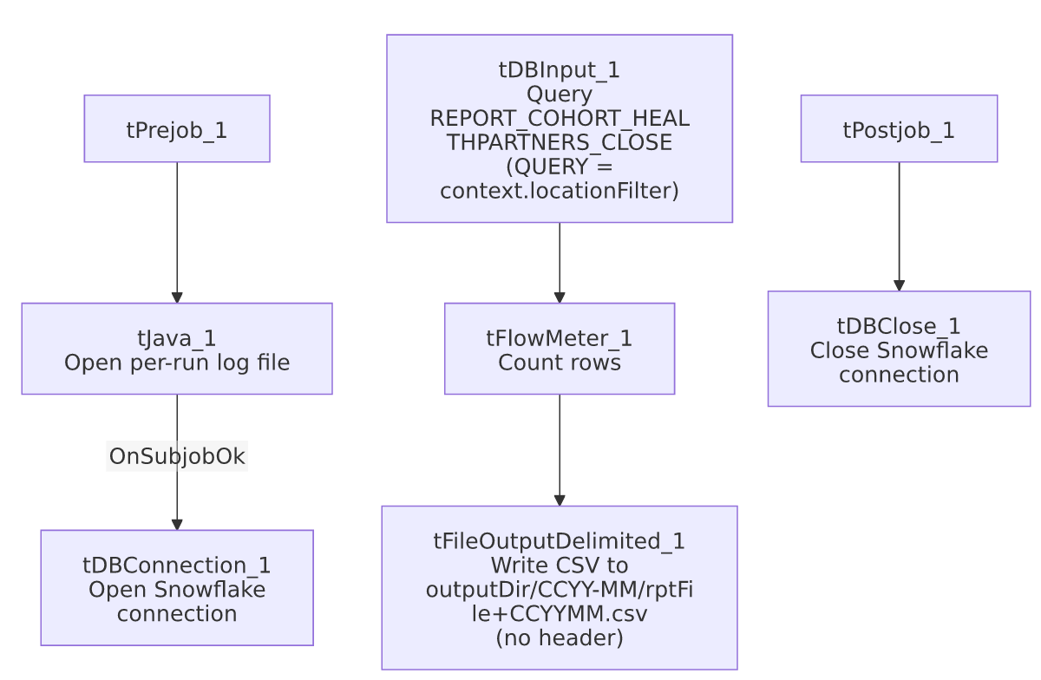

Settings tables

Source: `tDBInput_1` (`tSnowflakeInput`)
Setting | Value | What it means
Table | REPORT_COHORT_HEALTHPARTNERS_CLOSE | Named as the table, but the actual query text executed is...
Query | context.locationFilter | ...entirely supplied by a context variable rather than a literal query in this component — meaning the real SQL run each time (including any WHERE/location filter) is not visible in this job's own metadata at all. See Issues observed.
Columns | LOCATION, CLIENT, NAME, CDN, ACCOUNT, DT_ASSIGN, PN_ASSIGN, ST_CD, CANCELLED_AMT, CANCELLED_DATE, TOT_BAL, PRIN_COL, LST_PAY, DATE_SC_CHANGED | Close-report cohort fields — location/client/account identifiers, assignment and cancellation info, balances, and last-activity dates.

Target: `tFileOutputDelimited_1`
Setting | Value | What it means
FILENAME | context.outputDir + TalendDate.getDate("CCYY-MM") + "/" + context.rptFile + TalendDate.getDate("CCYYMM") + ".csv" | Writes into a year-month subfolder, with the report filename also carrying the year-month — parameterized entirely via context, no hardcoded path.
FIELDSEPARATOR | , | Comma-delimited.
INCLUDEHEADER | false | No header row in the output file.

Dependencies & configuration
- Triggers/depends on other jobs: none of its own — but is itself called 12 times by HealthPartners_Close_Rpt_Master (see 06_dependency_matrix.md's "Jobs → jobs" table, which lists this exact 12x call count).
- Context variables used: logDir, outputDir, rptFile. Additionally, the query itself is driven by context.locationFilter, which is referenced inside the tDBInput_1.QUERY parameter's string value but not separately listed in context_vars_referenced in this job's extracted metadata (it is present as literal parameter text, not a parsed context reference) — see Issues observed.
- Hardcoded paths: none found in this job's own components.

Glossary
Component type | Plain-English meaning
tSnowflakeConnection / tSnowflakeInput / tSnowflakeClose | Open a Snowflake connection, query it, and close the connection.
tFlowMeter | Counts rows passing through a point in the flow, for logging/monitoring.
tFileOutputDelimited | Writes rows to a delimited (CSV-style) text file.

Issues observed
- The actual query executed by `tDBInput_1` is entirely opaque in this metadata — its QUERY parameter is literally the string context.locationFilter, meaning the real SQL (including whatever location/cohort filter differentiates each of the 12 calls from HealthPartners_Close_Rpt_Master) lives in a context variable value not captured in this job's own JSON or in _shared_context.json. This is the mechanism that presumably makes each of the 12 tRunJob calls extract a different location's data, but the specific filter values, and therefore what makes each of the 12 runs distinct, is unable to determine from metadata — verify directly in Talend Studio's context configuration for this job (likely a per-call context override on each tRunJob_* component in the master job).
- No error handling specific to this job's business outcome — no tWarn/tDie/tSendMail if the query returns zero rows or fails; a problem would only surface as a generic Talend execution error, and given it's called 12 times per run of the master job, a failure in one call could be hard to distinguish from the others without checking per-call logs.
- No archiving of the source data or the previous month's output file — each run simply (re)writes to a year-month-stamped path, so accidental overwrites are only prevented by the filename changing month to month, not by any explicit archive step.

