Talend Job: HealthPartners_Close_Rpt_Master

Overview
This is a pure orchestrator job — like CO_Master_Load, it moves no data itself. Its only job is to call HealthPartners_Close_Reports_Extract 12 separate times, arranged as 4 parallel branches of 3 sequential calls each, almost certainly once per HealthPartners location/report variant per call (the CSV-writing job it calls is filtered entirely by a context.locationFilter value not visible in this job's own metadata — see HealthPartners_Close_Reports_Extract's doc). This matches the 06_dependency_matrix.md finding that this job calls the same target job 12 times.

Detail table
Field | Value
Job name | HealthPartners_Close_Rpt_Master
Version | 0.1
Project | EDW2SF
Author | jmach@harriscollect.com
Created | 2024-01-09T09:56:14.506-0800
Last Modified | 2025-08-28T08:57:17.268-0700

Step-by-step data flow
tParallelize_1 starts 4 parallel branches, each a chain of 3 sequential tRunJob calls (all 12 targeting HealthPartners_Close_Reports_Extract with CONTEXT_NAME=Default, DIE_ON_CHILD_ERROR=true, TRANSMIT_ORIGINAL_CONTEXT=true):
- Branch 1: tRunJob_1 → tRunJob_5 → tRunJob_9
- Branch 2: tRunJob_2 → tRunJob_6 → tRunJob_10
- Branch 3: tRunJob_3 → tRunJob_7 → tRunJob_11
- Branch 4: tRunJob_4 → tRunJob_13 → tRunJob_12
Each step in each chain only proceeds to the next after the previous call succeeds (OnSubjobOk). All 12 tRunJob components share identical configuration in this metadata — none carries a visibly different context override, so what actually differentiates each of the 12 calls (presumably a different locationFilter/rptFile value per call) is not captured here.
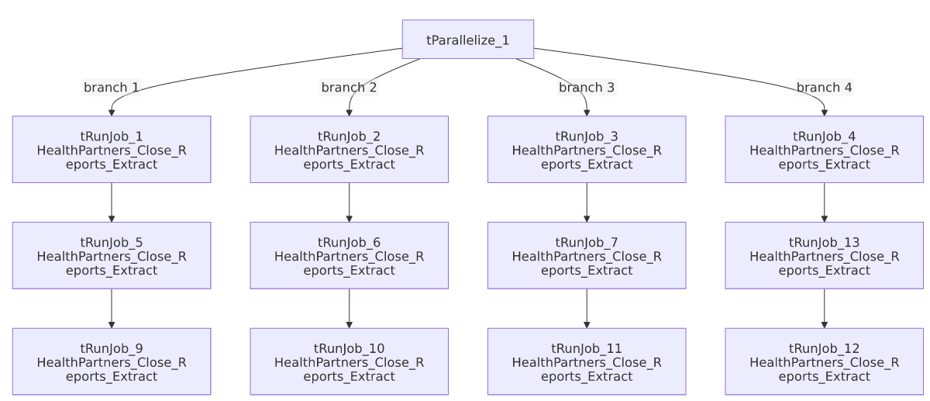

Settings tables

Orchestration: `tRunJob_*` components (all 12 share identical settings in this metadata)
Setting | Value | What it means
PROCESS | HealthPartners_Close_Reports_Extract | Every one of the 12 calls targets the exact same job.
CONTEXT_NAME | Default | No per-call named context group is visibly selected — if the 12 calls differ, that difference is set some other way (e.g. a per-tRunJob context parameter override not captured by this extraction).
DIE_ON_CHILD_ERROR | true (all 12) | If any called extract fails, the branch (and ultimately this master job) fails.
USE_INDEPENDENT_PROCESS | false (all 12) | Every call runs inside this master job's own JVM rather than as a separate process — unlike CO_Master_Load, where only one of ten calls behaves this way.
TRANSMIT_ORIGINAL_CONTEXT | true (all 12) | Each call receives the parent job's context values.

Dependencies & configuration
- This job calls `HealthPartners_Close_Reports_Extract` 12 times via tRunJob, confirmed against 06_dependency_matrix.md's "Jobs → jobs" table.
- Context variables used: none referenced directly in this job's own components (context_vars_referenced is empty) — all configuration lives in the called job.
- Hardcoded paths: none found in this job's own components.

Glossary
Component type | Plain-English meaning
tRunJob | Runs another Talend job as a sub-process (or, since USE_INDEPENDENT_PROCESS=false here, inline in the same JVM), optionally waiting for it to finish before continuing.
tParallelize | Runs its downstream branches at the same time instead of one after another — here, 4 branches of 3-deep sequential chains run concurrently.

Issues observed
- All 12 `tRunJob` components have identical visible configuration — same PROCESS, same CONTEXT_NAME=Default, no distinguishing parameter captured in this metadata. Per 06_dependency_matrix.md's note, confirming exactly what differs per call (almost certainly a location or report-variant context value set via a mechanism this extraction doesn't surface, such as a per-component context override) requires opening each tRunJob component individually in Talend Studio. Until that's done, it is unable to determine from metadata whether all 12 calls actually produce 12 different output files, or whether some are unintentional duplicates.
- `USE_INDEPENDENT_PROCESS=false` on all 12 calls means every one of the 12 extract runs shares this master job's JVM — unlike CO_Master_Load, which runs 9 of its 10 sub-jobs as independent processes. Running 12 sequential-chain-of-3 extracts in-process could mean a memory leak or unhandled exception in one extract affects the others sharing the JVM; this is a project-wide design choice specific to this job, not something flagged elsewhere.
- If any of the 12 branches' first call fails, `DIE_ON_CHILD_ERROR=true` fails that whole branch's remaining 2 calls (and ultimately this master job), but the branch structure means diagnosing which of the 12 individual calls broke requires checking each sub-job's own log — the same orchestrator-diagnosis difficulty documented for CO_Master_Load in 05_operational_runbook.md.

