Talend Job: I3_CALLDETAIL_DEDOR_LOAD

Overview
Builds a consolidated call-detail record for the "DE DOR" (Delaware Department of Revenue, inferred from the campaignname like '%DE DOR%' filter and job-name prefix "DEDOR" seen elsewhere in this project, e.g. the DEDOR_DW_0.1 context group) campaign by joining five Snowflake tables/views (i3_calldetail_viw, i3_InteractionWrapup, i3_CallHistory, i3_TS_CRC, i3_InteractionCustomAttributes, plus a lookup table I3_DIALERCALLLIST_DEDOR) entirely inside Snowflake, then writes the merged result into the I3_CALLDETAIL_40 table and runs a COPY_INTO_DEDOR_CALL_DETAIL() stored procedure afterward. Unlike most jobs in this project, there is no file or MSSQL source at all — everything happens against Snowflake.

Detail table
Field | Value
Job name | I3_CALLDETAIL_DEDOR_LOAD
Version | 0.1
Project | EDW2SF
Author | jmach@harriscollect.com
Created | 2023-09-14T11:17:19.192-0700
Last Modified | 2025-09-24T11:06:27.303-0700

Step-by-step data flow
Setup subjob: tPrejob_1 → tDBConnection_1 opens a Snowflake connection → on subjob-ok, tDBConnection_2 opens a second Snowflake connection.
Main subjob — runs independently of the setup subjob:
- tDBRow_1 runs CALL COPY_INTO_DEDOR_CALL_DETAIL(); — a stored procedure called *before* the main read/write flow, on the errorCode/errorMessage schema (result not captured into a context variable or branched on).
- On subjob-ok, tDBInput_1 runs a large multi-table Snowflake SELECT (distinct rows) joining i3_calldetail_viw (cd), i3_InteractionWrapup (w), i3_CallHistory (h), i3_TS_CRC (cr), i3_InteractionCustomAttributes (ca), and I3_DIALERCALLLIST_DEDOR (dcl) — deriving ~39 output columns including campaign, site, agent/debtor/client identifiers, call timing fields (adjusted by h.odsoffset), wrap-up code (built from a multi-branch CASE expression), call duration/hold/line-duration metrics, RPC/P2P flags, and a MessageType derived from wrap-up category. The query filters to LEN(RemoteNumber)>5, PurposeCode not in ('4'), and campaignname like '%DE DOR%'.
- tMap_1 passes the ~39 columns through to a same-shaped uppercase target schema.
- tDBOutput_1 UPSERTs the rows into Snowflake table I3_CALLDETAIL_40.
Teardown subjob: tPostjob_1 → tDBClose_1 → on subjob-ok, tDBClose_2.
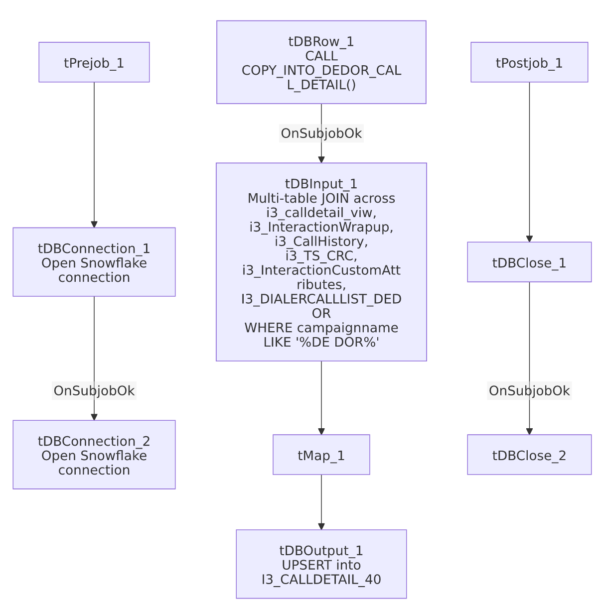

Settings tables

Pre-step: `tDBRow_1` (`tSnowflakeRow`)
Setting | Value | What it means
Query | CALL COPY_INTO_DEDOR_CALL_DETAIL(); | Calls a stored procedure (not shown in this metadata) before the main read — presumably stages/refreshes some source data the join below depends on. Its result is not checked or branched on.

Source: `tDBInput_1` (`tSnowflakeInput`)
Setting | Value | What it means
Table (label) | DEDOR_CALL_DETAIL | The component's declared table name, though the actual db.query is a full hand-written multi-table join, not a simple table read.
Joins | i3_calldetail_viw LEFT JOIN i3_InteractionWrapup, i3_CallHistory, i3_TS_CRC, i3_InteractionCustomAttributes; LEFT JOIN I3_DIALERCALLLIST_DEDOR on I3_IDENTITY | Merges call-detail, wrap-up, call-history, and dialer-list-lookup data into one row per call.
Filter | LEN(RemoteNumber)>5 AND PurposeCode not in ('4') AND h.campaignname like '%DE DOR%' | Restricts to calls with a plausible phone number, excludes purpose code 4, and scopes to the DE DOR campaign specifically.
Key derived fields | wrapupcode (multi-branch CASE prioritizing w.WrapUpCode then h.WrapUpCode), agentid (COALESCE(dcl.HH_AGENTID, cd.LocalUserId, h.agentid, cd.LocalUserId)), DebtorNumber (COALESCE(dcl.case_id, cd.CustomString1, '')), combinedID (concatenation used as a dedup/join key) | Business logic embedded directly in SQL rather than in a Talend tMap expression — see Issues observed.

Target: `tDBOutput_1` (`tSnowflakeOutput`)
Setting | Value | What it means
Table | I3_CALLDETAIL_40 | Destination table — same target table name used by the (separate, non-DEDOR-specific) i3_CallDetail_40_Load job documented elsewhere in this project.
Output action | UPSERT | Idempotent — safe to rerun.
Table action | NONE | Table is not recreated/altered by this job.
Schema | Includes 8 extra reject-style error columns with no wired reject flow | Same schema-drift artifact seen in several HUB_* jobs in this batch.

Dependencies & configuration
- Triggers/depends on other jobs: none — no tRunJob links found.
- Context variables used: none — every setting, including the entire multi-table SQL query, is hardcoded on the components.
- Hardcoded paths: none found in this job's own components.
- Relationship to `i3_CallDetail_40_Load`: both jobs write into the same I3_CALLDETAIL_40 Snowflake table, but from entirely different sources — this job builds its rows from a Snowflake-side multi-table join scoped to the "DE DOR" campaign, while i3_CallDetail_40_Load reads directly from the MSSQL i3_CallDetail_40 source table with no campaign filter. Whether these two jobs' outputs are meant to coexist in the same target table (e.g. DEDOR rows plus everything else) or whether one supersedes the other for DEDOR-specific rows is unable to determine from metadata — verify with the team, since both use UPSERT and could silently overwrite each other's rows if their key columns overlap unexpectedly.

Glossary
Component type | Plain-English meaning
tSnowflakeConnection / tSnowflakeInput / tSnowflakeOutput / tSnowflakeRow / tSnowflakeClose | Open a Snowflake connection, query it, write rows to a table, run an arbitrary SQL statement/procedure call, and close the connection.
tMap | Maps/transforms columns from one schema to another.

Issues observed
- This job's business logic lives almost entirely in one large hand-written SQL query, not in Talend's visual mapping components — the wrapupcode, agentid, DebtorNumber, and combinedID derivations are all multi-branch CASE/COALESCE expressions embedded in tDBInput_1's query text. This makes the job's actual behavior hard to audit from the Talend canvas alone; any future change to this logic would need to be made in the SQL text, not the job's visual flow. Not a defect, but a maintainability note distinct from the mapping-based tMap-driven jobs seen elsewhere in this project.
- `tDBRow_1`'s `COPY_INTO_DEDOR_CALL_DETAIL()` call result is not checked — no tWarn/tDie/branching on its errorCode/errorMessage output, so a silent failure in that procedure would let the job continue to the main join step regardless, potentially reading stale or incomplete DEDOR_CALL_DETAIL-related data.
- Potential target-table collision with `i3_CallDetail_40_Load` — see the Dependencies section above; both jobs write to I3_CALLDETAIL_40 via UPSERT from different sources.
- `tDBOutput_1`'s schema carries unused reject-style error columns, the same schema-drift artifact seen in several other jobs in this batch — cosmetic only.

