Talend Job: IDOR_Amnesty_Extract

Overview
Extracts a single-column list of debtor numbers from the Snowflake EXPORT_IDOR_AMNESTY table (or view) and writes it to a tab-delimited text file — almost certainly a list of accounts eligible for an "amnesty" program tied to IDOR (Illinois Department of Revenue, inferred from the job-name prefix, consistent with this project's pattern of state-agency-named extract jobs, e.g. ISO_Request_Export). This is the most recently created job in this batch (created and modified the same day in September 2025).

Detail table
Field | Value
Job name | IDOR_Amnesty_Extract
Version | 0.1
Project | EDW2SF
Author | jmach@harriscollect.com
Created | 2025-09-25T09:33:54.478-0700
Last Modified | 2025-09-25T09:47:16.176-0700

Step-by-step data flow
Setup subjob: tPrejob_1 → tJava_1 opens a per-run log file at context.logDir + jobName + "_" + <timestamp> + ".log" and redirects System.out/System.err to it → on subjob-ok, tSetKeystore_1 configures SSL trust/keystore using context.keystorePath for both the truststore and keystore paths (passwords redacted) → on subjob-ok, tDBConnection_1 opens the Snowflake connection.
Main subjob — runs independently of the setup subjob:
- tDBInput_1 reads the single DEBTORNUMBER column from Snowflake table EXPORT_IDOR_AMNESTY (no WHERE clause captured — query is blank, meaning it's a plain table read).
- tFlowMeter_1 counts rows passing through.
- tFileOutputDelimited_1 writes the rows, tab-delimited, no header, to context.outputDir + "idor_amnesty_texts_" + <CCYYMMDD> + ".csv".
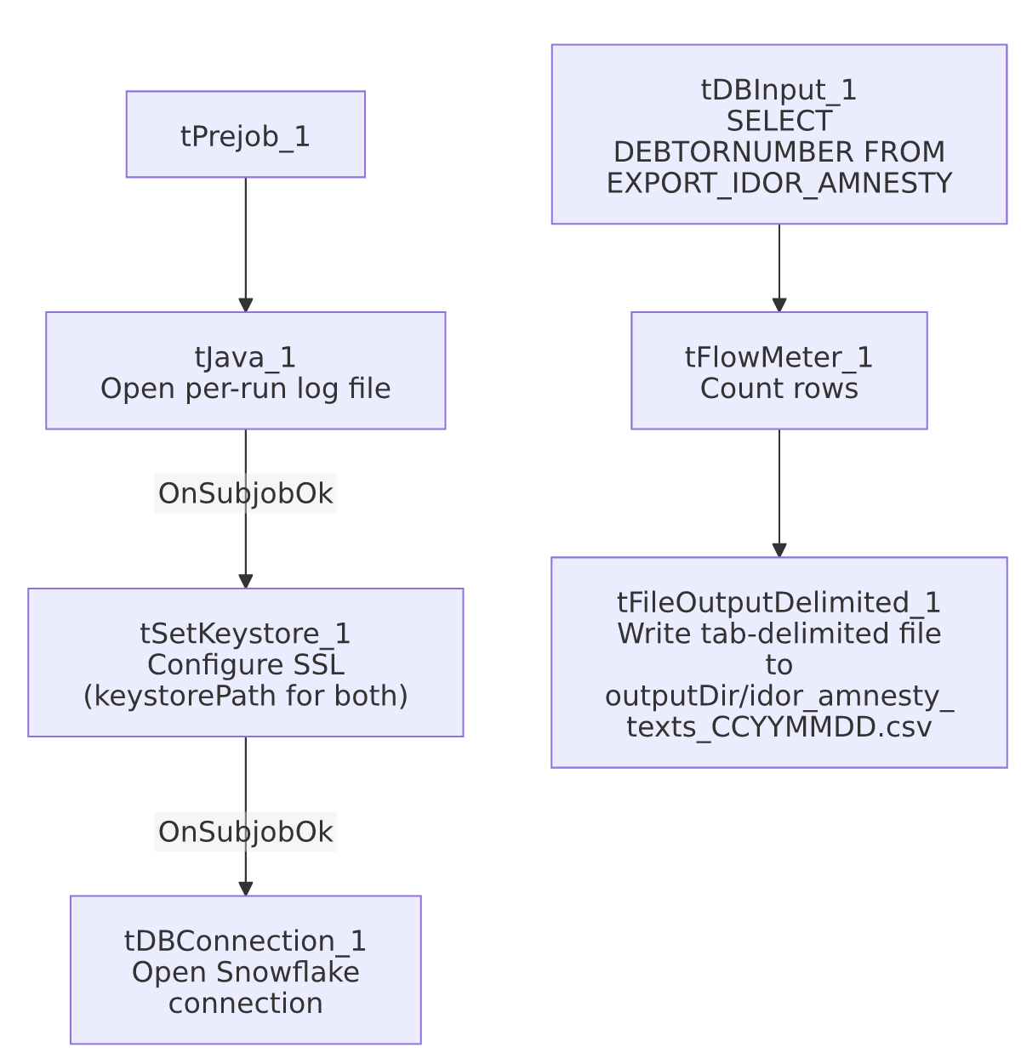

Settings tables

Source: `tDBInput_1` (`tSnowflakeInput`)
Setting | Value | What it means
Table | EXPORT_IDOR_AMNESTY | Source table/view — presumably pre-filtered upstream to just the amnesty-eligible debtor list.
Query | (blank) | No additional filtering applied by this job — a straight, unfiltered read of the source.
Schema | Single column DEBTORNUMBER (string) | The job's entire output is just a list of debtor numbers.

Target: `tFileOutputDelimited_1`
Setting | Value | What it means
FILENAME | context.outputDir + "idor_amnesty_texts_" + TalendDate.getDate("CCYYMMDD") + ".csv" | Date-stamped output filename, despite the tab-delimited field separator (the .csv extension is misleading given the actual separator — see Issues observed).
FIELDSEPARATOR | \t (tab) | Tab-delimited, not comma-delimited, despite the .csv extension.
INCLUDEHEADER | false | No header row.

Dependencies & configuration
- Triggers/depends on other jobs: none — no tRunJob links found.
- Context variables used: keystorePath, logDir, outputDir.
- Hardcoded paths: none found in this job's own components — this is one of the few jobs in this batch with zero entries in hardcoded_path_findings.

Glossary
Component type | Plain-English meaning
tSnowflakeConnection / tSnowflakeInput / tSnowflakeClose | Open a Snowflake connection, query it, and close the connection (note: no explicit tDBClose/tPostjob teardown is present in this job — see Issues observed).
tSetKeystore | Configures SSL trust/keystore settings used by subsequent database connections in the job.
tFlowMeter | Counts rows passing through a point in the flow, for logging/monitoring.
tFileOutputDelimited | Writes rows to a delimited text file.

Issues observed
- No `tPostjob`/`tDBClose` teardown exists in this job's metadata — every other job in this batch that opens a Snowflake connection also explicitly closes it in a tPostjob subjob; this job has no tPostjob_1 or tDBClose_* component at all. The Snowflake connection opened by tDBConnection_1 is presumably closed implicitly when the job's JVM exits, but this is a deviation from the project's otherwise-consistent open/close pattern and is worth confirming isn't an oversight, especially if this job is ever called as a sub-job via tRunJob (where an unclosed connection could linger in a shared JVM).
- Output file is named `.csv` but is actually tab-delimited, not comma-delimited — a naming/format mismatch that could confuse a downstream consumer expecting genuine comma-separated values.
- No error handling specific to this job's business outcome — no tWarn/tDie/tSendMail; a query failure or an empty result set would only surface as a generic Talend execution error or a silently empty/near-empty output file.
- `tSetKeystore_1` uses `context.keystorePath` for both the truststore and keystore paths — unlike several other jobs in this batch (e.g. INPUT_DIALER_LIST_GOV_Load, HUB_TempTransaction_Load) which hardcode the truststore path separately from the context-driven keystore path. This job's more consistent use of context variables here is a positive difference worth noting, not a defect.

