Talend Job: INPUT_DIALER_LIST_GOV_Load

Overview
Loads government-portfolio ("GOV") dialer-list extract files (account, address, balance, multiple phone numbers, scoring fields — 32 columns) from a source directory into the Snowflake INPUT_DIALER_LIST_UNIONED_GOV table, encrypting each row with a tDataEncrypt step before mapping and loading. This is one of two nearly-identical dialer-list loader jobs in this batch; the other, INPUT_DIALER_LIST_HC_Load, targets a different portfolio ("HC" — healthcare, inferred from its distinct phone/skip-trace column layout) with a different column set and target table.

Detail table
Field | Value
Job name | INPUT_DIALER_LIST_GOV_Load
Version | 0.1
Project | EDW2SF
Author | jmach@harriscollect.com
Created | 2022-09-21T10:10:48.388-0700
Last Modified | 2025-11-16T19:37:37.733-0800

Step-by-step data flow
Setup subjob: tPrejob_1 → tSetKeystore_1 configures SSL trust/keystore (truststore path hardcoded, keystore path from context.keystorePath) → on subjob-ok, tDBConnection_1 opens the Snowflake connection.
Main subjob — gated on the truncate step completing first:
- tDBRow_1 runs TRUNCATE TABLE INPUT_DIALER_LIST_UNIONED_GOV; against Snowflake.
- On subjob-ok, tFileList_1 lists files in context.inputPath (an EXCLUDEFILEMASK of *.txt is configured but IFEXCLUDE=false, so the exclusion is not actually applied — every file is picked up, same pattern flagged in ADP_Payroll_Load's doc).
- For each file, tJava_1 sets context.filePath/context.fileName and logs "Processing file <name>".
- tFileInputDelimited_1 reads the CSV (comma-delimited, header row present, DIE_ON_ERROR=false, no named repository schema — schema defined inline, 32 columns: account/address/balance fields plus PHONE1–PHONE7, SCORE, MEDIAN).
- tDataEncrypt_1 encrypts the row using AES (key/secret/password redacted) against context.cryptoPath.
- tMap_1 passes the columns through, adding a DIALER_FILE_NAME column (presumably populated from context.fileName, though the mapping expression itself isn't captured in this metadata).
- tFlowMeter_3 counts rows passing through.
- tDBOutput_1 inserts the rows into Snowflake table INPUT_DIALER_LIST_UNIONED_GOV (INSERT, following the earlier TRUNCATE).
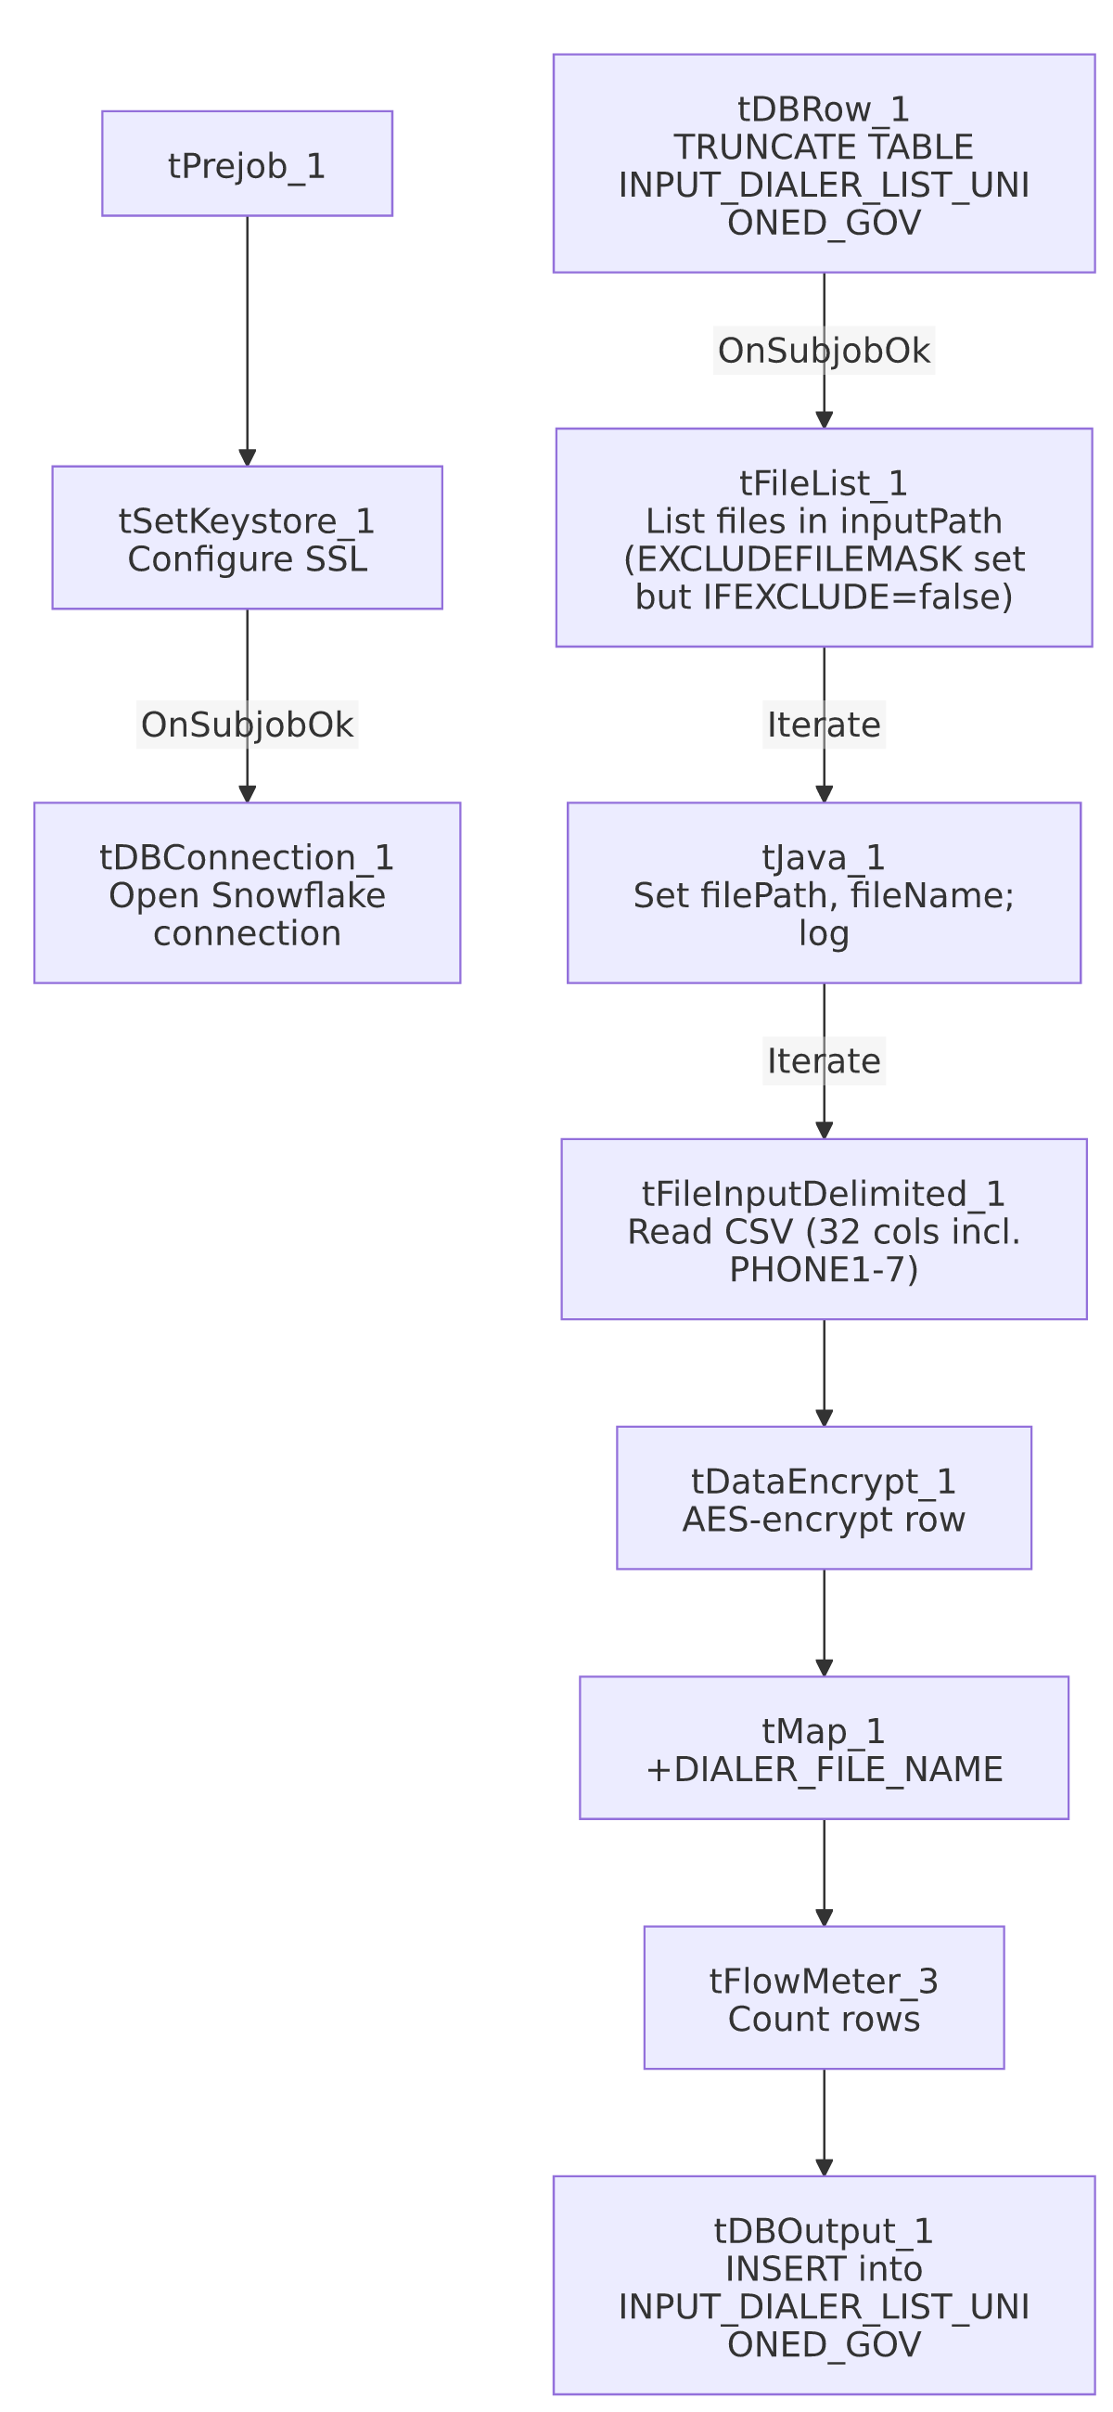

Settings tables

Truncate step: `tDBRow_1` (`tSnowflakeRow`)
Setting | Value | What it means
Query | TRUNCATE TABLE INPUT_DIALER_LIST_UNIONED_GOV; | Clears the target table before reload — standard truncate-then-load pattern, unlike the HUB reference jobs which use UPSERT with no truncate.

Source: `tFileInputDelimited_1`
Setting | Value | What it means
FILENAME | context.filePath | Current file from tFileList_1's iteration.
Schema | 32 columns including ACCOUNT_NUM, LOGON, CAMPAIGN, ADDRESS/CITY/ST/ZIP, BALANCE, PHONE_RES, EMP1_PHN, EMP2_PHN, AP_PHONE, PHONE1–PHONE7, SCORE, MEDIAN | No named repository schema (unlike INPUT_DIALER_LIST_HC_Load, which uses a repository schema labeled "HC10A_CLTAUTH").
DIE_ON_ERROR | false | Malformed rows do not fail the job; no reject flow is wired, so rejected rows are silently dropped (same pattern flagged in ADP_Payroll_Load).
TEMP_DIR | "C:/Talend-Studio-20211109_1610-V8.0.1/workspace" (hardcoded) | Developer-workstation path — see Issues observed.

Encryption: `tDataEncrypt_1`
Setting | Value | What it means
CRYPTO_METHOD | AES | Symmetric encryption applied to the row before it reaches the target table.
SECRET_KEY / SECRET_TYPE / PASSWORD_M1 | ***REDACTED*** | Encryption key material — preserved as redacted, not guessed.
CRYPTO_FILE_PATH | context.cryptoPath | Parameterized via context.

Target: `tDBOutput_1` (`tSnowflakeOutput`)
Setting | Value | What it means
Table | INPUT_DIALER_LIST_UNIONED_GOV | Destination table in Snowflake.
Output action | INSERT | Appends rows; relies on the earlier TRUNCATE to prevent duplicate accumulation.
Table action | NONE | Table is not recreated/altered by this job.

SSL setup: `tSetKeystore_1`
Setting | Value | What it means
SSL_TRUSTSERVER_TRUSTSTORE | "C:/clientTrustStore.trustStore" (hardcoded) | Developer-workstation path — see Issues observed.
SSL_KEYSTORE | context.keystorePath | Parameterized via context.

Dependencies & configuration
- Triggers/depends on other jobs: none — no tRunJob links found.
- Context variables used: cryptoPath, fileName, filePath, inputPath, keystorePath.
- 2 hardcoded path findings: tFileInputDelimited_1.TEMP_DIR = "C:/Talend-Studio-20211109_1610-V8.0.1/workspace"; tSetKeystore_1.SSL_TRUSTSERVER_TRUSTSTORE = "C:/clientTrustStore.trustStore" — the same project-wide developer-path risk documented in 05_operational_runbook.md.

Glossary
Component type | Plain-English meaning
tFileList | Lists files in a directory for the job to iterate over one at a time.
tFileInputDelimited | Reads a delimited (CSV-style) text file according to a schema.
tDataEncrypt | Encrypts specified column values (here, effectively the whole row) using a configured algorithm and key file.
tMap | Maps/transforms columns from one schema to another.
tFlowMeter | Counts rows passing through a point in the flow, for logging/monitoring.
tSnowflakeConnection / tSnowflakeOutput / tSnowflakeRow | Open a Snowflake connection, write rows to a table, and run an arbitrary SQL statement against Snowflake.
tSetKeystore | Configures SSL trust/keystore settings used by subsequent database connections.

Issues observed
- `EXCLUDEFILEMASK="*.txt"` is configured but `IFEXCLUDE=false`, so the exclusion never actually applies — every file in context.inputPath is picked up regardless of extension, the same dead-configuration pattern documented in ADP_Payroll_Load's doc. If a stray .txt or other non-CSV file lands in the input directory, it would be read (and likely rejected row-by-row, silently, given DIE_ON_ERROR=false and no reject flow) rather than being skipped as the mask's presence suggests was intended.
- No reject flow wired from `tFileInputDelimited_1` — malformed rows are silently dropped with no record of how many or which ones failed to parse.
- 2 hardcoded developer-workstation paths (TEMP_DIR, SSL_TRUSTSERVER_TRUSTSTORE) — same portability risk documented project-wide in 05_operational_runbook.md.
- No archiving or deletion of the source dialer-list files after load — unlike file-load jobs elsewhere in this project (e.g. ADP_Payroll_Load) that zip and delete the source file on success, this job leaves processed files in place with no visible cleanup step, which could lead to the same files being re-read (and, given INSERT with only a table-level TRUNCATE, re-inserted without duplication risk since the whole table is cleared first) on the next run.

