Talend Job: INPUT_DIALER_LIST_HC_Load

Overview
Loads "HC" portfolio (healthcare, inferred from the distinct phone/skip-trace-oriented column layout compared to its INPUT_DIALER_LIST_GOV_Load sibling) dialer-list extract files into the Snowflake INPUT_DIALER_LIST_UNIONED_HC table, encrypting each row with a tDataEncrypt step before mapping and loading. Structurally identical to INPUT_DIALER_LIST_GOV_Load (see that job's doc), but with a different source schema and target table.

Detail table
Field | Value
Job name | INPUT_DIALER_LIST_HC_Load
Version | 0.1
Project | EDW2SF
Author | jmach@harriscollect.com
Created | 2022-09-09T09:04:45.960-0700
Last Modified | 2025-11-16T19:40:23.696-0800

Step-by-step data flow
Setup subjob: tPrejob_1 → tSetKeystore_1 configures SSL trust/keystore (truststore path hardcoded, keystore path from context.keystorePath) → on subjob-ok, tDBConnection_1 opens the Snowflake connection.
Main subjob — gated on the truncate step completing first:
- tDBRow_1 runs TRUNCATE TABLE INPUT_DIALER_LIST_UNIONED_HC; against Snowflake.
- On subjob-ok, tFileList_1 lists files in context.inputPath (GLOBEXPRESSIONS=true here, unlike INPUT_DIALER_LIST_GOV_Load's false; same dead EXCLUDEFILEMASK="*.txt"/IFEXCLUDE=false combination — the exclusion never applies).
- For each file, tJava_1 sets context.filePath/context.fileName and logs "Processing file <name>".
- tFileInputDelimited_1 reads the CSV using repository schema HC10A_CLTAUTH (comma-delimited, header row present, DIE_ON_ERROR=false) — 32 columns including SKP_PHN_1, SKP_PHN_2, PHO_1, PHONE2–PHONE4, DIR_ASS1 (a healthcare/skip-trace-style column set, distinct from INPUT_DIALER_LIST_GOV_Load's PHONE1–PHONE7 layout).
- tDataEncrypt_1 encrypts the row using AES (key/secret/password redacted) against context.cryptoPath.
- tMap_1 passes the columns through, adding a DIALER_FILE_NAME column.
- tFlowMeter_3 counts rows passing through.
- tDBOutput_1 inserts the rows into Snowflake table INPUT_DIALER_LIST_UNIONED_HC (INSERT, following the earlier TRUNCATE).
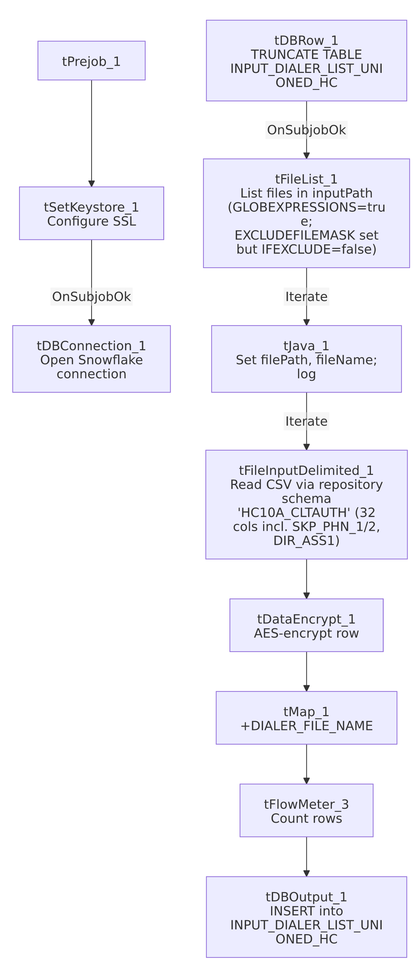

Settings tables

Truncate step: `tDBRow_1` (`tSnowflakeRow`)
Setting | Value | What it means
Query | TRUNCATE TABLE INPUT_DIALER_LIST_UNIONED_HC; | Clears the target table before reload.

Source: `tFileInputDelimited_1`
Setting | Value | What it means
FILENAME | context.filePath | Current file from tFileList_1's iteration.
Schema | Repository schema HC10A_CLTAUTH — 32 columns including ACCOUNT_NUM, LOGON, CAMPAIGN, ADDRESS/CITY/ST/ZIP, BALANCE, PHONE_RES, EMP1_PHN, EMP2_PHN, AP_PHONE, SKP_PHN_1, SKP_PHN_2, PHO_1, PHONE2–PHONE4, DIR_ASS1, SCORE, MEDIAN | Uses a named repository schema, unlike INPUT_DIALER_LIST_GOV_Load's inline schema. The SKP_PHN_*/DIR_ASS1 columns (skip-trace and directory-assistance fields) replace GOV's PHONE5–PHONE7.
DIE_ON_ERROR | false | Malformed rows do not fail the job; no reject flow is wired.
TEMP_DIR | "C:/Talend-Studio-20211109_1610-V8.0.1/workspace" (hardcoded) | Developer-workstation path — see Issues observed.

Encryption: `tDataEncrypt_1`
Setting | Value | What it means
CRYPTO_METHOD | AES | Symmetric encryption applied to the row before it reaches the target table.
SECRET_KEY / SECRET_TYPE / PASSWORD_M1 | ***REDACTED*** | Encryption key material — preserved as redacted.
CRYPTO_FILE_PATH | context.cryptoPath | Parameterized via context.

Target: `tDBOutput_1` (`tSnowflakeOutput`)
Setting | Value | What it means
Table | INPUT_DIALER_LIST_UNIONED_HC | Destination table in Snowflake.
Output action | INSERT | Appends rows; relies on the earlier TRUNCATE.
Table action | NONE | Table is not recreated/altered by this job.

Dependencies & configuration
- Triggers/depends on other jobs: none — no tRunJob links found.
- Context variables used: cryptoPath, fileName, filePath, inputPath, keystorePath — identical set to INPUT_DIALER_LIST_GOV_Load.
- 2 hardcoded path findings: tFileInputDelimited_1.TEMP_DIR = "C:/Talend-Studio-20211109_1610-V8.0.1/workspace"; tSetKeystore_1.SSL_TRUSTSERVER_TRUSTSTORE = "C:/clientTrustStore.trustStore".

Glossary
Component type | Plain-English meaning
tFileList | Lists files in a directory for the job to iterate over one at a time.
tFileInputDelimited | Reads a delimited (CSV-style) text file according to a schema.
tDataEncrypt | Encrypts specified column values (here, effectively the whole row) using a configured algorithm and key file.
tMap | Maps/transforms columns from one schema to another.
tFlowMeter | Counts rows passing through a point in the flow, for logging/monitoring.
tSnowflakeConnection / tSnowflakeOutput / tSnowflakeRow | Open a Snowflake connection, write rows to a table, and run an arbitrary SQL statement against Snowflake.
tSetKeystore | Configures SSL trust/keystore settings used by subsequent database connections.

Issues observed
- Same dead `EXCLUDEFILEMASK`/`IFEXCLUDE` combination as `INPUT_DIALER_LIST_GOV_Load` — EXCLUDEFILEMASK="*.txt" is set but IFEXCLUDE=false, so it never applies; every file in context.inputPath is picked up.
- `GLOBEXPRESSIONS=true` here vs. `false` in `INPUT_DIALER_LIST_GOV_Load`'s otherwise-identical `tFileList_1` — this sibling job allows glob-style wildcard matching in its file listing while GOV does not. Given both configure the same (non-functional) EXCLUDEFILEMASK, this difference likely has no practical effect today, but it is a real configuration divergence between two structurally identical jobs — verify with the team whether this was intentional.
- No reject flow wired from `tFileInputDelimited_1` — malformed rows are silently dropped, same as INPUT_DIALER_LIST_GOV_Load.
- 2 hardcoded developer-workstation paths (TEMP_DIR, SSL_TRUSTSERVER_TRUSTSTORE) — same portability risk documented project-wide in 05_operational_runbook.md.
- No archiving or deletion of source files after load — same as INPUT_DIALER_LIST_GOV_Load.

