Talend Job: ISO_Request_Export

Overview
A minimal, single-column export job: reads a CONCAT_YES_RN value from the Snowflake ISO.REQUEST_EXPORT table and writes it to a semicolon-delimited text file, date-stamped by filename. The job's shape (no tPrejob/tPostjob, no explicit tDBConnection/tDBClose component, and a blank author field) suggests this is a very lightweight, possibly hastily-built or template-derived utility job rather than a fully-formed production pipeline — it was also created and last modified on the same day.

Detail table
Field | Value
Job name | ISO_Request_Export
Version | 0.1
Project | EDW2SF
Author | (blank — not recorded in metadata)
Created | 2026-06-08T11:15:54.414-0700
Last Modified | 2026-06-08T11:30:16.503-0700

Step-by-step data flow
There is no tPrejob/tPostjob or explicit database connection/close component in this job — it consists of exactly three components in a single linear chain:
- tSetKeystore_1 configures SSL trust/keystore (truststore path hardcoded, keystore path from context.keystorePath, passwords redacted).
- On subjob-ok, tDBInput_1 runs SELECT CONCAT_YES_RN FROM ISO.REQUEST_EXPORT; against Snowflake — no visible connection-opening component precedes it in this job's own metadata (see Issues observed).
- tFileOutputDelimited_1 writes the single CONCAT_YES_RN column, semicolon-delimited, no header, to context.outputDir + "iso_request_export_" + <CCYYMMDD> + ".txt".
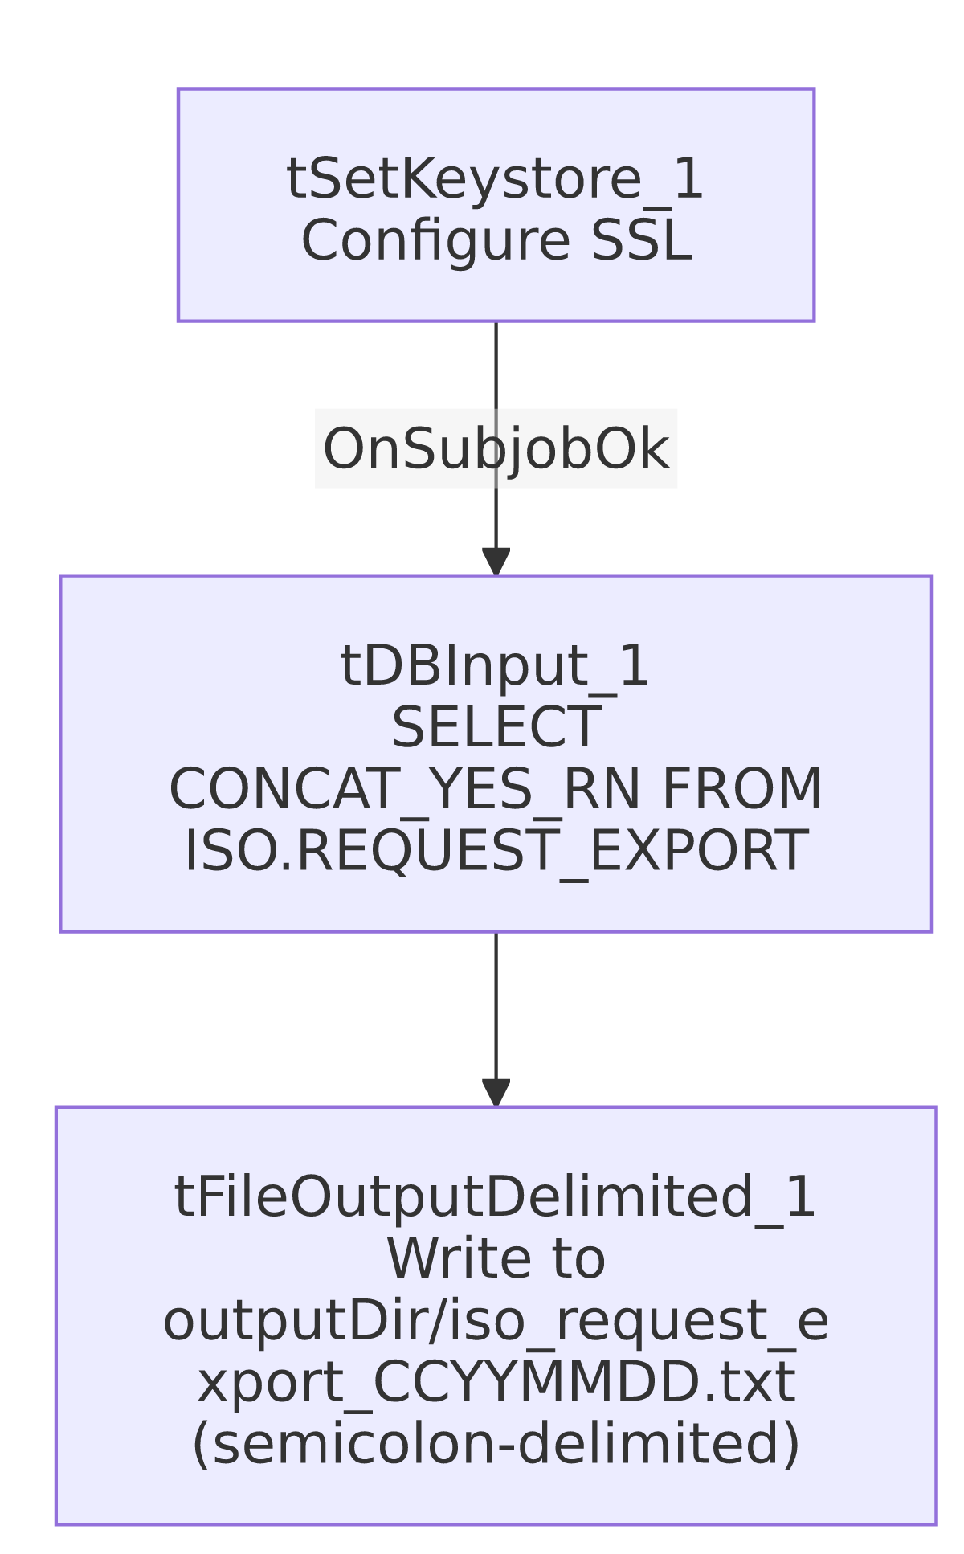

Settings tables

Source: `tDBInput_1` (`tSnowflakeInput`)
Setting | Value | What it means
Query | SELECT CONCAT_YES_RN FROM ISO.REQUEST_EXPORT; | A single pre-concatenated column, suggesting the actual row-formatting logic lives in the ISO.REQUEST_EXPORT table/view definition in Snowflake, not in this Talend job.
Schema | Single column CONCAT_YES_RN (string) | Confirms this job is a thin export wrapper around a Snowflake-side view.

Target: `tFileOutputDelimited_1`
Setting | Value | What it means
FILENAME | context.outputDir + "iso_request_export_" + TalendDate.getDate("CCYYMMDD") + ".txt" | Date-stamped output filename, parameterized via context.
FIELDSEPARATOR | ; (semicolon) | Unusual choice compared to the comma/tab separators used elsewhere in this batch — may reflect a specific downstream ISO (state agency, inferred from naming) file-format requirement.
INCLUDEHEADER | false | No header row.

SSL setup: `tSetKeystore_1`
Setting | Value | What it means
SSL_TRUSTSERVER_TRUSTSTORE | "C:/clientTrustStore.trustStore" (hardcoded) | Developer-workstation path — see Issues observed.
SSL_KEYSTORE | context.keystorePath | Parameterized via context.

Dependencies & configuration
- Triggers/depends on other jobs: none — no tRunJob links found.
- Context variables used: keystorePath, outputDir.
- 1 hardcoded path finding: tSetKeystore_1.SSL_TRUSTSERVER_TRUSTSTORE = "C:/clientTrustStore.trustStore".

Glossary
Component type | Plain-English meaning
tSetKeystore | Configures SSL trust/keystore settings used by subsequent database connections.
tSnowflakeInput | Runs a query against Snowflake and returns its result rows.
tFileOutputDelimited | Writes rows to a delimited text file.

Issues observed
- No `tPrejob`/`tPostjob`, and no explicit `tDBConnection`/`tDBClose` component anywhere in this job's metadata — every other job in this batch that queries Snowflake does so through an explicit tDBConnection/tDBClose pair (often wrapped in tPrejob/tPostjob). Here, tDBInput_1 runs directly with no visible connection-opening step feeding it. This could mean the job relies on an implicit/default Snowflake connection configured outside this component (not captured in this extraction), or it could be an incomplete job. Unable to determine from metadata whether this job would actually run successfully as-is; verify directly in Talend Studio.
- `author` field is blank — every other job in this batch (and the vast majority of the project) records jmach@harriscollect.com as author; this is the only job in the batch with no author recorded, consistent with it being a newer, possibly still-in-progress job (created mid-2026, the most recent creation date of any job in this batch).
- No error handling — no tWarn/tDie/tSendMail; a query or file-write failure would only surface as a generic Talend execution error.
- No teardown/connection-close step, consistent with the missing tDBConnection noted above — if a connection is in fact opened somewhere not captured here, it may never be explicitly closed by this job.

