Talend Job: Ins_Cvg_Debtor_NPI_Load

Overview
Loads a debtor-to-NPI (National Provider Identifier — a healthcare provider identifier, consistent with this job's role alongside the other Insurance Discovery/Insurance Coverage jobs in this batch) mapping from a fixed local text file into the Snowflake INS_CVG_DEBTOR_NPI table. This is a simple two-column reference load with no incremental logic, truncate step, or archiving.

Detail table
Field | Value
Job name | Ins_Cvg_Debtor_NPI_Load
Version | 0.1
Project | EDW2SF
Author | jmach@harriscollect.com
Created | 2023-02-23T11:09:10.416-0800
Last Modified | 2025-08-28T08:57:23.780-0700

Step-by-step data flow
Setup subjob: tPrejob_1 → tDBConnection_1 opens the Snowflake connection.
Main subjob:
- tFileInputDelimited_1 reads a fixed, hardcoded local file C:/Data/Insurance Coverage Debtor NPI list.txt (tab-delimited, header row present, DIE_ON_ERROR=false) — two columns, DEBTOR_IDX and NPI.
- tMap_1 passes both columns through unchanged.
- tDBOutput_1 inserts the rows into Snowflake table INS_CVG_DEBTOR_NPI (INSERT, no table-recreate action).
Teardown subjob: tPostjob_1 → tDBClose_1 (close Snowflake).
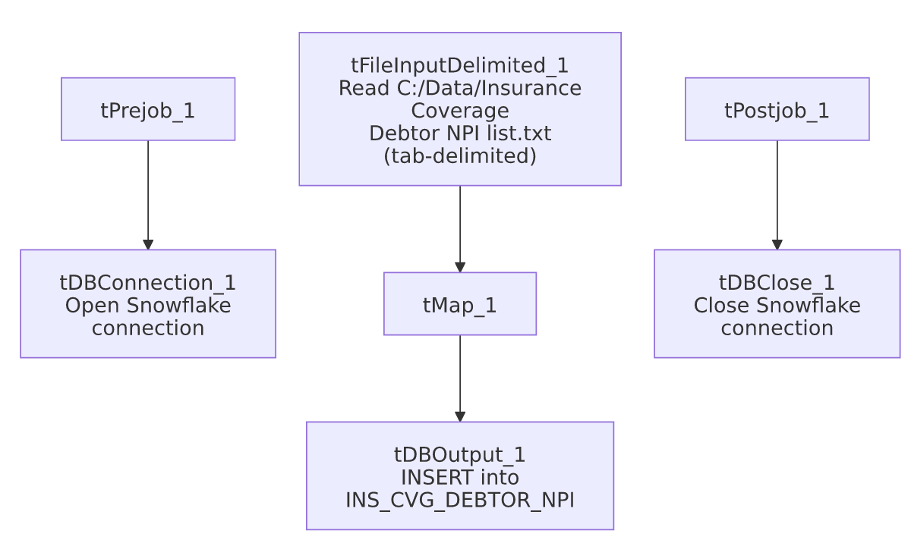

Settings tables

Source: `tFileInputDelimited_1`
Setting | Value | What it means
FILENAME | "C:/Data/Insurance Coverage Debtor NPI list.txt" (hardcoded, not parameterized via context) | A fixed local path on whatever machine runs this job — see Issues observed.
FIELDSEPARATOR | \t (tab) | Tab-delimited.
Schema | DEBTOR_IDX (string), NPI (string) | Simple two-column mapping file.
DIE_ON_ERROR | false | Malformed rows do not fail the job; no reject flow is wired, so rejected rows are silently dropped.
TEMP_DIR | "C:/Talend-Studio-20211109_1610-V8.0.1/workspace" (hardcoded) | Developer-workstation path — captured in hardcoded_path_findings.

Target: `tDBOutput_1` (`tSnowflakeOutput`)
Setting | Value | What it means
Table | INS_CVG_DEBTOR_NPI | Destination table in Snowflake.
Output action | INSERT | Appends rows; there is no TRUNCATE step before this insert.
Table action | NONE | Table is not recreated/altered by this job.
Schema | Includes 8 extra reject-style error columns with no wired reject flow | Same schema-drift artifact seen in several HUB_* jobs in this batch.

Dependencies & configuration
- Triggers/depends on other jobs: none — no tRunJob links found.
- Context variables used: none — this job uses no context.* variables at all; every path is either hardcoded or (for the Snowflake connection) presumably defaulted.
- 1 hardcoded path finding (per extraction): tFileInputDelimited_1.TEMP_DIR = "C:/Talend-Studio-20211109_1610-V8.0.1/workspace". Additionally, `tFileInputDelimited_1.FILENAME` itself is hardcoded to "C:/Data/Insurance Coverage Debtor NPI list.txt" — not flagged in the extraction's hardcoded_path_findings array (which only captured the TEMP_DIR value), but directly visible in the job's own parameters and equally a portability/reproducibility risk.

Glossary
Component type | Plain-English meaning
tSnowflakeConnection / tSnowflakeOutput / tSnowflakeClose | Open a Snowflake connection, write rows to a table, and close the connection.
tFileInputDelimited | Reads a delimited (tab-separated, in this case) text file according to a schema.
tMap | Maps/transforms columns from one schema to another.

Issues observed
- The source file path is fully hardcoded (C:/Data/Insurance Coverage Debtor NPI list.txt), not parameterized through a context.sourceDir-style variable as most other file-reading jobs in this project are. This means the file must exist at that exact path on whatever machine runs this job, and running it in a different environment (e.g. a Linux-based scheduler or a different developer's machine) would require editing the job itself. This is the same class of risk as the project-wide TEMP_DIR hardcoding documented in 05_operational_runbook.md, but applied to the actual business-data source path rather than just a scratch directory — a more direct operational risk for this specific job.
- `tFileInputDelimited_1`'s schema_columns list shows `DEBTOR_IDX` and `NPI` each listed twice in the raw extracted metadata (once for the main flow, once seemingly duplicated) — likely a metadata-capture artifact rather than an actual duplicate-column schema, since the downstream tMap_1 and tDBOutput_1 both cleanly show only the two expected columns. Not a functional concern, but noted for completeness.
- No reject flow, no truncate/incremental logic, no archiving — this is a minimal append-only load with no error visibility beyond DIE_ON_ERROR=false silently dropping malformed rows, and repeated runs would keep appending the same file's contents (no TRUNCATE), risking duplicate DEBTOR_IDX/NPI pairs if the job is ever rerun without the source file changing.

