Talend Job: Insurance_Discovery_Scrub_Extract

Overview
Extracts a coverage-detection cohort (patient reference, name, SSN, DOB, sex, dates of service, claim amount, address, NPI) from the EDWPRODHH.PUB_MBOICH.COVERAGE_DETECTION_FILE_CD Snowflake table, decrypts the sensitive fields, strips dashes from the patient SSN, and writes the result to a date-stamped CSV — the standard "scrub" pattern used for insurance-discovery vendor submissions elsewhere in this project's naming (e.g. LW_*_Scrub jobs referenced in 05_operational_runbook.md).

Detail table
Field | Value
Job name | Insurance_Discovery_Scrub_Extract
Version | 0.2
Project | EDW2SF
Author | jmach@harriscollect.com
Created | 2023-10-20T13:35:30.328-0700
Last Modified | 2025-11-16T19:46:33.973-0700

Step-by-step data flow
Setup subjob: tPrejob_1 → tSetKeystore_1 configures SSL trust/keystore (truststore path hardcoded, keystore path from context.keystorePath) → on subjob-ok, tDBConnection_1 opens the Snowflake connection.
Main subjob — runs independently of the setup subjob:
- tDBInput_1 runs SELECT REF, PLN, PFN, PMN, PSSN, PDOB, PSEX, BDOS, EDOS, CLAIM_AMOUNT, ADDRESS1, ADDRESS2, CITY, STATE, ZIP5, NOTES, ACCT_VISIT_NO, NPI FROM EDWPRODHH.PUB_MBOICH.COVERAGE_DETECTION_FILE_CD; against Snowflake.
- tDataDecrypt_1 decrypts the row using AES against context.cryptoPath + "dimdbtr.crypt" (key/secret/password redacted), with DIE_ON_ERROR=true.
- tJavaRow_1 copies each field through explicitly, applying input_row.PSSN.replace("-","") to strip dashes from the patient SSN (the remainder of the custom code is truncated in this metadata, so any other per-field transformations beyond the SSN cleanup are not visible).
- tFileOutputDelimited_1 writes the rows, comma-delimited with header (CSV_OPTION=true), to context.outputDir + "coverage_detection_file_cd_" + <CCYYMMDD> + ".csv".
Teardown subjob: tPostjob_1 → tDBClose_1 (close Snowflake).
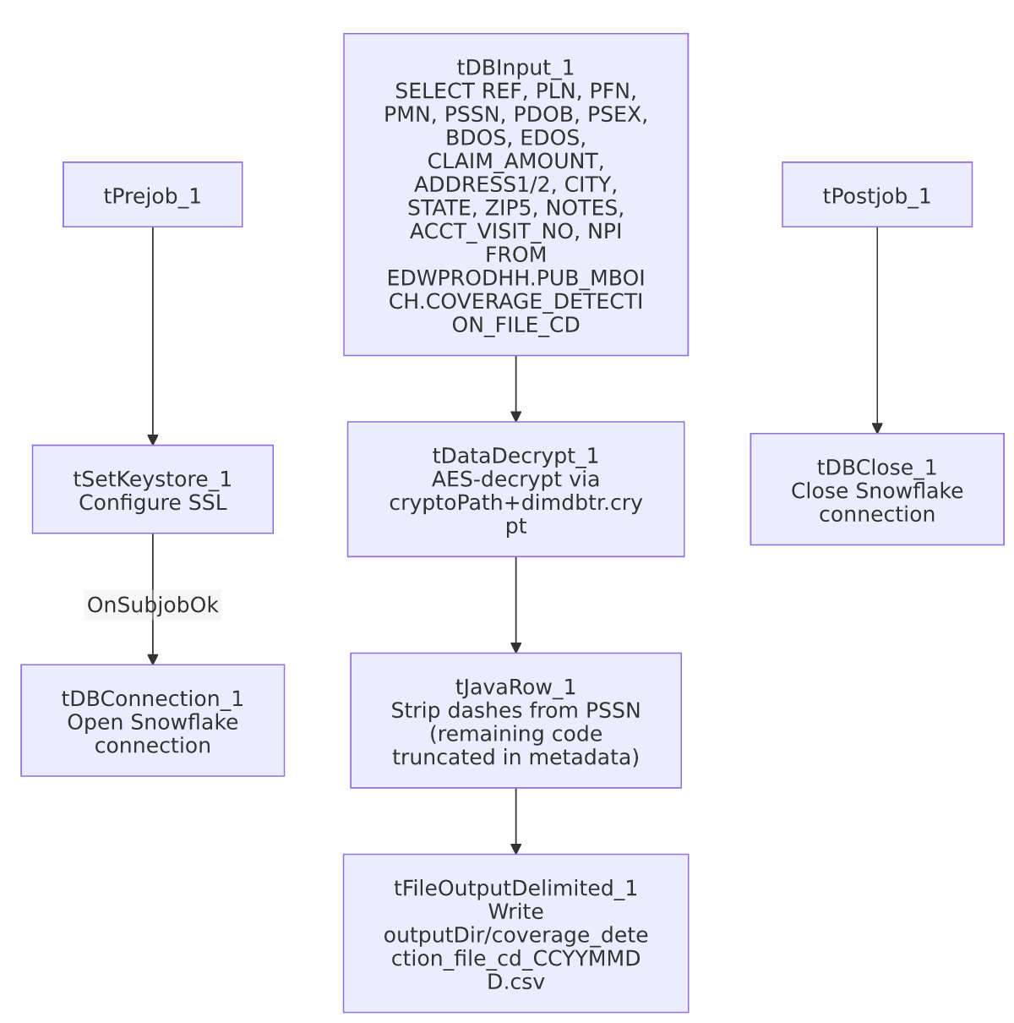

Settings tables

Source: `tDBInput_1` (`tSnowflakeInput`)
Setting | Value | What it means
Query | SELECT REF, PLN, PFN, PMN, PSSN, PDOB, PSEX, BDOS, EDOS, CLAIM_AMOUNT, ADDRESS1, ADDRESS2, CITY, STATE, ZIP5, NOTES, ACCT_VISIT_NO, NPI FROM EDWPRODHH.PUB_MBOICH.COVERAGE_DETECTION_FILE_CD; | Reads from a fully-qualified cross-database Snowflake path (EDWPRODHH.PUB_MBOICH.<table>) rather than the job's own default connection's database/schema — notable since most other jobs in this project reference tables unqualified.
Schema | REF, PLN, PFN, PMN, PSSN, PDOB (date), PSEX, BDOS/EDOS (dates), CLAIM_AMOUNT, ADDRESS1/ADDRESS2, CITY, STATE, ZIP5, NOTES, ACCT_VISIT_NO, NPI (not nullable) | Patient reference, demographics, claim, and address fields; NPI is the only non-nullable column.

Decryption: `tDataDecrypt_1`
Setting | Value | What it means
CRYPTO_FILE_PATH | context.cryptoPath+"dimdbtr.crypt" | Parameterized via context, unlike the hardcoded crypto paths used in the Initial-Insurance-Discovery utility jobs elsewhere in this batch.
DIE_ON_ERROR | true | A decryption failure fails the job outright.

Scrub transform: `tJavaRow_1`
Setting | Value | What it means
Code (partial, truncated in metadata) | output_row.PSSN = input_row.PSSN.replace("-","") (plus other field copies not fully captured) | Strips dashes from the patient SSN before it's written to the output file — a light "scrub"/normalization step, not a full de-identification.

Target: `tFileOutputDelimited_1`
Setting | Value | What it means
FILENAME | context.outputDir+"coverage_detection_file_cd_"+TalendDate.getDate("CCYYMMDD")+".csv" | Date-stamped output filename, parameterized via context.
CSV_OPTION | true | Uses Talend's CSV-aware output mode (proper quoting/escaping), unlike most other file-output jobs in this batch which leave CSV_OPTION=false.
INCLUDEHEADER | true | Output includes a header row.

Dependencies & configuration
- Triggers/depends on other jobs: none — no tRunJob links found.
- Context variables used: cryptoPath, keystorePath, outputDir.
- 1 hardcoded path finding: tSetKeystore_1.SSL_TRUSTSERVER_TRUSTSTORE = "C:/clientTrustStore.trustStore".

Glossary
Component type | Plain-English meaning
tSnowflakeConnection / tSnowflakeInput / tSnowflakeClose | Open a Snowflake connection, query it, and close the connection.
tDataDecrypt | Decrypts specified column values using a configured algorithm and key file.
tJavaRow | Runs custom Java code once per input row — here used to strip dashes from the patient SSN and copy other fields through.
tFileOutputDelimited | Writes rows to a delimited text file.
tSetKeystore | Configures SSL trust/keystore settings used by subsequent database connections.

Issues observed
- `tJavaRow_1`'s custom code is truncated in this metadata after the PSSN dash-stripping line — the full extent of what this "scrub" step does to the other 17 columns is unable to determine from metadata; verify directly in Talend Studio whether any additional PII-scrubbing logic (e.g. partial masking of other fields) exists beyond the visible SSN cleanup.
- Source query reads from a fully-qualified cross-database path (EDWPRODHH.PUB_MBOICH.COVERAGE_DETECTION_FILE_CD), while most other Snowflake-reading jobs in this project reference tables unqualified within their own connection's default database/schema. This is a deliberate cross-database reference rather than an anomaly, but worth noting for anyone tracing this job's actual data dependency, since it means the job depends on the EDWPRODHH database/PUB_MBOICH schema being accessible from whatever Snowflake role/connection this job uses.
- Output writes patient SSN (with dashes stripped but otherwise in the clear) to a plaintext CSV file — appropriate if the output is meant for a controlled downstream insurance-discovery vendor process, but there is no masking/redaction of the SSN in the visible portion of the transform logic; confirm the output directory (context.outputDir) has appropriate access controls.
- No row-count logging or `tWarn`/`tDie` on the extract's success/failure beyond the DIE_ON_ERROR=true on decryption — a query returning zero rows, or any failure after decryption, would only surface as a generic Talend execution error.

