Talend Job: Insurance_Discovery_Test

Overview
A test/utility job that reads a fixed local Excel file (Insurance Discovery Test File.xlsx, password-protected), decrypts it against the project's dimdbtr.crypt key file, and writes the decrypted result back out to a CSV with the same base name. Like Initial_Insurance_Discovery_File and Initial_Ins_Discovery_V2_Decrypted, this is a standalone file-to-file utility with no database connection, no tPrejob/tPostjob, and no context variables — but it is the only one of the three that reads from Excel rather than CSV, and the only one whose name ("Test") explicitly signals it is not a production job.

Detail table
Field | Value
Job name | Insurance_Discovery_Test
Version | 0.1
Project | EDW2SF
Author | jmach@harriscollect.com
Created | 2025-02-19T11:43:39.318-0800
Last Modified | 2025-08-28T08:57:23.814-0700

Step-by-step data flow
A single linear chain, no setup/teardown subjobs:
- tFileInputExcel_2 reads C:/Data/Insurance Discovery Test File.xlsx (VERSION_2007=true, password-protected — password redacted, header row present, DIE_ON_ERROR=false) using repository schema metadata — 20 patient/guarantor/claim columns (same field set as Initial_Insurance_Discovery_File minus REQUEST_ID, with PATIENT_DOB/ADMIT_DATE/DISCHARGE_DATE typed as actual dates rather than strings).
- tDataDecrypt_1 decrypts the row using AES against a hardcoded crypto file path C:/Data/dimdbtr.crypt (key/secret/password redacted), with DIE_ON_ERROR=true — a decryption failure fails the job.
- tMap_1 passes all 20 columns through unchanged.
- tFileOutputDelimited_1 writes the decrypted rows, comma-delimited with header, to the hardcoded path C:/Data/Insurance Discovery Test File.csv.
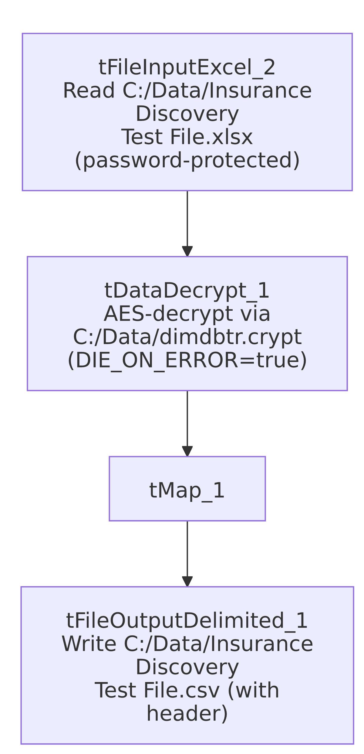

Settings tables

Source: `tFileInputExcel_2`
Setting | Value | What it means
FILENAME | "C:/Data/Insurance Discovery Test File.xlsx" (hardcoded) | Fixed local Excel file, not parameterized via context.
PASSWORD | ***REDACTED*** | The Excel file itself is password-protected.
Schema | Repository schema metadata — 20 columns (CLIENT_FACILITY through NPI, no REQUEST_ID) with PATIENT_DOB, ADMIT_DATE, DISCHARGE_DATE typed as dates | One fewer column than Initial_Insurance_Discovery_File's 21-column layout, and with proper date typing rather than string dates.
DIE_ON_ERROR | false | Malformed rows on read do not fail the job.

Decryption: `tDataDecrypt_1`
Setting | Value | What it means
CRYPTO_FILE_PATH | "C:/Data/dimdbtr.crypt" (hardcoded) | Same key file used by the other two Initial-Insurance-Discovery utility jobs in this batch.
DIE_ON_ERROR | true | A decryption failure fails the job outright, same as Initial_Insurance_Discovery_File.

Target: `tFileOutputDelimited_1`
Setting | Value | What it means
FILENAME | "C:/Data/Insurance Discovery Test File.csv" (hardcoded) | Same base name as the source Excel file, just a .csv extension — writes into the same C:/Data/ folder as the source.
INCLUDEHEADER | true | Output includes a header row.

Dependencies & configuration
- Triggers/depends on other jobs: none — no tRunJob links found.
- Context variables used: none — every path in this job is hardcoded.
- Hardcoded paths: none captured in the extraction's hardcoded_path_findings array for this job (unlike its Initial-Insurance-Discovery siblings, which each have a TEMP_DIR entry), but the source file path, crypto file path, and output file path are all directly hardcoded in the job's own parameters.

Glossary
Component type | Plain-English meaning
tFileInputExcel | Reads rows from an Excel workbook (optionally password-protected), according to a schema.
tDataDecrypt | Decrypts specified column values (here, effectively the whole row) using a configured algorithm and key file.
tMap | Maps/transforms columns from one schema to another.
tFileOutputDelimited | Writes rows to a delimited text file.

Issues observed
- This is explicitly a "Test" job (per its name), reading a "Test File" and writing an output file with the same base name into the same folder as the source. If run against real production insurance-discovery data by mistake, it would overwrite C:/Data/Insurance Discovery Test File.csv in place — a low-blast-radius risk given the fixed, clearly test-labeled filename, but worth confirming this job is not accidentally scheduled or invoked outside of manual testing.
- Reads from a password-protected Excel file with the password redacted in this metadata — consistent with the project's general handling of credentials, but notable that the source file itself carries its own password protection layer independent of the tDataDecrypt step that follows.
- Same hardcoded-path, no-context-variable pattern as `Initial_Insurance_Discovery_File` and `Initial_Ins_Discovery_V2_Decrypted` — see those docs' Issues sections for the shared implication (personal/fixed-machine dependency, no environment portability).
- No archiving, no row-count logging — a single pass with no audit trail of how many rows were processed.

