Talend Job: Insurance_Report_Extract

Overview
This job pulls one row per debtor with an identified insurance/NPI match from the Snowflake DM.INS_CVG_DEBTOR_NPI table (left-joined to dw.dimdebtor and two HH fiscal dimension tables, dw.dimfiscal_HH_A/dw.dimfiscal_HH_B), decrypts the debtor's protected fields, and writes the result to a fixed local file, C:/Data/insurance.txt. It is a small, single-purpose extract — likely feeding an insurance-coverage/claims workflow that needs debtor name, SSN, DOB, admit/discharge dates, and assignment amount alongside the matched NPI.

Detail table
Field | Value
Job name | Insurance_Report_Extract
Version | 0.1
Project | EDW2SF
Author | jmach@harriscollect.com
Created | 2023-02-23T11:55:50.249-0800
Last Modified | 2025-08-28T08:57:23.864-0700

Step-by-step data flow
Setup: tPrejob_1 → tDBConnection_1 opens the Snowflake connection (OnComponentOk).
Main flow: tDBInput_1 runs the join query below, tDataDecrypt_1 decrypts the resulting rows using a local crypto file (C:/Data/dimdbtr.crypt), and tFileOutputDelimited_1 writes the decrypted rows to C:/Data/insurance.txt (tab-delimited, header included, file recreated each run since APPEND=false).
Teardown: tPostjob_1 → tDBClose_1 closes the Snowflake connection.
Note: unlike most other jobs in this project, there is no explicit connection in the extracted connections array between tDBConnection_1/tPrejob_1 and tDBInput_1 — the main flow (tDBInput_1 → tDataDecrypt_1 → tFileOutputDelimited_1) appears in the metadata as a self-contained chain with no incoming trigger link shown. See Issues observed.
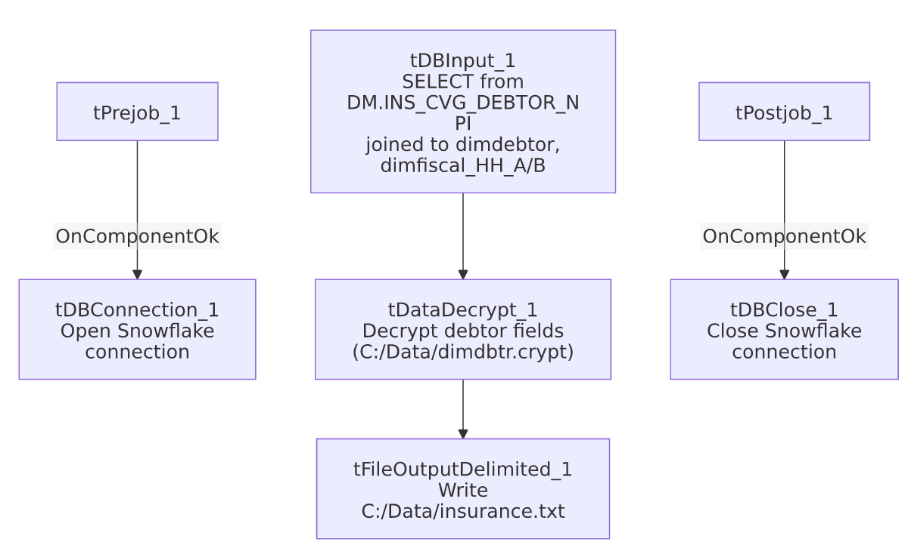

Settings tables

Source: `tDBInput_1` (`tSnowflakeInput`)
Setting | Value | What it means
Query | SELECT npi.debtor_idx, name1 AS First, '' AS last, '' AS Middle, SSN, patient_dob, SEX_F17 AS Sex, admit_date, discharge_date, asgn_amt, add1, add2, city, st, substring(zip,1,5) AS zip5, '' AS notes, CDN, NPI FROM DM.INS_CVG_DEBTOR_NPI npi LEFT JOIN dw.dimdebtor dd ON dd.debtor_idx = npi.debtor_idx LEFT JOIN dw.dimfiscal_HH_A hha ON hha.debtor_idx = npi.debtor_idx LEFT JOIN dw.dimfiscal_HH_B hhb ON hhb.debtor_idx = npi.debtor_idx; | Joins the NPI-matched debtor list to core debtor and HH fiscal dimensions. Note LAST, MIDDLE, and NOTES are hardcoded empty-string literals in the query, not real source columns.

Transform: `tDataDecrypt_1`
Setting | Value | What it means
CRYPTO_METHOD | AES | Standard AES decryption, same pattern used across other LW_* scrub jobs in this project.
CRYPTO_FILE_PATH | "C:/Data/dimdbtr.crypt" | Hardcoded local file path for the decryption key material — not driven by a context variable (compare to LW_Carle_Asset_Scrub/LW_ProMedica_Scrub, which use context.cryptoPath+"dimdbtr.crypt").
SECRET_TYPE / SECRET_KEY / PASSWORD_M1 | ***REDACTED*** | Preserved as redacted in source metadata — not guessable.
DIE_ON_ERROR | true | A decryption failure fails the job outright.

Target: `tFileOutputDelimited_1`
Setting | Value | What it means
FILENAME | "C:/Data/insurance.txt" | Hardcoded local output path, not driven by context.outputDir (unlike most other LW_* report jobs in this batch).
FIELDSEPARATOR | "\t" (tab) | Differs from the comma-delimited CSV convention used by the other LW_* scrub/report jobs.
APPEND / INCLUDEHEADER | false / true | File is recreated fresh each run with a header row.

Dependencies & configuration
- Triggers/depends on other jobs: none — no tRunJob links found (runjob_targets is empty).
- Context variables used: none — context_vars_referenced is empty. This is unusual for this batch; every other job in this batch references at least logDir/outputDir/keystorePath. This job hardcodes its output path, decryption key path, and has no per-run log file setup (no tJava_1 log-redirect component at all) or SSL/keystore configuration (no tSetKeystore component) — see Issues observed.
- Hardcoded paths: hardcoded_path_findings is empty in the extracted metadata, but the job's own components show two hardcoded local paths not classified as such by the extraction: tFileOutputDelimited_1.FILENAME ("C:/Data/insurance.txt") and tDataDecrypt_1.CRYPTO_FILE_PATH ("C:/Data/dimdbtr.crypt"). Both point to a local C:/Data/ directory rather than a shared/context-driven location.

Glossary
Component type | Plain-English meaning
tSnowflakeConnection / tSnowflakeInput / tSnowflakeClose | Open a Snowflake connection, run a query against it, and close the connection.
tDataDecrypt | Decrypts one or more input columns using a local key/crypto file — used project-wide to unmask protected debtor fields (SSN, DOB, etc.) before they're written to an output file.
tFileOutputDelimited | Writes rows to a delimited (CSV/TSV-style) text file.

Issues observed
- No `tJava` log-file setup and no `tSetKeystore` SSL configuration — every other job in this batch opens a per-run log file (tJava_1) and configures a client trust store (tSetKeystore_1) before connecting to Snowflake. This job skips both, going straight from tPrejob_1 to tDBConnection_1. Unable to determine from metadata whether this is intentional (e.g., an older/simpler job predating those conventions) or an oversight; it does mean this job's own execution won't produce a dedicated timestamped log file the way its siblings do.
- No visible connection between the Snowflake connection setup and the main query/decrypt/write chain. The connections array shows tPrejob_1 → tDBConnection_1 and tDBInput_1 → tDataDecrypt_1 → tFileOutputDelimited_1 as two separate chains, with nothing explicitly linking the connection-open step to the query step. In practice, Talend jobs typically still execute a "detached" main flow using whatever DB connection is configured on the component, but this means the ordering guarantee (connection is open before the query runs) is not explicit in this job's own wiring — worth confirming directly in Talend Studio rather than assuming from this metadata.
- Hardcoded local `C:/Data/` paths for both the decryption key file and the output file, rather than using context.outputDir/context.cryptoPath as sibling jobs (LW_Carle_Asset_Scrub, LW_ProMedica_Scrub, LW_Property_Scrub) do. This is the same class of portability risk flagged project-wide in 05_operational_runbook.md, though these two specific paths weren't captured in this job's own hardcoded_path_findings list.
- The query embeds three empty-string literal columns ('' AS last, '' AS Middle, '' AS notes) rather than sourcing real LAST/MIDDLE/NOTES values, meaning the output file's LAST, MIDDLE, and NOTES columns will always be blank. Unable to determine from metadata whether this is intentional (e.g., those fields are populated downstream, or are simply not tracked for this extract) or a leftover/placeholder from an earlier version of the query; verify with the team.

