Talend Job: LW_COC_Water_Scrub

Overview
This job produces a monthly "City of Chicago Water" scrub report: it queries a curated Snowflake view (EDWPRODHH.PUB_LWASHINGTON.COC_WATER_SCRUB) for debtor/collection details relevant to that client relationship, appends the rows to a CSV file, and emails the report to a distribution list. It's one of several LW_* client-specific "scrub" report jobs in this project (see also LW_Carle_Asset_Scrub, LW_ProMedica_Scrub, LW_Property_Scrub), all built on a similar delete-old-file/query/write/mail template but pointed at different client tables.

Detail table
Field | Value
Job name | LW_COC_Water_Scrub
Version | 0.1
Project | EDW2SF
Author | jmach@harriscollect.com
Created | 2024-11-25T11:52:06.376-0800
Last Modified | 2025-11-16T19:54:18.113-0800

Step-by-step data flow
Setup subjob: tPrejob_1 → tJava_1 opens a per-run log file (context.logDir+jobName+"_"+<timestamp>+".log") → on subjob-ok, tSetKeystore_1 configures SSL trust/keystore from context.keystorePath → on subjob-ok, tDBConnection_1 opens the Snowflake connection.
File-reset subjob (a separate, parallel chain not wired to the connection setup above):
- tFileExist_1 checks whether context.outputDir+"coc_water_scrub.csv" already exists.
- If it does (RUN_IF), tFileDelete_1 deletes it.
- Either way, on subjob-ok, tSleep_1 pauses 30 seconds, then tJava_2 builds a header-record string (see Issues observed — the code as captured is truncated and never appears to write anything to the file), then tSleep_2 pauses another 30 seconds, then tDBInput_1 runs the query below.
Query and output: tDBInput_1 → tFlowMeter_1 (row count) → tFileOutputDelimited_1 appends the rows to context.outputDir+"coc_water_scrub.csv" (APPEND=true, INCLUDEHEADER=false — the file is expected to already have a header from elsewhere, e.g. the tJava_2 step, though that step's captured code does not show it actually writing one). Separately, tDBInput_1 → on subjob-ok → tSendMail_1 emails the finished report.
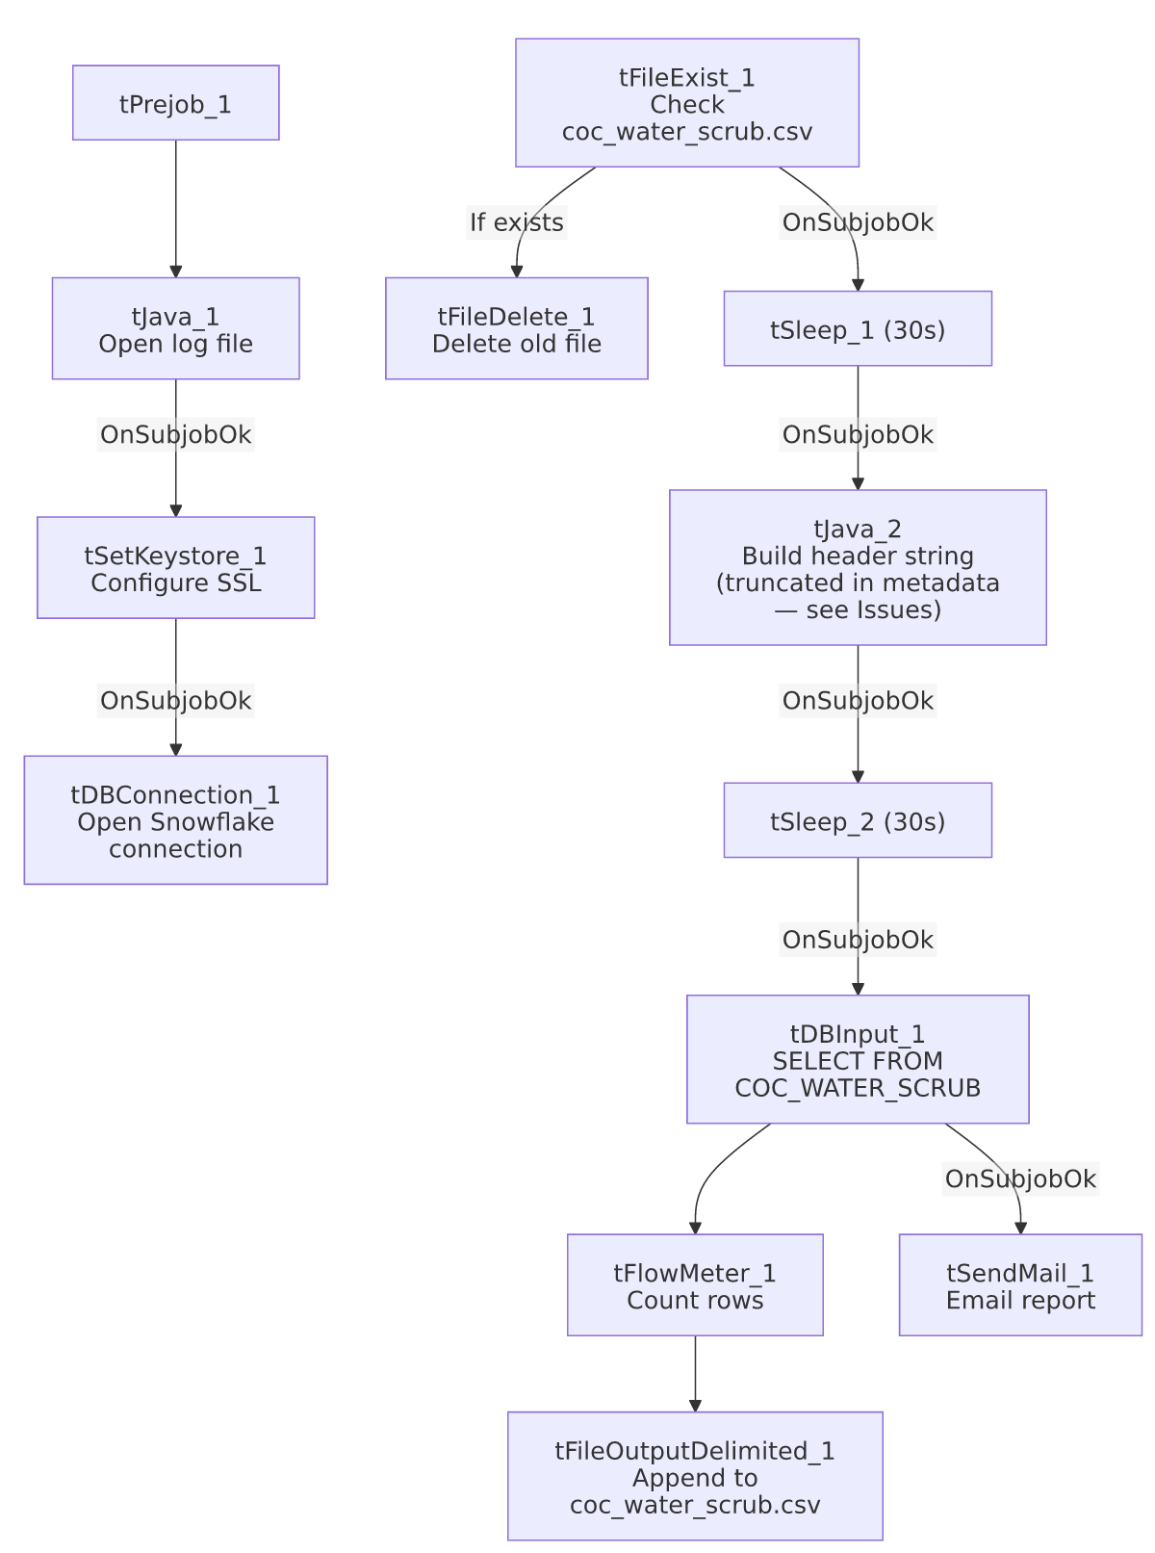

Settings tables

Source: `tDBInput_1` (`tSnowflakeInput`)
Setting | Value | What it means
Query | SELECT "DEBTOR#", "CLIENT#", "NAME", ADDRESS, CITY, ST, ZIP, PHONE, DESK, "C.D.#", "ST CD", "DT-ASSIGN", "PKT AGN", "PKT COL", "PKT BAL", EMP1_NAME, "MEDIAN RTG", "PACKET NBR", "MISC. 2" FROM EDWPRODHH.PUB_LWASHINGTON.COC_WATER_SCRUB; | Reads from a curated publish-schema view already scoped to this client relationship — cross-database reference (EDWPRODHH.PUB_LWASHINGTON) rather than the connection's own default database.

Target: `tFileOutputDelimited_1`
Setting | Value | What it means
FILENAME | context.outputDir+"coc_water_scrub.csv" | Output path driven by context, unlike Insurance_Report_Extract's hardcoded path.
APPEND / INCLUDEHEADER | true / false | File is appended to (not recreated) and no header row is written by this component — the header is expected to come from the earlier tJava_2 step.

Mail: `tSendMail_1`
Setting | Value | What it means
TO / FROM | context.mailRecipients / "svc_analytics@harriscollect.com" | Sent from a shared analytics service account.
SUBJECT / MESSAGE | "City of Chicago Water Scrub Report" / "The monthly City of Chicago Water scrub report is attached."
CHECK_ATTACHMENT / DIE_ON_ERROR | true / true | Job fails if the attachment check fails or the send fails.
AUTH_MODE / AUTH_USERNAME / AUTH_PASSWORD / TOKEN | ***REDACTED*** | Preserved as redacted.

Dependencies & configuration
- Triggers/depends on other jobs: none — no tRunJob links found.
- Context variables used: keystorePath, logDir, mailRecipients, outputDir.
- Hardcoded paths: tFileDelete_1.DIRECTORY and tFileDelete_1.PATH are both set to the generic Talend-Studio-workspace placeholder path (C:/Talend-Studio-20211109_1610-V8.0.1/workspace/delete_folder...), and tSetKeystore_1.SSL_TRUSTSERVER_TRUSTSTORE is hardcoded to "C:/clientTrustStore.trustStore" — same class of developer-workstation path risk documented project-wide in 05_operational_runbook.md.
- Per 05_operational_runbook.md, this job is one of the small set of LW_*/scrub jobs that sends email on completion — appropriate for a partner-facing monthly report.

Glossary
Component type | Plain-English meaning
tFileExist / tFileDelete | Check whether a file exists, then conditionally delete it — used here to reset the output CSV before a fresh run appends new rows.
tSleep | Pauses the job for a fixed number of seconds — used here (twice, 30s each) around the header-writing step, likely to avoid a race condition with the file-delete step.
tSnowflakeConnection / tSnowflakeInput | Open a Snowflake connection and run a query against it.
tFlowMeter | Counts rows passing a point in the flow for logging/monitoring.
tFileOutputDelimited | Writes rows to a delimited (CSV-style) text file.
tSendMail | Sends an email with the finished report attached.
tSetKeystore | Configures the SSL trust store/keystore used for the Snowflake JDBC connection.

Issues observed
- `tJava_2`'s CODE parameter is truncated in the extracted metadata — it defines fileName, filePath, and a headerRecord string that itself cuts off mid-literal ("...Misc....", with no closing quote), and never shows a call that actually writes headerRecord to the file. Given tFileOutputDelimited_1 is configured with INCLUDEHEADER=false, this tJava_2 step is the only plausible place a header row would get written — if its code truly stops short of a file-write call (rather than the metadata extraction simply cutting off a longer script), the output CSV could end up with no header row at all after the first (deleted-and-recreated) run. Unable to determine from metadata whether this is a real bug or an extraction artifact; verify directly in Talend Studio.
- The 30-second sleeps around the delete/header steps suggest a known race-condition concern (e.g., waiting for a network file delete or lock release to fully complete before re-reading/writing), but the metadata doesn't document what specifically motivated them — worth confirming with the team whether they're still necessary or a defensive leftover.
- No `tDie`/`tWarn` logic beyond tSendMail_1's DIE_ON_ERROR=true — a query or file-write failure elsewhere in this job would only surface as a generic Talend execution error, consistent with 05_operational_runbook.md's note that not every job has job-specific failure messaging.

