Talend Job: LW_Carle_Asset_Scrub

Overview
This job produces a monthly "Carle" asset scrub report for a health-system client: it queries a curated Snowflake view (EDWPRODHH.PUB_LWASHINGTON.CARLE_ASSET_SCRUB) for debtor/account/employment details, decrypts protected debtor fields, writes the result to a CSV file, and emails it to a distribution list. It follows the same query→decrypt→write→mail template as LW_ProMedica_Scrub, differing in the source table, target client, and specific column list (it includes employment address/phone and last-payment-date fields that LW_ProMedica_Scrub does not).

Detail table
Field | Value
Job name | LW_Carle_Asset_Scrub
Version | 0.1
Project | EDW2SF
Author | jmach@harriscollect.com
Created | 2024-06-10T13:33:05.059-0700
Last Modified | 2025-11-16T19:53:27.177-0800

Step-by-step data flow
Setup subjob: tPrejob_1 → tJava_1 opens a per-run log file → on subjob-ok, tSetKeystore_1 configures SSL from context.keystorePath → on subjob-ok, tDBConnection_1 opens the Snowflake connection.
Main flow: tDBInput_1 runs the query below → tDataDecrypt_1 decrypts protected debtor fields using context.cryptoPath+"dimdbtr.crypt" → tFlowMeter_1 counts rows → tFileOutputDelimited_1 writes the full result (with header, file recreated each run) to context.outputDir+"query_carle_asset_scrub.csv". Separately, on subjob-ok from tDBInput_1, tSendMail_1 emails the finished report.
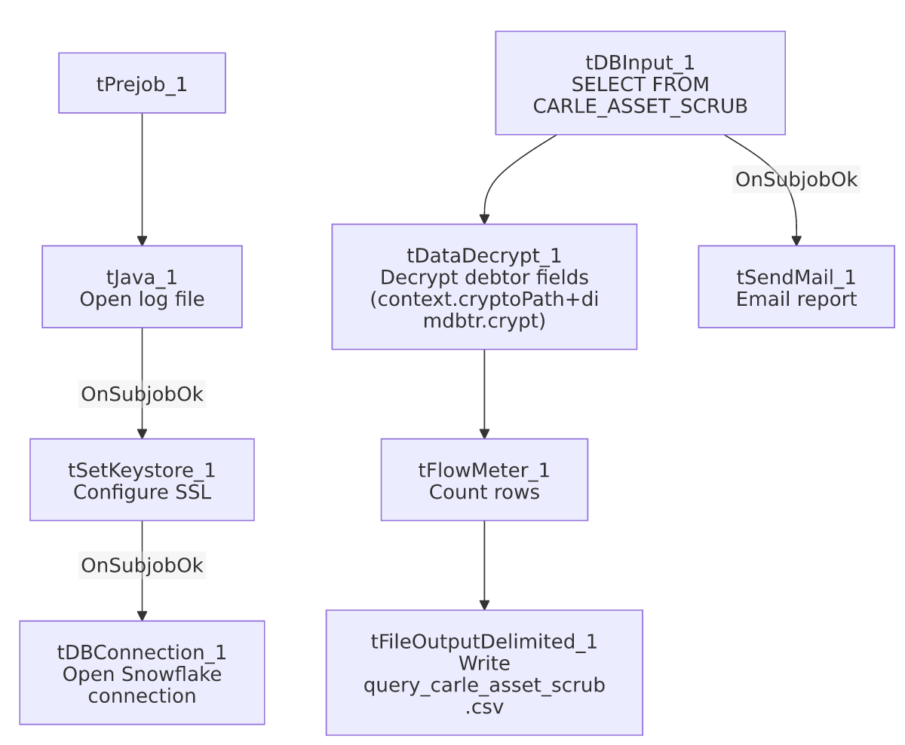

Settings tables

Source: `tDBInput_1` (`tSnowflakeInput`)
Setting | Value | What it means
Query | SELECT DEBTORNUMBER, CLIENT, NAME1, ADD1, CITY, ST, ZIP, PACKET, PHONE, DOB, DESK, "C.D.#" AS CD_NO, LST_PAY_DT, DT_ASSIGNED, SSN, STATUS, ASGN_AMT, ASGN_COLL, TOTAL_BAL, BALANCE_DIMDEBTOR_PACKET, ADMIT_DATE, DISCHARGE_DATE, EMP1_NAME, EMP1_ADDR, EMP1_CSZ, EMP1_PHN, "MISC. 4" AS MISC_4 FROM EDWPRODHH.PUB_LWASHINGTON.CARLE_ASSET_SCRUB; | 26-column pull including SSN, employment address/phone, and last-payment/discharge dates — a richer column set than LW_ProMedica_Scrub's equivalent query.

Transform: `tDataDecrypt_1`
Setting | Value | What it means
CRYPTO_FILE_PATH | context.cryptoPath+"dimdbtr.crypt" | Context-driven key path (unlike Insurance_Report_Extract's hardcoded equivalent).
DIE_ON_ERROR | true | Decryption failure fails the job.
SECRET_TYPE / SECRET_KEY / PASSWORD_M1 | ***REDACTED*** | Preserved as redacted.

Target: `tFileOutputDelimited_1`
Setting | Value | What it means
FILENAME | context.outputDir+"query_carle_asset_scrub.csv"
APPEND / INCLUDEHEADER | false / true | File recreated fresh each run with a header — differs from LW_COC_Water_Scrub's append-without-header pattern.

Mail: `tSendMail_1`
Setting | Value | What it means
SUBJECT / MESSAGE | "Carle Asset Scrub Report" / "The monthly Carle asset scrub report is attached."
DIE_ON_ERROR | true

Dependencies & configuration
- Triggers/depends on other jobs: none.
- Context variables used: cryptoPath, keystorePath, logDir, mailRecipients, outputDir.
- Hardcoded paths: tSetKeystore_1.SSL_TRUSTSERVER_TRUSTSTORE = "C:/clientTrustStore.trustStore" (same as other jobs in this batch).
- Per 05_operational_runbook.md, this is one of the jobs that sends email on completion, consistent with its role as a partner-facing monthly report.

Glossary
Component type | Plain-English meaning
tSnowflakeConnection / tSnowflakeInput | Open a Snowflake connection and run a query against it.
tDataDecrypt | Decrypts protected debtor fields (SSN, etc.) using a local key file before the data is written out.
tFlowMeter | Counts rows passing a point in the flow.
tFileOutputDelimited | Writes rows to a CSV file.
tSendMail | Emails the finished report to a distribution list.
tSetKeystore | Configures SSL trust store/keystore for the Snowflake JDBC connection.

Issues observed
- No job-specific issues beyond the project-wide hardcoded truststore path already covered in 05_operational_runbook.md. Unlike LW_COC_Water_Scrub/LW_Property_Scrub, this job has no file-exist/delete/sleep pre-flight steps and no truncated inline Java header-building code — its structure is simpler and more straightforwardly wired (single query → decrypt → write → mail).
- No reject-row handling or row-count logging tied to a warning/failure path — tFlowMeter_1 counts rows but nothing branches on that count; a zero-row result (e.g., an empty upstream view) would still produce and email a header-only CSV with no indication in the job's own logic that something may be wrong. Unable to determine from metadata whether this is by design; consistent with the general pattern noted in 05_operational_runbook.md that most jobs lack this kind of business-outcome check.

