Talend Job: LW_Dashboard_Base_Report

Overview
This job extracts raw agent/call metric records from a Snowflake publish-schema view (EDWPRODHH.PUB_LWASHINGTON.DASHBOARD_BASE_REPORT) — one row per agent/call-date/metric combination — and writes them to a fixed local-mount CSV file (/mnt/lsw/query_dashboard_base_report.csv). It appears to be the raw/granular data feed underlying the two summarized dashboard jobs in this batch (LW_Dashboard_By_Agent, LW_Dashboard_By_Metric), which likely aggregate this same base data by agent or by metric for a BI dashboard tool.

Detail table
Field | Value
Job name | LW_Dashboard_Base_Report
Version | 0.1
Project | EDW2SF
Author | jmach@harriscollect.com
Created | 2025-10-08T13:14:16.455-0700
Last Modified | 2025-11-04T11:08:09.248-0800

Step-by-step data flow
Setup subjob: tPrejob_1 → tJava_1 opens a per-run log file → on subjob-ok, tSetKeystore_1 configures SSL from context.keystorePath → on subjob-ok, tDBConnection_1 opens the Snowflake connection.
Main flow (single step, no explicit trigger link into it — see Issues observed): tDBInput_1 runs the query below, and its MAIN output connects directly to tFileOutputDelimited_1, which writes the full result (with header, file recreated each run) to /mnt/lsw/query_dashboard_base_report.csv.
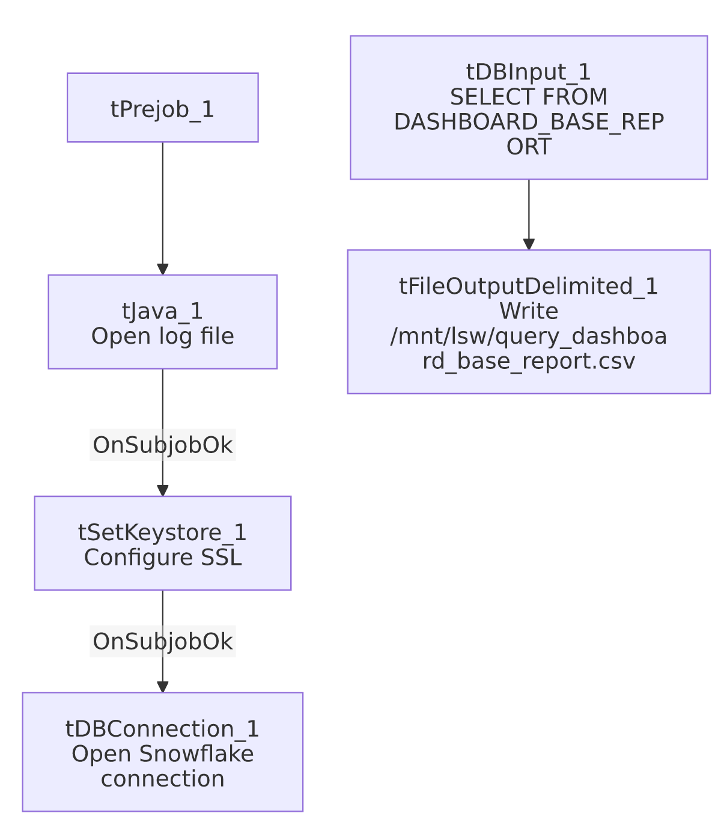

Settings tables

Source: `tDBInput_1` (`tSnowflakeInput`)
Setting | Value | What it means
Query | SELECT FILE, CALL_DATE, AGENT_NAME, EMPLOYEE_TYPE, SUPERVISOR, CAMPAIGN, LINE_OF_BUSINESS, SUBGROUP, ACCOUNT_NUMBER, METRIC_NAME, METRIC_VALUE FROM EDWPRODHH.PUB_LWASHINGTON.DASHBOARD_BASE_REPORT; | 11-column raw/granular agent-metric feed — one row per metric per agent per call date, not pre-aggregated.

Target: `tFileOutputDelimited_1`
Setting | Value | What it means
FILENAME | "/mnt/lsw/query_dashboard_base_report.csv" | Hardcoded Linux mount path — unlike the client-scrub jobs in this batch, this one is not driven by context.outputDir. /mnt/lsw is presumably a mounted share for this dashboard/BI process, distinct from the Windows-path conventions (context.outputDir, C:/...) seen elsewhere.
APPEND / INCLUDEHEADER | false / true | File recreated fresh each run with a header row.

Dependencies & configuration
- Triggers/depends on other jobs: none — no tRunJob links found. Not called by LW_Dashboard_By_Agent/LW_Dashboard_By_Metric either, per runjob_targets/06_dependency_matrix.md — despite the apparent data relationship (base feed vs. summarized views), these three jobs are not orchestrated together in this metadata; they appear to be run independently, likely on the same or a coordinated external schedule.
- Context variables used: keystorePath, logDir. Notably, outputDir is not referenced — the output path is fully hardcoded.
- Hardcoded paths: tSetKeystore_1.SSL_TRUSTSERVER_TRUSTSTORE = "C:/clientTrustStore.trustStore", plus the /mnt/lsw/... output path (not flagged in hardcoded_path_findings, which only captures the truststore path, but visible directly in tFileOutputDelimited_1.FILENAME).

Glossary
Component type | Plain-English meaning
tSnowflakeConnection / tSnowflakeInput | Open a Snowflake connection and run a query against it.
tFileOutputDelimited | Writes rows to a CSV file.
tSetKeystore | Configures SSL trust store/keystore for the Snowflake JDBC connection.

Issues observed
- No explicit trigger link connects the connection-setup subjob to the query/write subjob — the connections array shows tPrejob_1 → tJava_1 → tSetKeystore_1 → tDBConnection_1 as one chain and tDBInput_1 → tFileOutputDelimited_1 as a separate, unconnected chain. As with Insurance_Report_Extract, this means the ordering guarantee (Snowflake connection open before the query runs) isn't explicit in this job's own wiring; verify directly in Talend Studio.
- Output path is a hardcoded Linux mount (`/mnt/lsw/...`) rather than `context.outputDir`, unlike most other jobs in this batch. If this job is meant to run on the same host/environment as the context.outputDir-based jobs, the inconsistent pathing convention could make it harder to relocate this job's output alongside the others during an environment migration.
- No email, no row-count check, no `tWarn`/`tDie` logic — a query failure or empty result set here would only surface as a generic Talend execution error, and nothing downstream (e.g., a BI refresh trigger) is visibly notified of success or failure in this job's own metadata.

