Talend Job: LW_Dashboard_By_Agent

Overview
This job extracts a per-agent rollup of dashboard metrics (current/previous week values, month-to-date compliance percentage, year-to-date value, and week-over-week/month-over-month variance) from a Snowflake publish-schema view (EDWPRODHH.PUB_LWASHINGTON.DASHBOARD_BY_AGENT) and writes them to a fixed local-mount CSV file. It's a sibling of LW_Dashboard_By_Metric — same column shape and same file-reset/header-writing template — but grouped by agent (adding AGENT_NAME, EMPLOYEE_TYPE, SUPERVISOR columns) rather than purely by metric.

Detail table
Field | Value
Job name | LW_Dashboard_By_Agent
Version | 0.1
Project | EDW2SF
Author | jmach@harriscollect.com
Created | 2025-10-08T14:09:47.857-0700
Last Modified | 2025-11-04T11:08:13.141-0800

Step-by-step data flow
Setup subjob: tPrejob_1 → tJava_1 opens a per-run log file → on subjob-ok, tSetKeystore_1 configures SSL → on subjob-ok, tDBConnection_1 opens the Snowflake connection.
File-reset subjob (separate chain): tFileExist_1 checks whether /mnt/lsw/query_dashboard_by_agent.csv exists → if so (RUN_IF), tFileDelete_1 deletes it → on subjob-ok, tSleep_2 (30s) → tJava_2 builds a header-record string (again truncated in the captured metadata — see Issues observed) → on subjob-ok, tSleep_1 (30s) → tDBInput_1 runs the query below.
Query and output: tDBInput_1 → tFileOutputDelimited_1 appends the rows (no header written by this component; APPEND=true, INCLUDEHEADER=false) to /mnt/lsw/query_dashboard_by_agent.csv.
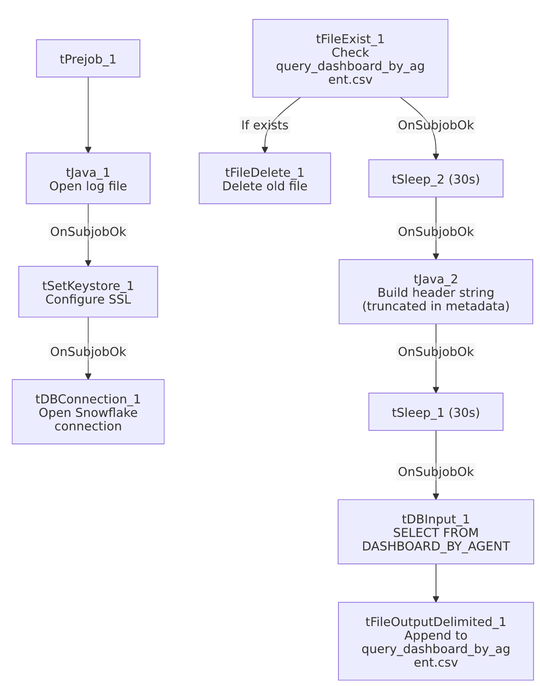

Settings tables

Source: `tDBInput_1` (`tSnowflakeInput`)
Setting | Value | What it means
Query | SELECT CAMPAIGN, METRIC_NAME, AGENT_NAME, EMPLOYEE_TYPE, SUPERVISOR, "Current Week", "Previous Week", "Current Week-2", "Current Week-3", "Compliance % MTD", "Last Month", "YTD Metric Value", "Variance (MoM)", "Variance(Current Week vs Latest Week)" FROM EDWPRODHH.PUB_LWASHINGTON.DASHBOARD_BY_AGENT; | Per-agent rollup: 4 weeks of trailing values, MTD compliance %, prior-month value, YTD value, and two variance metrics.

Target: `tFileOutputDelimited_1`
Setting | Value | What it means
FILENAME | "/mnt/lsw/query_dashboard_by_agent.csv" | Hardcoded Linux mount path, same convention as LW_Dashboard_Base_Report.
APPEND / INCLUDEHEADER | true / false | Header expected from the (truncated) tJava_2 step, same pattern as LW_COC_Water_Scrub.

Dependencies & configuration
- Triggers/depends on other jobs: none — no tRunJob links.
- Context variables used: keystorePath, logDir only — outputDir is not referenced; the output path and delete-folder path are fully hardcoded.
- Hardcoded paths: tSetKeystore_1.SSL_TRUSTSERVER_TRUSTSTORE ("C:/clientTrustStore.trustStore"), plus tFileDelete_1.DIRECTORY/PATH (the generic Talend-Studio-workspace placeholder path).

Glossary
Component type | Plain-English meaning
tFileExist / tFileDelete | Check for and conditionally delete the prior run's output file before rebuilding it.
tSleep | Pauses the job for a fixed duration — used here around the delete/header-build steps.
tSnowflakeConnection / tSnowflakeInput | Open a Snowflake connection and run a query against it.
tFileOutputDelimited | Writes rows to a CSV file.
tSetKeystore | Configures SSL trust store/keystore for the Snowflake JDBC connection.

Issues observed
- Same truncated-header-write pattern as `LW_COC_Water_Scrub` and `LW_Dashboard_By_Metric`. tJava_2's CODE parameter defines filePath and a headerRecord string that cuts off mid-literal ("...Variance...") with no visible statement that writes it to the file. Since tFileOutputDelimited_1 has INCLUDEHEADER=false, this is the only place a header could be written — if the code genuinely stops short of a file-write call, the output CSV may end up headerless. This same pattern recurs across at least three jobs in this batch (LW_COC_Water_Scrub, LW_Dashboard_By_Agent, LW_Dashboard_By_Metric), suggesting either a shared copy-paste template with a real gap, or a metadata-extraction limit on how much inline Java code is captured — worth checking one job directly in Talend Studio to determine which.
- Output path and delete-folder path are both hardcoded rather than context-driven — same portability observation as LW_Dashboard_Base_Report.
- No relationship in the metadata to `LW_Dashboard_Base_Report`, despite the apparent data lineage (aggregated-by-agent view likely built from the base report's underlying table) — these are not chained via tRunJob; any dependency between them is presumably enforced at the Snowflake view/materialization layer, not visible here.

