Talend Job: LW_Dashboard_By_Metric

Overview
This job extracts a per-metric (not per-agent) rollup of dashboard values — current/previous week, month-to-date compliance percentage, year-to-date value, and variance figures — from a Snowflake publish-schema view (EDWPRODHH.PUB_LWASHINGTON.DASHBOARD_BY_METRIC) and writes them to a fixed local-mount CSV file. It is structurally identical to LW_Dashboard_By_Agent (same file-reset/header/query/append template) but its query omits the agent-level columns (AGENT_NAME, EMPLOYEE_TYPE, SUPERVISOR), aggregating only by CAMPAIGN and METRIC_NAME.

Detail table
Field | Value
Job name | LW_Dashboard_By_Metric
Version | 0.1
Project | EDW2SF
Author | jmach@harriscollect.com
Created | 2025-10-08T13:41:00.128-0700
Last Modified | 2025-11-04T11:08:04.027-0800

Step-by-step data flow
Setup subjob: tPrejob_1 → tJava_1 opens a per-run log file → on subjob-ok, tSetKeystore_1 configures SSL → on subjob-ok, tDBConnection_1 opens the Snowflake connection.
File-reset subjob (separate chain): tFileExist_1 checks whether /mnt/lsw/query_dashboard_by_metric.csv exists → if so (RUN_IF), tFileDelete_1 deletes it → on subjob-ok, tSleep_2 (30s) → tJava_2 builds a header-record string (truncated in metadata — see Issues observed) → on subjob-ok, tSleep_1 (30s) → tDBInput_1 runs the query below.
Query and output: tDBInput_1 → tFileOutputDelimited_1 appends the rows (APPEND=true, INCLUDEHEADER=false) to /mnt/lsw/query_dashboard_by_metric.csv.
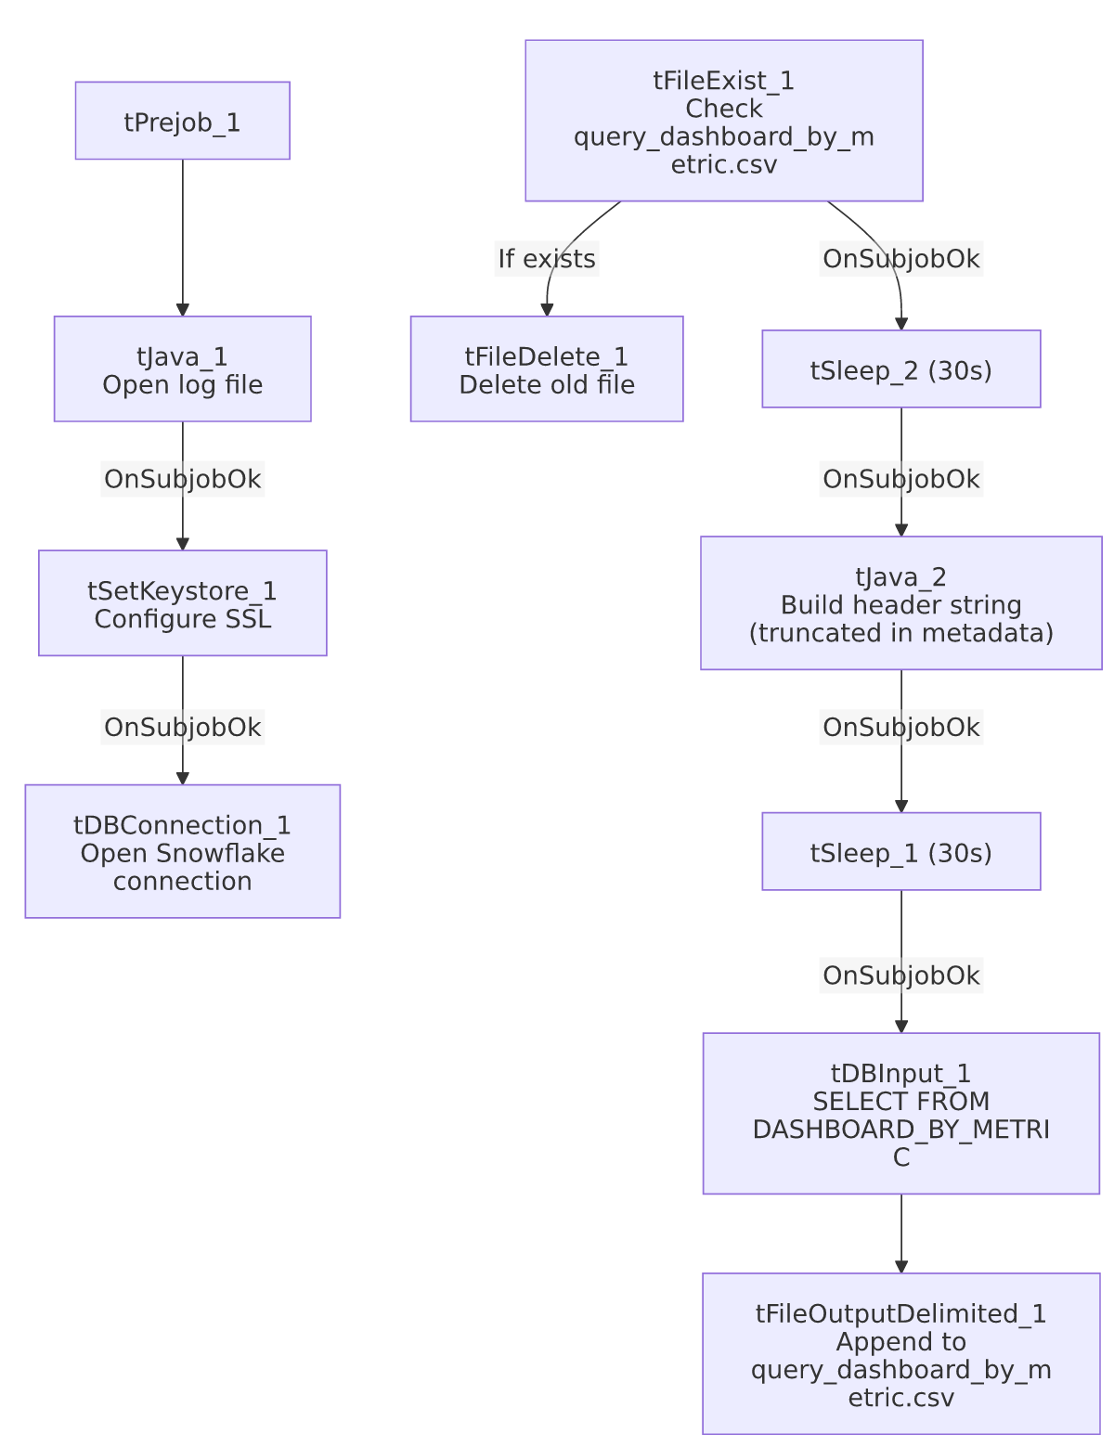

Settings tables

Source: `tDBInput_1` (`tSnowflakeInput`)
Setting | Value | What it means
Query | SELECT CAMPAIGN, METRIC_NAME, "Current Week", "Previous Week", "Current Week-2", "Current Week-3", "Compliance % MTD", "Last Month", "YTD Metric Value", "Variance (MoM)", "Variance(Current Week vs Latest Week)" FROM EDWPRODHH.PUB_LWASHINGTON.DASHBOARD_BY_METRIC; | Same trailing-weeks/MTD/YTD/variance shape as LW_Dashboard_By_Agent, but grouped by campaign+metric only — no agent/employee/supervisor breakdown.

Target: `tFileOutputDelimited_1`
Setting | Value | What it means
FILENAME | "/mnt/lsw/query_dashboard_by_metric.csv" | Hardcoded Linux mount path.
APPEND / INCLUDEHEADER | true / false | Same append-without-header pattern as its siblings.

Dependencies & configuration
- Triggers/depends on other jobs: none.
- Context variables used: keystorePath, logDir only — outputDir not referenced.
- Hardcoded paths: tSetKeystore_1.SSL_TRUSTSERVER_TRUSTSTORE, plus tFileDelete_1.DIRECTORY/PATH (generic Talend-Studio-workspace placeholder).

Glossary
Component type | Plain-English meaning
tFileExist / tFileDelete | Check for and conditionally delete the prior run's output file.
tSleep | Pauses the job for a fixed duration.
tSnowflakeConnection / tSnowflakeInput | Open a Snowflake connection and run a query against it.
tFileOutputDelimited | Writes rows to a CSV file.
tSetKeystore | Configures SSL trust store/keystore for the Snowflake JDBC connection.

Issues observed
- Same truncated header-write pattern as `LW_Dashboard_By_Agent`/`LW_COC_Water_Scrub` — tJava_2's headerRecord string is cut off mid-literal with no visible file-write statement, and tFileOutputDelimited_1 relies on INCLUDEHEADER=false, so a header row may not actually get written if the code truly stops there. See LW_Dashboard_By_Agent's doc for the same finding in more detail — this is a recurring pattern across the LW_Dashboard_* and LW_COC_Water_Scrub jobs, not unique to this one.
- Only difference from `LW_Dashboard_By_Agent` is the query's column list (no agent-level breakdown) and the target table/filename — every other component, connector type, and setting is identical between the two jobs, confirming they share a copy-paste template rather than independent development.
- Output path hardcoded, not context-driven — same observation as its LW_Dashboard_* siblings.

