Talend Job: LW_Delaware_Focus_Attributes_Granular

Overview
This job extracts a narrow, long-format (name/value pair) view of Delaware focus-attribute scores from a Snowflake view (PUB_LWASHINGTON.DELAWARE_FOCUS_GRANULAR) and writes them to Delaware_Focus_Attributes_Granular_View.csv. Unlike LW_Delaware_Focus_Attributes (32 wide numeric columns, one row presumably per audit period), this job's source appears to already be pivoted into a two-column SCORE_NAME/SCORE_VALUE shape — likely a per-attribute breakdown feeding a chart or table that needs one row per named score rather than one row with 32 columns.

Detail table
Field | Value
Job name | LW_Delaware_Focus_Attributes_Granular
Version | 0.1
Project | EDW2SF
Author | jmach@harriscollect.com
Created | 2024-07-10T09:38:23.454-0700
Last Modified | 2025-11-16T19:56:03.248-0800

Step-by-step data flow
Setup subjob: tPrejob_1 → tJava_1 opens a per-run log file → on subjob-ok, tSetKeystore_1 configures SSL → on subjob-ok, tDBConnection_1 opens the Snowflake connection.
Main flow (no explicit trigger link into it): tDBInput_1 runs SELECT SCORE_NAME, SCORE_VALUE FROM PUB_LWASHINGTON.DELAWARE_FOCUS_GRANULAR; → tFlowMeter_1 counts rows → tFileOutputDelimited_1 writes the result (with header, file recreated each run) to context.outputDir+"Delaware_Focus_Attributes_Granular_View.csv".
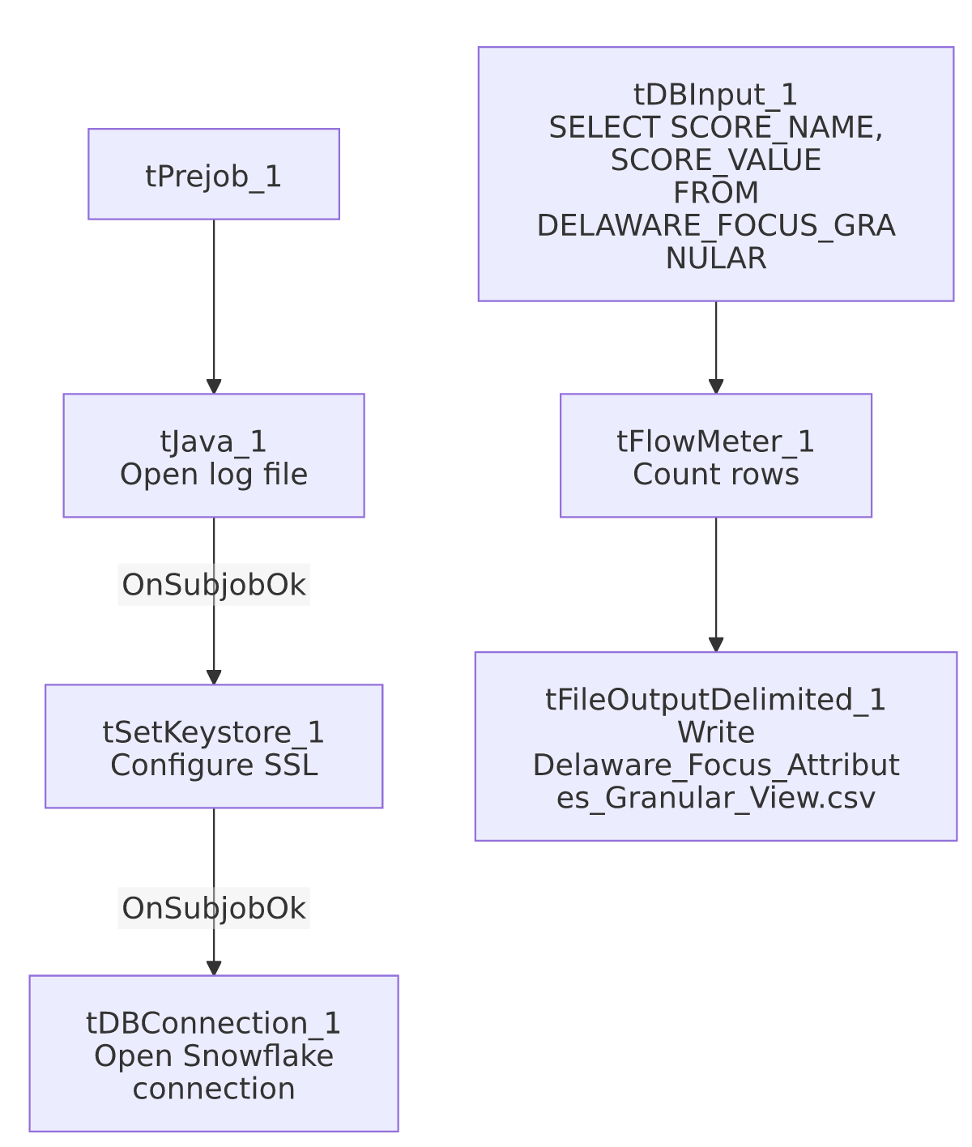

Settings tables

Source: `tDBInput_1` (`tSnowflakeInput`)
Setting | Value | What it means
Query | SELECT SCORE_NAME, SCORE_VALUE FROM PUB_LWASHINGTON.DELAWARE_FOCUS_GRANULAR; | Two-column long-format extract: SCORE_NAME (string) and SCORE_VALUE (BigDecimal, precision 28) — the pivot/unpivot logic that turns the 32-attribute wide table into this long format lives entirely in the Snowflake view, not in this Talend job.

Target: `tFileOutputDelimited_1`
Setting | Value | What it means
FILENAME | context.outputDir+"Delaware_Focus_Attributes_Granular_View.csv"
APPEND / INCLUDEHEADER | false / true

Dependencies & configuration
- Triggers/depends on other jobs: none.
- Context variables used: keystorePath, logDir, outputDir.
- Hardcoded paths: tSetKeystore_1.SSL_TRUSTSERVER_TRUSTSTORE.
- Sibling comparison: LW_HPS_Focus_Attributes_Granular and LW_Lurie_Focus_Attributes_Granular are structurally identical (same 2-column query shape), differing only in source view name and output filename. This job is the granular counterpart to LW_Delaware_Focus_Attributes (32-wide columns) and LW_Delaware_Scorecard_Report/LW_Deleware_Audit_Scorecard (per-call scorecards) — together these represent three different shapes of the same underlying Delaware compliance-scoring data.

Glossary
Component type | Plain-English meaning
tSnowflakeConnection / tSnowflakeInput | Open a Snowflake connection and run a query against it.
tFlowMeter | Counts rows passing a point in the flow.
tFileOutputDelimited | Writes rows to a CSV file.
tSetKeystore | Configures SSL trust store/keystore for the Snowflake JDBC connection.

Issues observed
- Same missing explicit trigger link between the connection-setup subjob and the query subjob as the other Focus Attributes jobs in this batch.
- No client/debtor/audit identifying columns — with only SCORE_NAME/SCORE_VALUE, there's no way from this job's own metadata to tell which audit period, call, or agent a given score row belongs to; that context must live either in the view's own row grouping (not visible here) or be joined downstream by whatever consumes this CSV. Unable to determine from metadata; verify with the team.
- No email/notification, consistent with the rest of this "Focus Attributes" family.

