Talend Job: LW_Deleware_Audit_Scorecard

Overview
This job extracts a per-call audit scorecard for the Delaware client relationship — collector name, call/audit dates, overall score, per-category percentage scores (opening, bridging, get-the-facts, negotiation flow, customer service, call closing, documentation), the 32 underlying pass/fail attribute flags, and a free-text "area of opportunity"/compliance-status pair — from a Snowflake view (PUB_LWASHINGTON.DELAWARE_AUDIT_REPORT) and writes the full result to a CSV report. Note the job's own name is misspelled ("Deleware" rather than "Delaware") relative to its sibling jobs (LW_Delaware_Focus_Attributes, LW_Delaware_Scorecard_Report) — see Issues observed.

Detail table
Field | Value
Job name | LW_Deleware_Audit_Scorecard
Version | 0.1
Project | EDW2SF
Author | jmach@harriscollect.com
Created | 2024-07-10T09:17:15.091-0700
Last Modified | 2025-11-16T20:03:56.337-0800

Step-by-step data flow
Setup subjob: tPrejob_1 → tJava_1 opens a per-run log file → on subjob-ok, tSetKeystore_1 configures SSL → on subjob-ok, tDBConnection_1 opens the Snowflake connection.
Main flow (no explicit trigger link into it): tDBInput_1 runs the query below → tFlowMeter_1 counts rows → tFileOutputDelimited_1 writes the result (with header, file recreated each run) to context.outputDir+"Deleware_Audit_Scorecard_Report.csv" (note the output filename also carries the "Deleware" misspelling).
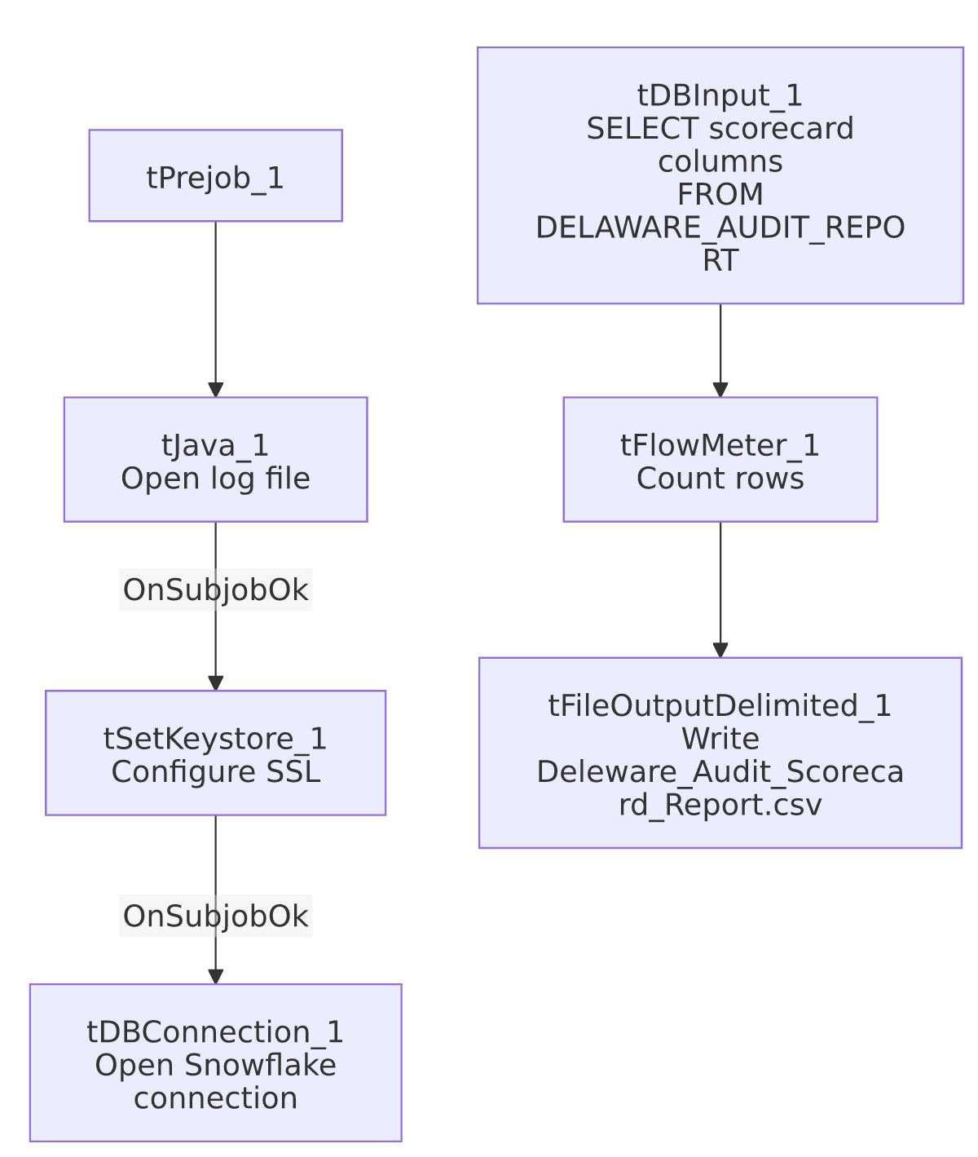

Settings tables

Source: `tDBInput_1` (`tSnowflakeInput`)
Setting | Value | What it means
Query | SELECT COLLECTOR_NAME, "CALL DATE", "AUDIT DATE", "OVERALL SCORE", OPENING_SCORE_PCT, SECOND_IDENTIFIER, IDENTIFY_SELF, COMPLIANCE_STATEMENT, IDENTIFY_CLIENT, STRATEGIC_PAUSES, AVOIDING_EARLY_TERMINATION_SCORE_PCT, ACKNOWLEDGE_THE_STAT, TRANSITION_BACK, BRIDGING_SCORE_PCT, LISTEN_TO_CONSUMER, REMOVE_ISOLATION, OFFER_TO_HELP, GET_THE_FACTS_SCORE_PCT, STATE_THE_BALANCE, MAKE_DEMAND_FOR_BALANCE, IF_NOT_BIF_TODAY, WHEN_CAN_REMAINING_BAL, IF_NOT_SOMETHING_TODAY, GATHER_F_AND_C_INFORMATION, NEGOTIATION_FLOW_SCORE_PCT, WIIFM, F_C_INFORMATION, SELL_THE_URGENCY, EMPHASIZE_TEMPORARY, NEGOTIATE_MAD, CUSTOMER_SERVICE_SCORE_PCT, EMPATHY_AND_RESPECT, DISPLAYED_COURTESY, SPEED_TONE_AND_VOLUME, CALL_CLOSING_SCORE_PCT, MAD, SET_FOLLOW_UP, REGRET, RECAP_AGREEMENT, COMMUNICATE_CONSEQUENCES, CONTACT_INFORMATION, END_WITH_A_PLEASANTRY, DOCUMENTATION_SCORE_PCT, ACTION_CODE, ACC_DOCUMENTATION, "AREA OF OPPORTUNITY", COMPLIANCE_STATUS FROM PUB_LWASHINGTON.DELAWARE_AUDIT_REPORT; | 46 columns: identifying info (collector, dates), 7 category percentage scores, the 32 underlying pass/fail flags (as BigDecimal(1), i.e. 0/1), and 2 free-text summary columns. This is the per-call detail behind the aggregated LW_Delaware_Focus_Attributes job.

Target: `tFileOutputDelimited_1`
Setting | Value | What it means
FILENAME | context.outputDir+"Deleware_Audit_Scorecard_Report.csv" | Filename preserves the "Deleware" misspelling from the job name.
APPEND / INCLUDEHEADER | false / true

Dependencies & configuration
- Triggers/depends on other jobs: none.
- Context variables used: keystorePath, logDir, outputDir.
- Hardcoded paths: tSetKeystore_1.SSL_TRUSTSERVER_TRUSTSTORE.
- Sibling comparison: LW_HPS_Audit_Scorecard and LW_Lurie_Audit_Scorecard use the identical 46-column query shape and category breakdown, differing only in source view (HPS_AUDIT_REPORT, LURIE_AUDIT_SCORECARD_REPORT) and output filename. LW_Delaware_Scorecard_Report is a closely related but not identical job: it queries a different view (DELAWARE_SCORECARD_REPORT vs. this job's DELAWARE_AUDIT_REPORT) and its column list includes one extra column, CORE, that does not appear in this job's query — see that job's own doc for detail.

Glossary
Component type | Plain-English meaning
tSnowflakeConnection / tSnowflakeInput | Open a Snowflake connection and run a query against it.
tFlowMeter | Counts rows passing a point in the flow.
tFileOutputDelimited | Writes rows to a CSV file.
tSetKeystore | Configures SSL trust store/keystore for the Snowflake JDBC connection.

Issues observed
- The job name itself is misspelled ("Deleware" instead of "Delaware"), inconsistent with LW_Delaware_Focus_Attributes, LW_Delaware_Focus_Attributes_Granular, and LW_Delaware_Scorecard_Report, all of which spell it correctly. The output filename (Deleware_Audit_Scorecard_Report.csv) inherits the same misspelling. This is a naming/discoverability issue rather than a functional one — anyone searching the job repository or output directory for "Delaware" jobs by exact name could miss this one.
- Same missing explicit trigger link between the connection-setup subjob and the query subjob as the rest of this batch.
- No email/notification and no client/debtor identifying key beyond collector name and call/audit dates — there's no debtor number or account identifier in this scorecard extract, so joining a given row back to a specific debtor/account would require a separate lookup not visible in this job.

