Talend Job: LW_HPS_Audit_Scorecard

Overview
This job extracts a per-call audit scorecard for the HPS client relationship — collector name, call/audit dates, overall score, 7 category percentage scores, the 32 underlying pass/fail attribute flags, and free-text summary columns — from a Snowflake view (PUB_LWASHINGTON.HPS_AUDIT_REPORT) and writes the full result to HPS_Audit_Scorecard_Report.csv. It is structurally and column-for-column identical to LW_Deleware_Audit_Scorecard and LW_Lurie_Audit_Scorecard, differing only in source view and output filename.

Detail table
Field | Value
Job name | LW_HPS_Audit_Scorecard
Version | 0.1
Project | EDW2SF
Author | jmach@harriscollect.com
Created | 2024-08-12T10:23:27.648-0700
Last Modified | 2025-11-16T20:04:46.303-0800

Step-by-step data flow
Setup subjob: tPrejob_1 → tJava_1 opens a per-run log file → on subjob-ok, tSetKeystore_1 configures SSL → on subjob-ok, tDBConnection_1 opens the Snowflake connection.
Main flow (no explicit trigger link into it): tDBInput_1 runs the 46-column query below → tFlowMeter_1 counts rows → tFileOutputDelimited_1 writes the result (with header, file recreated each run) to context.outputDir+"HPS_Audit_Scorecard_Report.csv".
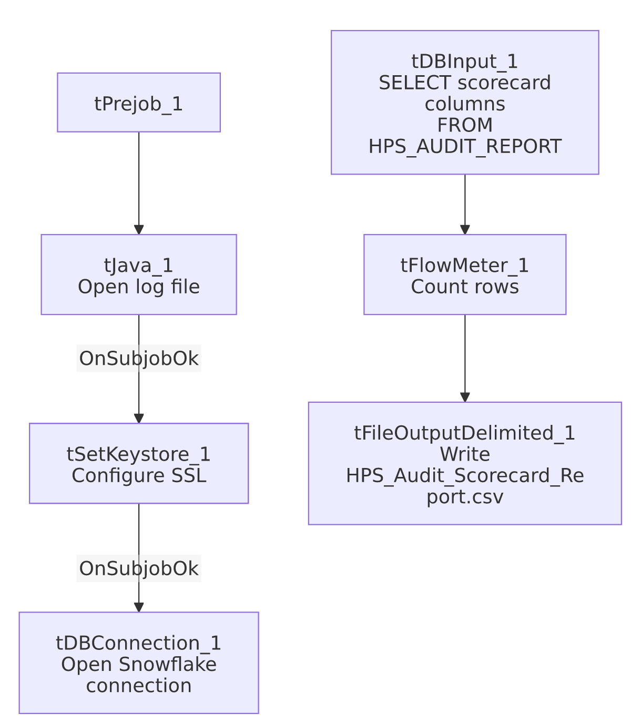

Settings tables

Source: `tDBInput_1` (`tSnowflakeInput`)
Setting | Value | What it means
Query | SELECT COLLECTOR_NAME, "CALL DATE", "AUDIT DATE", "OVERALL SCORE", OPENING_SCORE_PCT, ... ACTION_CODE, ACC_DOCUMENTATION, "AREA OF OPPORTUNITY", COMPLIANCE_STATUS FROM PUB_LWASHINGTON.HPS_AUDIT_REPORT; (same 46-column list as LW_Deleware_Audit_Scorecard) | Identical shape to the Delaware and Lurie audit-scorecard siblings — only HPS_AUDIT_REPORT differs as the source view.

Target: `tFileOutputDelimited_1`
Setting | Value | What it means
FILENAME | context.outputDir+"HPS_Audit_Scorecard_Report.csv"
APPEND / INCLUDEHEADER | false / true

Dependencies & configuration
- Triggers/depends on other jobs: none.
- Context variables used: keystorePath, logDir, outputDir.
- Hardcoded paths: tSetKeystore_1.SSL_TRUSTSERVER_TRUSTSTORE.
- Sibling comparison: Identical structure to LW_Deleware_Audit_Scorecard and LW_Lurie_Audit_Scorecard. This is the per-call detail counterpart to LW_HPS_Focus_Attributes (aggregated) and LW_HPS_Focus_Attributes_Granular (long-format).

Glossary
Component type | Plain-English meaning
tSnowflakeConnection / tSnowflakeInput | Open a Snowflake connection and run a query against it.
tFlowMeter | Counts rows passing a point in the flow.
tFileOutputDelimited | Writes rows to a CSV file.
tSetKeystore | Configures SSL trust store/keystore for the Snowflake JDBC connection.

Issues observed
- Same missing explicit trigger link between the connection-setup subjob and the query subjob as the rest of this batch.
- No email/notification and no debtor/account identifier, same as the Delaware sibling — a given scorecard row can only be traced to a collector name and call/audit date, not to a specific account.
- Note this job's name is spelled correctly ("HPS"), so unlike LW_Deleware_Audit_Scorecard there is no naming-consistency issue for this specific job — the misspelling flagged there is unique to the Delaware variant.

